LPG-DG2
2.0M Low power intelligent
doorbell wireless HD camera module

Features:
- 2.0M resolution, clear and fine images;
- PIR infrared human sensor to support passive infrared sensing;
- The standard is equipped with 24V AC charging module and doorbell pressing module;
- Support 2D/3D noise reduction, digital wide dynamic;
- Advanced H.265X video compression, Super low rate ,high definition quality of image;
- Professional anti-lightning, conform to GB/T17626.5 and IEC61000-4-5。
- Support mobile phone monitoring(iOS, Android);
- Support cloud technology ,easy to achieve network penetration, fro in-line and alarm information pushed
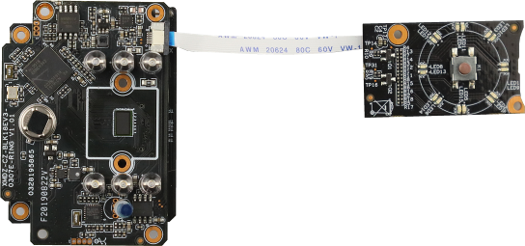
Model | LPG-DG2
System structure | Embedded RTOS, dual-core 32-bit DSP ( Hi3518EV300),pure hard compression ,watch dog
Sensor | 2.0M 1/2.9"SC307E CMOS sensor ,color 0.1Lux@F1.2,black/white 0.01Lux@F1.2
Video compression | H.265X,support dual stream,AVI;0.1M~8Mpbs variable
Image output | Main stream: 1920*1080@6fps,sub-stream: 704*576@6fps
Shutter | 1/50(1/60)s to 1/10,000s
Lens | N/A
Day and night | Support IR-CUT
Noise reduction | Support 2D/3D
Wide dynamic | Support
Auto iris | N/A
Audio compression | G.711 standard compression, support two-way Bidrectional Talk, support for audio and video synchronization
Audio interface | 1ch input,level:2Vp-p,impedance:1kΩ,support sound pick-up input;1ch output,impedance:16Ω,30mw,support microphone;
Network interface | N/A
Extension interface | N/A
Singal interface | one IR-CUT interface
PIR | Support
Motor interface | N/A
Alarm I/O | N/A
WIFI interface | Support wireless connections
Reset interface | Support
SD Card | Support
Reliability | Comprehensive lightning protection,7 * 24 hours 65 ℃ high temperature stable and reliable testing
Intelligence analysis | NO
Other function | Support for smart alarms; Support APP remote monitoring software; Full SDK development package
ONVIF | NO
Mobile monitoring | Support multiple mobile monitoring（Ios,Android）
Power | Power(optional):DC5V, DC24V,2*18650
Dimension | Low Power Doorbell
Other | Does not accept any custom.

Parameters：

BRD_XMDZ-CZ-LED-KEY-FPC-RING-V1_01
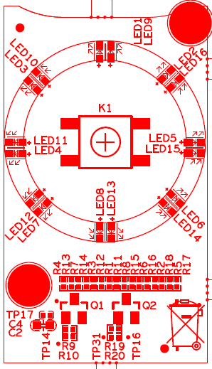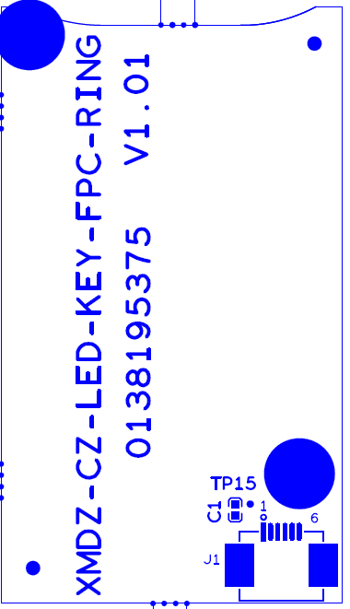

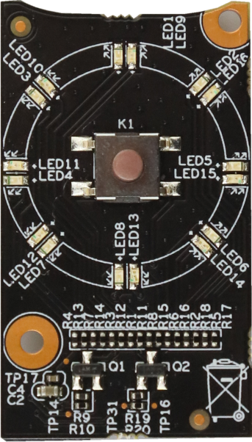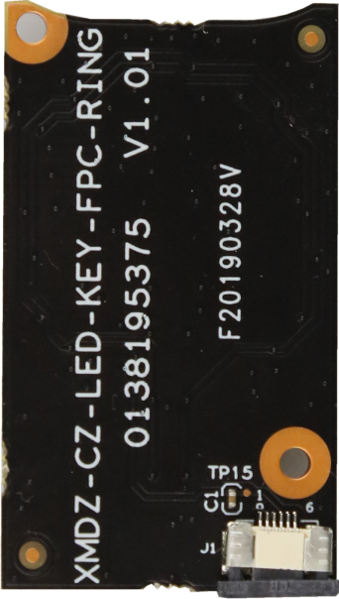
P13

P1
1 2 3 4 5 6

sign | Socket | Specific No | Interface Description | Function
P1 | J1 | 1 | 3.3V | 3.3V Power input
P1 | J1 | 2 | GND | GND
P1 | J1 | 3 | GND | GND
P1 | J1 | 4 | SET_GPIO03 | Doorbell button signal
P1 | J1 | 5 | MCU_LED2 | Led control signal 1
P1 | J1 | 6 | MCU_LED1 | Led control signal 2
P13 | K1 | 1 | GND | GND
P13 | K1 | 2 | GND | GND
P13 | K1 | 3 | SET_GPIO03 | Doorbell button signal
P13 | K1 | 4 | SET_GPIO03 | Doorbell button signal

BRD_XMDZ-CZ-POWER-SD-USB-433-RING-V2_01
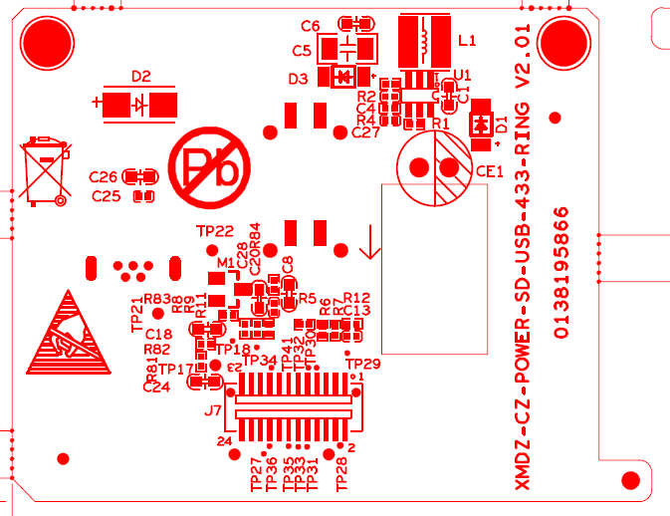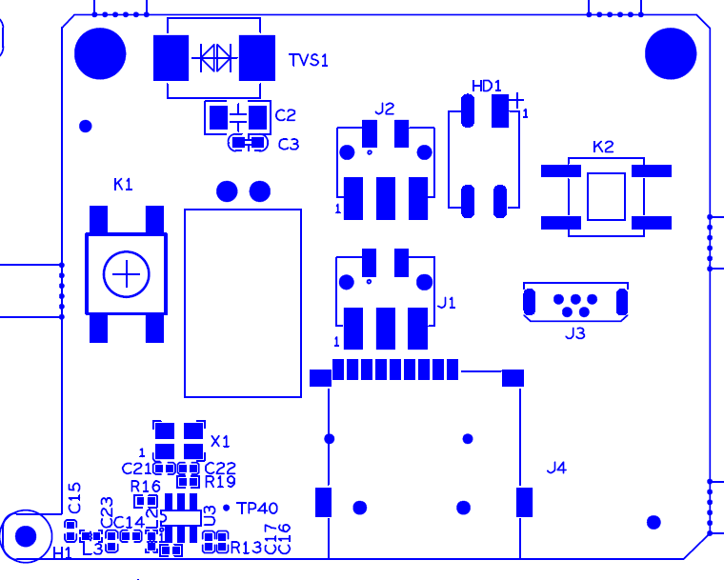
P3
1 2 3

P14

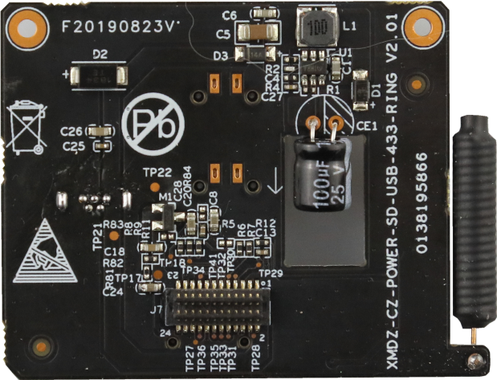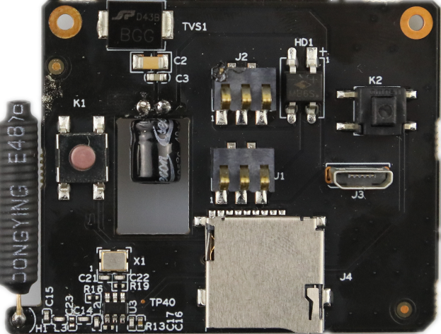
P4

P15

P2
1 2 3

P5
23 21……..5 3 1
24 22……..6 4 2

sign | Socket | Specific No | Interface Description | Function
P2 | J1 | 1 | AC24+ | AC24 V+ input
P2 | J1 | 2 | AC24+ | AC24V+ input
P2 | J1 | 3 | AC24+ | AC24V+ input
P3 | J2 | 1 | AC24- | AC24V- input
P3 | J2 | 2 | AC24- | AC24V- input
P3 | J2 | 3 | AC24- | AC24V- input
P4 | J3 | 1 | +5V | USB5V Power input
P4 | J3 | 2 | Nc | /
P4 | J3 | 3 | Nc | /
P4 | J3 | 4 | Nc | /
P4 | J3 | 5 | Gnd | Gnd
P4 | J3 | 6 | Gnd | Gnd
P4 | J3 | 7 | Gnd | Gnd
P5 | J7 | 1 | +5V | 5V Power input
P5 | J7 | 2 | +5V | 5V Power input
P5 | J7 | 3 | Gnd | Gnd
P5 | J7 | 4 | +5V | 5V Power input
P5 | J7 | 5 | Gnd | Gnd
P5 | J7 | 6 | Gnd | Gnd
P5 | J7 | 7 | SD_ EN | SD_ EN
P5 | J7 | 8 | CARD_DETECT | CARD_DETECT
P5 | J7 | 9 | SDIO1_CDATA1 | SDIO1_CDATA1
P5 | J7 | 10 | SDIO1_CDATA0 | SDIO1_CDATA0
P5 | J7 | 11 | SDIO1_CDATA3 | SDIO1_CDATA3
P5 | J7 | 12 | SDIO1_CDATA2 | SDIO1_CDATA2
P5 | J7 | 13 | Gnd | Gnd
P5 | J7 | 14 | SDIO1_CCMD | SDIO1_CCMD
P5 | J7 | 15 | 433_IN | 433_IN
P5 | J7 | 16 | Gnd | Gnd
P5 | J7 | 17 | SW_ON/OFF | SW_ON/OFF
P5 | J7 | 18 | SDIO1_CCLK_OUT | SDIO1_CCLK_OUT
P5 | J7 | 19 | SET_GPIO04 | SET_GPIO04
P5 | J7 | 20 | Gnd | Gnd
P5 | J7 | 21 | Gnd | Gnd
P5 | J7 | 22 | Gnd | Gnd
P5 | J7 | 23 | +3.3V | +3.3V
P5 | J7 | 24 | SDIO1_VOUT | SDIO1_VOUT
P14 | K1 | 1 | Gnd | Gnd
P14 | K1 | 2 | Gnd | Gnd
P14 | K1 | 3 | SW_ON/OFF | Restore factory set key signal
P14 | K1 | 4 | SW_ON/OFF | Restore factory set key signal
P15 | K2 | 1 | Gnd | Gnd
P15 | K2 | 2 | SET_GPIO04 | Anti disassembly key signal
BRD_XMDZ-CZ-BLK18EV3-0307E-RING-V1_01
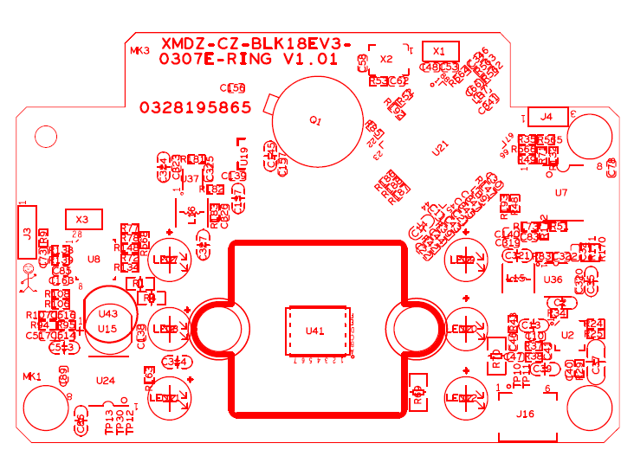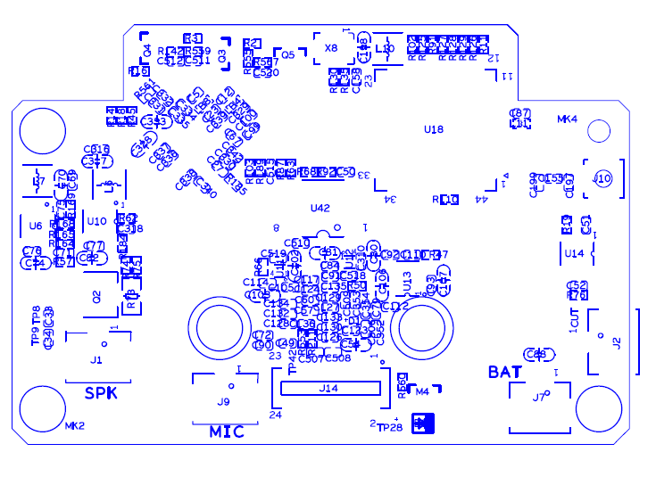
P2
1 2 3

P6
2 1

P8
1 2 3

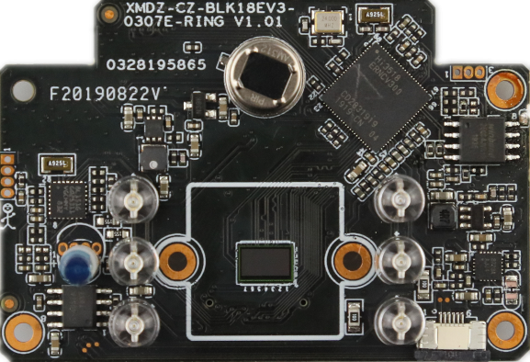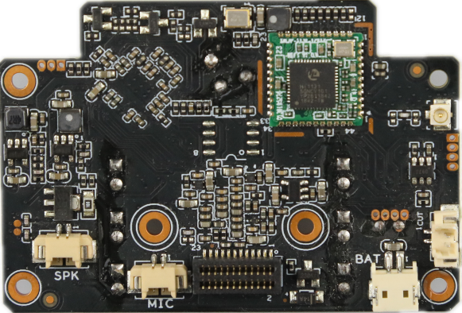
P7
1
2

P9
2 1

P10
2 1

P11
23 21……..5 3 1
24 22……..6 4 2

P12
1 2 3 4 5 6

sign | Socket | Specific No | Interface Description | Function
P6 | J1 | 1 | VOP | Horn signal+
P6 | J1 | 2 | VON | Horn signal-
P7 | J2 | 1 | IR_CUT1 | IR_CUT signal 1
P7 | J2 | 2 | IR_CUT2 | IR_CUT signal 2
P8 | J4 | 1 | UART0_RXD | UART0_RXD
P8 | J4 | 2 | UART0_TXD | UART0_TXD
P8 | J4 | 3 | Gnd | Gnd
P9 | J7 | 1 | +5V_BQ | +5V_BQ
P9 | J7 | 2 | Gnd | Gnd
P10 | J9 | 1 | GND | GND
P10 | J9 | 2 | MIC_P | Microphone signal
P11 | J14 | 1 | +3.3V | 3.3V Power output
P11 | J14 | 2 | +3.3V | 3.3V Power output
P11 | J14 | 3 | Gnd | Gnd
P11 | J14 | 4 | Gnd | Gnd
P11 | J14 | 5 | SET_GPIO04 | Anti disassembly key signal
P11 | J14 | 6 | Gnd | Gnd
P11 | J14 | 7 | SW_ON/OFF1 | Restore factory set key signal
P11 | J14 | 8 | SD0_CLK/SFC_INPUT_SEL | SD clock
P11 | J14 | 9 | 433_IN | 433 signal
P11 | J14 | 10 | Gnd | Gnd
P11 | J14 | 11 | Gnd | Gnd
P11 | J14 | 12 | SD0_CMD | SD0_CMD
P11 | J14 | 13 | SD0_D3 | SD0_D3
P11 | J14 | 14 | SD0_D2 | SD0_D2
P11 | J14 | 15 | SD0_D1 | SD0_D1
P11 | J14 | 16 | SD0_D0 | SD0_D0
P11 | J14 | 17 | SD_EN | SD_EN
P11 | J14 | 18 | SD0_CARD_DETECT | SD0_CARD_DETECT
P11 | J14 | 19 | Gnd | Gnd
P11 | J14 | 20 | Gnd | Gnd
P11 | J14 | 21 | Gnd | Gnd
P11 | J14 | 22 | +5V_IN | +5V_IN
P11 | J14 | 23 | +5V_IN | +5V_IN
P11 | J14 | 24 | +5V_IN | +5V_IN
P12 | J16 | 1 | +3.3V_PIR | +3.3V_PIR
P12 | J16 | 2 | GND | GND
P12 | J16 | 3 | GND | GND
P12 | J16 | 4 | SET_GPIO03 | SET_GPIO03
P12 | J16 | 5 | MCU_RLED | MCU_RLED
P12 | J16 | 6 | MCU_BED1 | MCU_BED1

