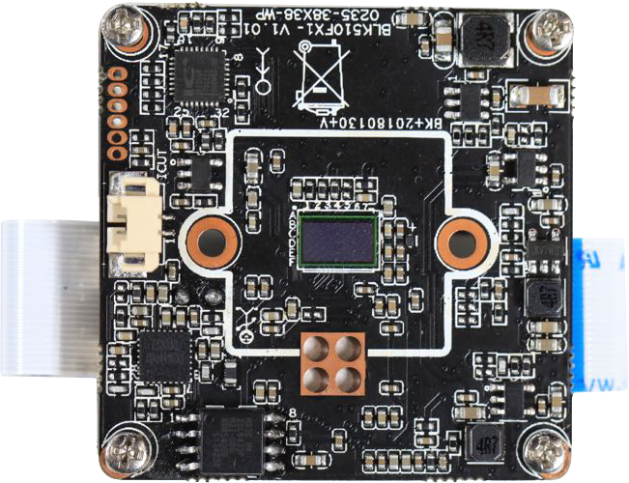
LPG-PG2
Features:
- 2.0M resolution, clear and fine images;
- The standard is equipped with 24V AC charging module and doorbell pressing module;
- Support 2D/3D noise reduction, digital wide dynamic;
- Advanced H.265X/H.264 video compression, Super low rate ,high definition quality of image;
- Professional anti-lightning, conform to GB/T17626.5 and IEC61000-4-5。
- Support mobile phone monitoring(iOS, Android);
- Support cloud technology ,easy to achieve network penetration, fro in-line and alarm information pushed

Parameters：

Model | LPG-PG2
System structure | Embedded RTOS, dual-core 32-bit DSP (Hi3518EV200),pure hard compression ,watch dog
Sensor | 2.0M 1/2.7 "SC2145 CMOS sensors; Color 0.1 Lux@F1 .2, black and white 0.01 Lux@F1 .2
Video compression | H.265X/H.264,support dual stream,AVI;0.1M~8Mpbs variable
Image output | Main stream: 1920*1080，sub-stream: 704*576;
Shutter | 1/50(1/60)s to 1/10,000s
Lens | N/A
Day and night | Support IR-CUT
Noise reduction | Support 2D/3D
Wide dynamic | Support
Auto iris | N/A
Audio compression | G.711 standard compression, support two-way Bidrectional Talk, support for audio and video synchronization
Audio interface | 1ch input,level:2Vp-p,impedance:1kΩ,support sound pick-up input;1ch output,impedance:16Ω,30mw,support microphone;
Network interface | N/A
Extension interface | N/A
Singal interface | one IR-CUT interface
PIR | Support
Motor interface | N/A
Alarm I/O | N/A
WIFI interface | Support wireless connections
Reset interface | Support
SD Card | Support Maximum 64G
Reliability | Comprehensive lightning protection, 7 * 24 hours 65 ℃ high temperature stable and reliable testing
Intelligence analysis | NO
Other function | Support for smart alarms; Support APP remote monitoring software; Full SDK development package
ONVIF | NO
Mobile monitoring | Support multiple mobile monitoring（iOS，Android）
Power | Power(optional): DC5V;
Dimension | Low Power card machine
Other | Does not accept any custom.

