NBD8032RA-UL
32ch 4K H.265 NVR Board
Feature：
- Support HDMI 4K output VGA HD output;
- Support ONVIF;access third party;
- Support web, CMS, center platform management software MYEYE, provide SDK development;
- Support multiple cloud technology, network penetration, alarm information pushed to your phone and other functions;
- Support multiple network services (support DHCP, FTP, DNS, DDNS, NTP, UPNP, EMAIL, IP searches, Alarm Center, etc.);
2*SATA
118mm

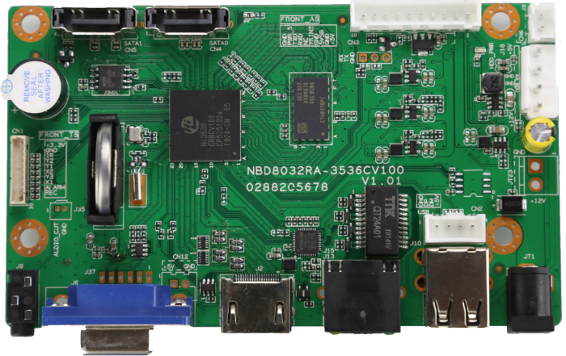

69.5mm

HDMI
3.5mm
Audio input and output
Parameters：

VGA
2*USB2.0
12V
RJ45
Model：NBD8032RA-UL
 | Model | NBD8032RA-UL
System | Main processor | Hi3536C
System | Operating System | Embedded Linux
System | System resources | Simultaneous multi-channel real-time recording, playback, network operation, USB backup
Interface | Operator interface | 16-bit true color graphic menu operation interface, support mouse operation
Interface | Preview | 1/2/4/6/8/9/16/25/32
Video | Video input (IP) | 32*4K
Video | Video compression | H.265AI/H.265+(compatible H.265/H.264)
Video | Display quality | Max:4K
Video | Playback quality | 4K/5M/4M/3M/1080P
Video | VR | Unsupport
Video | Motion detection | Support(depend on camera)
Audio | Audio compression | G.711A
Audio | Intercom | support
Record  &  playback | Recording mode | Manual>Alarm>Dynamic Detection>Timing
Record  &  playback | Local payback(real-time+Un real-time) | 4K（1+2）/5M（2+3）/4M(2+5)/3M（3+6）/1080P（5+9）
Record  &  playback | Search mode | Search by Time/Calendar/Event/Channel/Face
Record  &  playback | Record storage | HDD、Network
Record  &  playback | Backup mode | Network backup, USB hard disk, USB burner, SATA burner
External interface | Video output | 1ch VGA，1ch HDMI HD output
External interface | Audio I/O | 1/1（3.5MM）
External interface | Alarm I/O | 0/0
External interface | Network interface | 1*RJ45 10M/100M/1000M Adaptive Ethernet port
External interface | USB interface | 2*USB2.0 ports
External interface | HDD | 2 SATA(Up to 14TB for each disk)
External interface | ESATA | No
External interface | Serial interface | No
Other | ONVIF | Support
Other | Power supply | 12V/4A
Other | Power Consumption | <10W(Without HDD)
Other | Work environment | Temperature:0℃ －55℃ , Humidity:10%－90%RH , Atm:86kpa－106kp
Other | Dimension | 118mm*69.5mm
Other | Weight | A total of about 63g

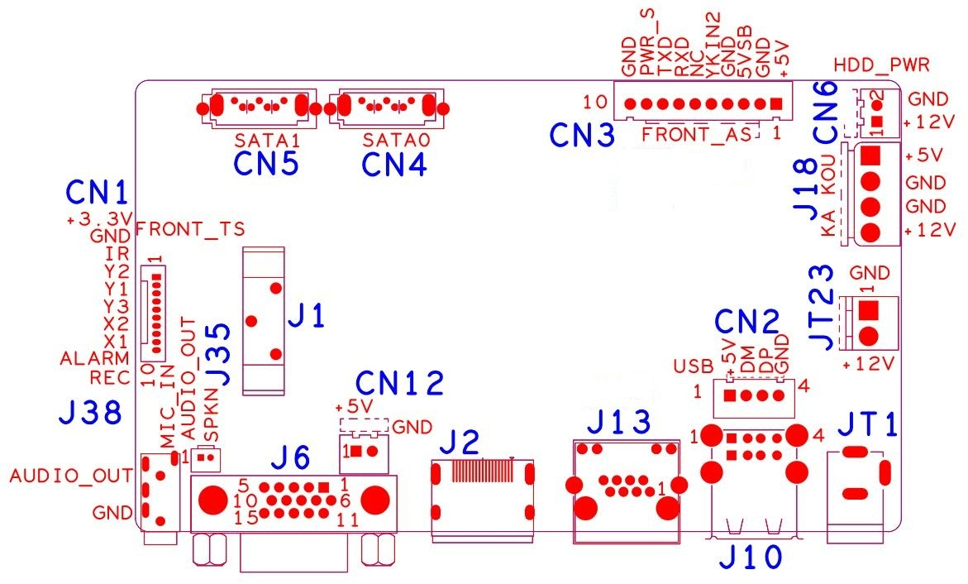

Sign | Function | Interface Description
CN1 | Expansion socket without MCU front panel（1.25*10P） | 1:+3.3 | 2:GND | 3:IR | 4:COL2
CN1 | Expansion socket without MCU front panel（1.25*10P） | 5:COL1 | 6:ROW2 | 7:COL3 | 8:ROW1
CN1 | Expansion socket without MCU front panel（1.25*10P） | 9:ALARM | 10:REC
CN5 | SATA
CN4 | SATA
CN3 | Expansion base with MCU front panel | 1:+5 | 2:GND | 3:+5_STB | 4:GND
CN3 | Expansion base with MCU front panel | 5:NC | 6:NC | 7:RXD_FRONT | 8:TX_FRONT
CN3 | Expansion base with MCU front panel | 9:PWR_S | 10:GND
CN6 | Fan power holder | 1:+12 | 2:GND
J18 | Hard disk power socket | 1:+5 | 2:GND | 3:GND | 4:+12
JT23 | 12V input (reserved for POE expansion)
JT1 | 12V input
J10 | 2*USB
CN2 | USB Extension interface(Scalable 3G WIFI)
J13 | RJ45
J2 | HDMI
J6 | VGA
CN12 | 5V output 2PIN extension (reserved)
J35 | Speaker extension (reserved, can be connected to speakers)
J9 | Audio 3.5mm input and output interface
J1 | CR2032 Battery holder

