# AHD-XM330V200-0235P-32X32-V1_01接口说明

**CN2** 1 2 3

**CN5** 1 2

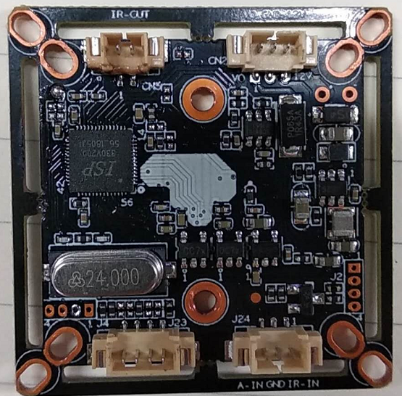

**J24** 3 2 1

**J4**  4 3 2 1

**详细定义**

|  |  |  |  |
| --- | --- | --- | --- |
| 位号 | 接口详细编号 | 接口定义 | 实现功能 |
| CN2 | 1 | CVBS | Video Out |
| 2 | GND | 地 |
| 3 | 12V | 12V电源输入 |
| CN5 | 1 | IRCUTA | IRCUT接口 |
| 2 | IRCUTB |
| J24 | 1 | ADC1VIN | Red_CTRL |
| 2 | GND | 地 |
| 3 | ALARM_IN1 | 报警输入 |
| J23 | 1 | GND | 地 |
| 2 | ADC | 切换CII |
| 3 | MODE_N-P | N-P制式切换 |
| 4 | ADC | 切换TVI |