AHD-4K-Apollo-32X32 V1.0 Interface Description

CN1 1 2
CN2 1 2 3

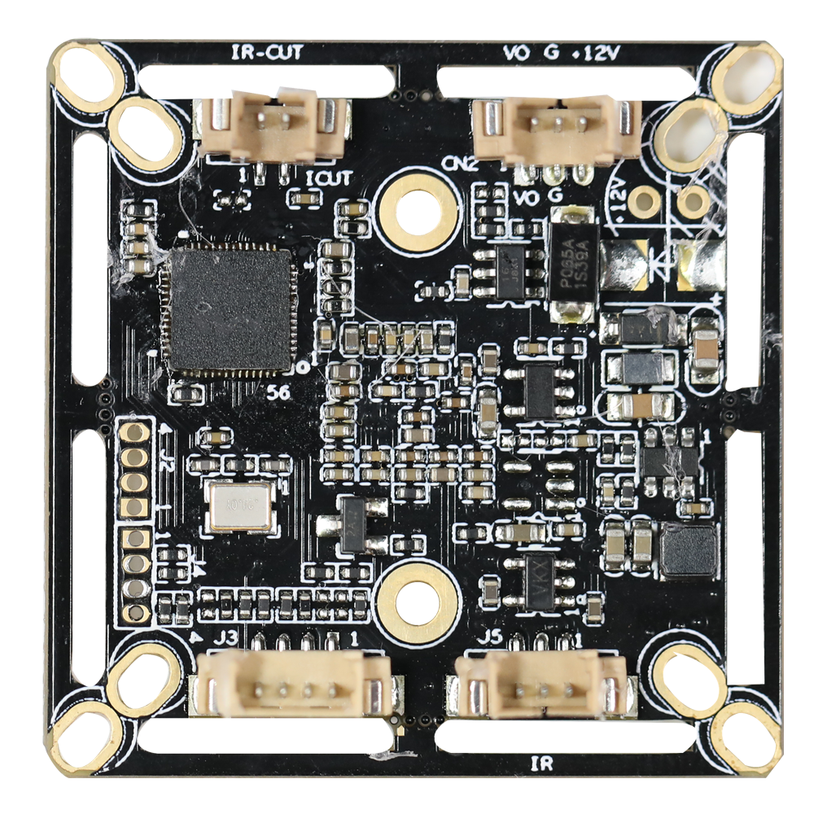
J3 4 3 2 1

J5 3 2 1

Detailed Definition：
Socket | Specific No. | Interface Description | Function
CN2 | 1 | CVBS | Video Out
CN2 | 2 | GND | Ground
CN2 | 3 | 12V | 12V DC input
CN1 | 1 | IRCUTA | IRCUT
CN1 | 2 | IRCUTB | IRCUT
J5 | 1 | ADC1VIN | Red_CTRL
J5 | 2 | GND | Ground
J5 | 3 | LED2 | GPIO35
J3 | 1 | GND | Ground
J3 | 2 | CVI | Switch to CVI by grounding
J3 | 3 | MODE_N-P | N/P
J3 | 4 | TVI | Switch to TVI by grounding

