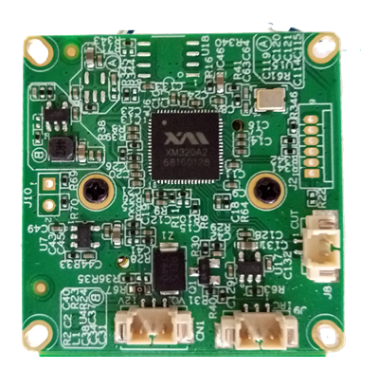
AHD-BLK320-S1-38X38-IM Interface Description

P3
1 2

P1 3 2 1
P2 3 2 1

Detailed Definition
Label | Socket | Specific No. | Interface Description | Function
P1 | J9 | 1 | Infrared led Input | Signal input
P1 | J9 | 2 | GND | Ground
P1 | J9 | 3 | NC | Undefined
P2 | CN1 | 1 | VIDEO | Video output
P2 | CN1 | 2 | GND | Ground
P2 | CN1 | 3 | +12V | 12V DC input
P3 | J8 | 1 | ICR control signal | output
P3 | J8 | 2 | ICR control signal | output

