AHD-XM320F2-0035-38X38-V1_02 Interface Description 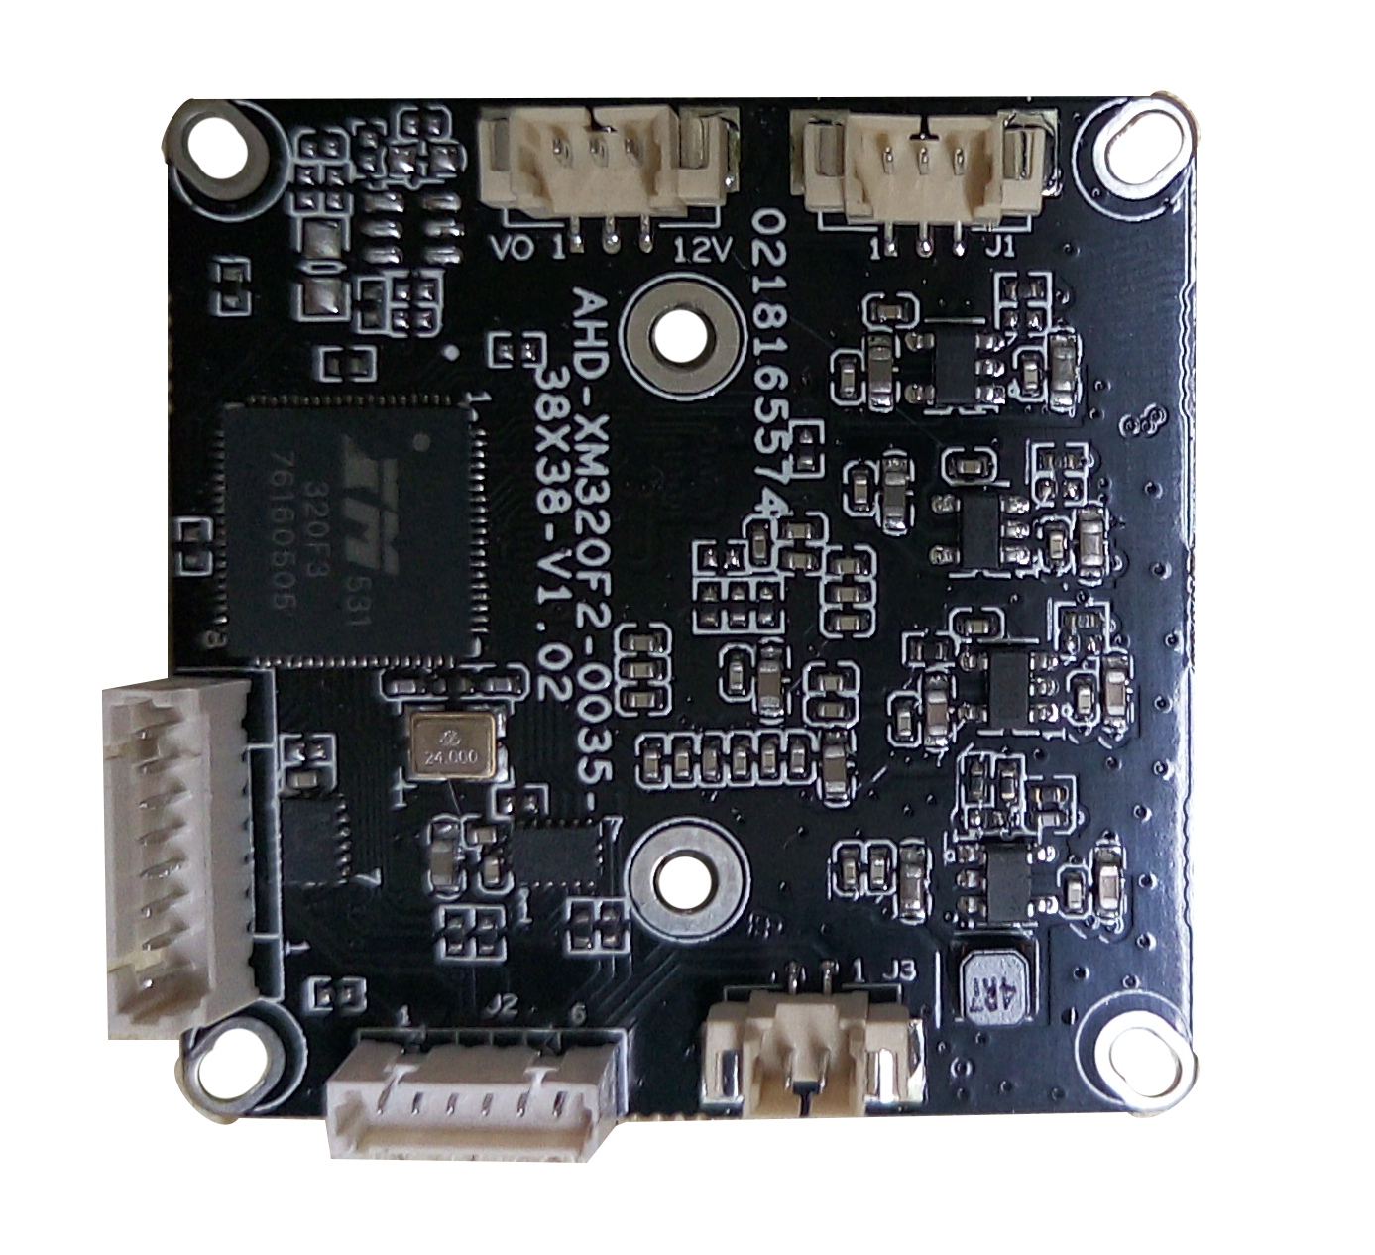
P1 1 2 3 4 5 6
P4 2 1

P2 1 2 3

P3 1 2 3

P5
8
7
6
5
4
3
2
1

Detailed Definition
Label | Socket | Specific No. | Interface Description | Function
P1 | J2 | 1 | GND | Ground
P1 | J2 | 2 | 3.3V | 3.3V power input
P1 | J2 | 3 | UART0_TXD | Debug serial port
P1 | J2 | 4 | UART0_RXD | Debug serial port
P1 | J2 | 5 | SWITCH_KEY | 0n-off control
P1 | J2 | 6 | EXT_RSTN | reset
P2 | J1 | 1 | Infrared led Input | Signal Input
P2 | J1 | 2 | GND | Ground
P2 | J1 | 3 | NC | Undefined
P3 | CN1 | 1 | VIDEO | Video output
P3 | CN1 | 2 | GND | Ground
P3 | CN1 | 3 | +12V | 12V DC input
P4 | J3 | 1 | ICR control signal | output
P4 | J3 | 2 | ICR control signal | output
P5 | J11 | 1 | ZA- | Electric motor socket
P5 | J11 | 2 | ZA+ | Electric motor socket
P5 | J11 | 3 | FB+ | Electric motor socket
P5 | J11 | 4 | FB- | Electric motor socket
P5 | J11 | 5 | FA- | Electric motor socket
P5 | J11 | 6 | FA+ | Electric motor socket
P5 | J11 | 7 | ZB- | Electric motor socket
P5 | J11 | 8 | ZB+ | Electric motor socket

