AHD-XM330A1-0062-32X32-S-V1.02 Interface Description
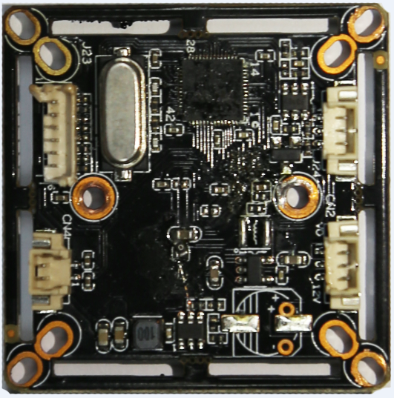
J24 1
2
3

3
J231
2
3
4
5
6

CN2 1
2 3

CN4
2
1

Detailed Definition
Socket | Specific No. | Interface Description | Function
J24 | 1 | IRC | Infrared led Input
J24 | 2 | GND | Ground
J24 | 3 | NC | Undefined
J23 | 1 | GND | Ground
J23 | 2 | NC | Undefined
J23 | 3 | PAL/NTSC | Video Format Switch
J23 | 4 | NC | Undefined
J23 | 5 | CVI | Switch to CVI by grounding
J23 | 6 | TVI | Switch to TVI by grounding
CN2 | 1 | VIDEO | Video output
CN2 | 2 | GND | Ground
CN2 | 3 | 12V | 12V DC input
CN4 | 1 | ICR control signal | output
CN4 | 2 | ICR control signal | output

