# AHD-XM330V200-0235E-32X32-V1_01 Interface Description

**CN2** 1 2 3

**CN5** 1 2

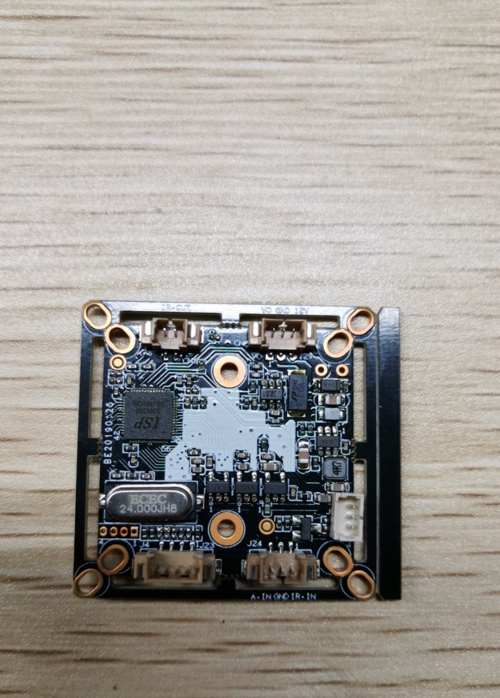

**J2**

**1**

**2**

**3**

**4**

**J24** 3 2 1

**J23**  4 3 2 1

Detailed Definition：

|  |  |  |  |  |  |
| --- | --- | --- | --- | --- | --- |
| Socket | | Specific No. | Interface Description | Function | |
| CN2 | | 1 | CVBS | Video Out | |
| 2 | GND | Ground | |
| 3 | 12V | 12V DC input | |
| CN5 | | 1 | IRCUTA | IRCUT | |
| 2 | IRCUTB |
| J24 | | 1 | ADC1VIN | Red_CTRL | |
| 2 | GND | Ground | |
| 3 | NC | Undefined | |
| J2 | | 1 | ALARM_IN1 | White light CTRL | |
| 2 | GND | Ground | |
| 3 | 3.3V | 3.3V DC input | |
| 4 | GND | Ground | |
| J23 | 1 | | GND | | Ground |
| 2 | | CVI | | Switch to CVI by grounding |
| 3 | | MODE_N-P | | Red_CTRL |
| 4 | | TVI | | Switch to TVI by grounding |