AHG模块-AHD-XM330V200-0D25-32X32-S V2.01 Interface Description
CN5 1 2
CN2 1 2 3
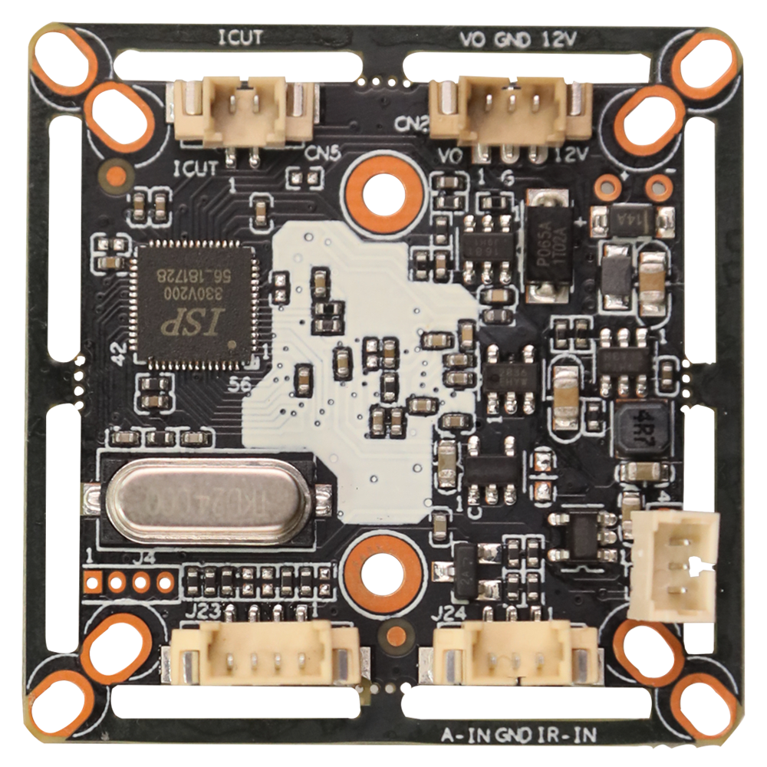

J2
1
2
3
4

J23 4 3 2 1

J24 3 2 1

Detailed Definition：

Socket |  | Specific No. | Interface Description | Function
CN2 |  | 1 | CVBS | Video Out
 |  | 2 | GND | Ground
 |  | 3 | 12V | 12V DC input
CN5 |  | 1 | IRCUTA | IRCUT
 |  | 2 | IRCUTB
J24 |  | 1 | ADC1VIN | Photosensitive signal
 |  | 2 | GND | Ground
 |  | 3 | NC | Undefined
J2 |  | 1 | R_N_P | Red CTRL
 |  | 2 | GND | Ground
 |  | 3 | 3V3 | 3.3V DC input
J23 | 1 |  | GND |  | Ground
J23 | 2 |  | CVI |  | Switch to CVI by grounding
J23 | 3 |  | WL_N_P |  | White light CTRL
J23 | 4 |  | XVI |  | Switch to XVI by grounding

