AHD-XM330V200-0D25-32X32-S-V1_01 Interface Description
CN5 1 2
CN2 1 2 3

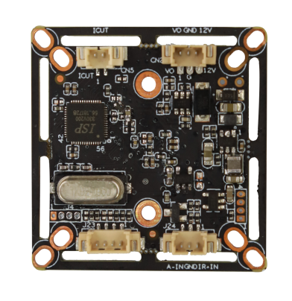

J23 4 3 2 1

J24 3 2 1

Detailed Definition：
Socket |  | Specific No. | Interface Description | Function
CN2 |  | 1 | CVBS | Video Out
 |  | 2 | GND | Ground
 |  | 3 | 12V | 12V DC input
CN5 |  | 1 | ICUT_A | IRCUT
 |  | 2 | ICUT_B
J23 |  | 1 | GND | Ground
 |  | 2 | ADC | CVI
 |  | 3 | WL_N_P | N/P
 |  | 4 | ADC | TVI
J24 | 1 |  | ADC1VIN |  | RED CTRL
J24 | 2 |  | GND |  | Ground
J24 | 3 |  | NC |  | NC

