AHD-XM350-0239-32X32-V2_02 Interface Description
CN1 1 2
CN2 1 2 3

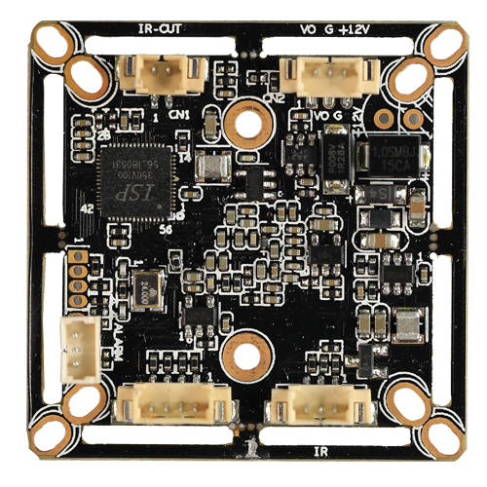
J3 4 3 2 1

J1 3 2 1

J2
4
3
2
1

Detailed Definition：
Socket |  | Specific No. | Interface Description | Function
CN2 |  | 1 | CVBS | Video Out
 |  | 2 | GND | Ground
 |  | 3 | 12V | 12V DC input
CN1 |  | 1 | IRCUTA | IRCUT
 |  | 2 | IRCUTB
J1 |  | 1 | ADC1VIN | Red_CTRL
 |  | 2 | GND | Ground
 |  | 3 | NC | Undefined
J2 |  | 1 | ALARM_IN1 | White light CTRL
 |  | 2 | GND | Ground
 |  | 3 | 3.3V | 3.3V DC input
 |  | 4 | GND | Ground
J3 | 1 |  | GND |  | Ground
J3 | 2 |  | CVI |  | Switch to CVI by grounding
J3 | 3 |  | MODE_N-P |  | Red_CTRL
J3 | 4 |  | TVI |  | Switch to TVI by grounding

