AHD-XM350-0239-38X38-X V1.01 Interface Description

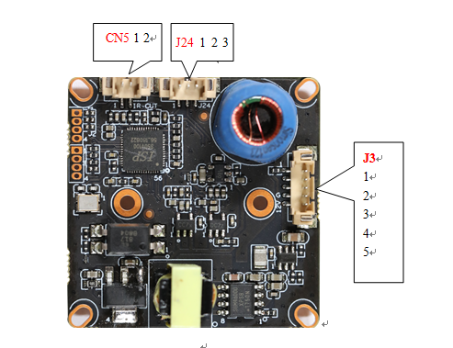

详细定义：
Socket | Specific No. | Interface Description | Function
J24 | 1 | IRC | Infrared led Input
J24 | 2 | IR-GND | IR-Ground
J24 | 3 | ALARM_IN1 | ALARM input(Reserved)
J3 | 1 | LED+ | Led+
J3 | 2 | GND | Video Ground
J3 | 3 | VIDEO | Video output
J3 | 4 | GND | 12V Ground
J3 | 5 | 12V | 12V DC input
CN5 | 1 | ICR control signal | output
CN5 | 2 | ICR control signal | output

