AHD-XM380V200-0005-32X32-V1_01接口说明
J2 4 3 2 1

CN2 1 2 3

CN1 1 2
J2 4 3 2 1

CN2 1 2 3

CN1 1 2
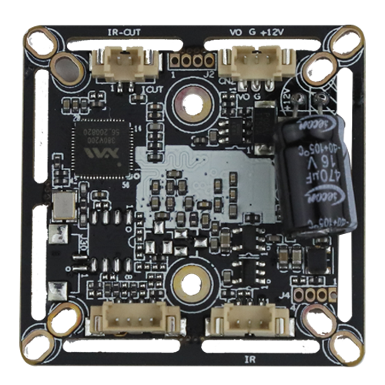

J3 4 3 2 1

J5 3 2 1

Detailed Definition：
Socket | Specific No. | Interface Description |  | Function
J3 | 1 | GND |  | Ground
J3 | 2 | ADC2VIN |  | System Switch
J3 | 3 | MODE_N/P |  | N/P Switch
J3 | 4 | ADC2VIN |  | System Switch
CN1 | 1 | DRIOUT1 |  | IRCUT
CN1 | 2 | DRIOUT2 |  | IRCUT
J5 | 1 | ADC1VIN |  | White light signal
J5 | 2 | GND |  | Ground
J5 | 3 | LED1 |  | Infrared drive signal
CN2 | 1 | CVBS |  | Video out
CN2 | 2 | GND |  | Ground
CN2 | 3 | +12V |  | 12V input
J2 | 1 |  | ALARM_IN1 | Alarm input/Infrared signal
J2 | 2 |  | GND | Ground
J2 | 3 |  | 3.3V | 3.3V input
J2 | 4 |  | GND | Ground

