AHG-CMOS0081-XM310-32X32-V1_02 Interface Description 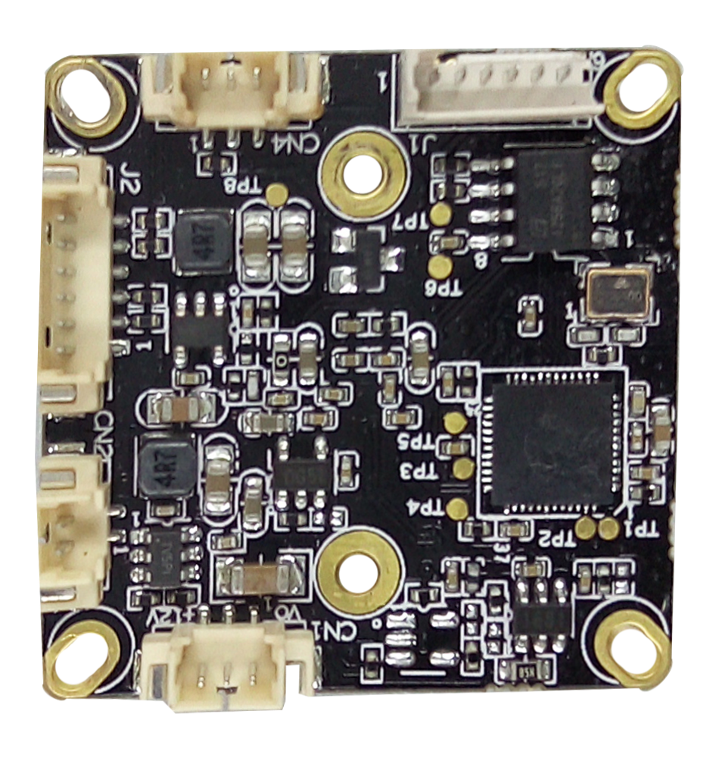
P26 5
4
3
2
1
P3 3 2 1
P1 1 2 3
P4
2 1
Detailed Definition
Label | Socket | Specific No. | Interface Description | Function
P1 | CN4 | 1 | IRC | Infrared led Input
P1 | CN4 | 2 | GND | Ground
P1 | CN4 | 3 | NC | Undefined
P2 | J2 | 1 | GND | Ground
P2 | J2 | 2 | PAL/NTSC | Video standard switch
P2 | J2 | 3 | PAL/NTSC | Video standard switch
P2 | J2 | 4 | NC | Undefined
P2 | J2 | 5 | HD_SEL | Video format switch
P2 | J2 | 6 | AHD/TVI | Video format switch
P3 | CN1 | 1 | VIDEO | Video output
P3 | CN1 | 2 | GND | Ground
P3 | CN1 | 3 | +12V_IN | 12V DC input
P4 | CN2 | 1 | ICR control signal | output
P4 | CN2 | 2 | ICR control signal | output

