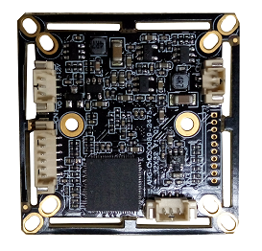
AHG-CMOS0089-2475-32X32-V1_02 Interface Description
P3 3
2
1

P4 1
2

P1 6
5
4
3
2
1

P2 3 2 1

Detailed Definition
Label | Socket | Specific No. | Interface Description | Function
P1 | J1 | 1 | GND | Ground
P1 | J1 | 2 | K_LEFT | OSD Menu
P1 | J1 | 3 | K_RIGHT | OSD Menu
P1 | J1 | 4 | K_SET | OSD Menu
P1 | J1 | 5 | K_UP | OSD Menu
P1 | J1 | 6 | K_DOWN | OSD Menu
P2 | CN11 | 1 | Infrared led Input | Signal Input
P2 | CN11 | 2 | GND | Ground
P2 | CN11 | 3 | NC | Undefined
P3 | CN1 | 1 | VIDEO | Video output
P3 | CN1 | 2 | GND | Ground
P3 | CN1 | 3 | +12V | 12V DC input
P4 | CN4 | 1 | ICR control signal | output
P4 | CN4 | 2 | ICR control signal | output

