AHG-NVP2477-S2-38X38-IM-V1_01 InterfaceDescription 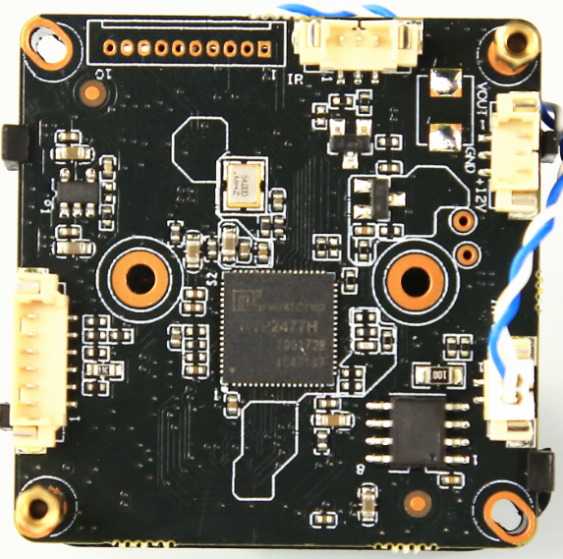
P4 1 2

P2 1 2 3

P3 1 2 3

P1
6
5
4
3
2
1
2
1

表-核心板接口详细定义
Marking | Socket | Specific No. | Interface Description | Function
P1 | J2 | 1 | GND | Ground
P1 | J2 | 2 | K_LEFT | OSD menu
P1 | J2 | 3 | K_RIGHT | OSD menu
P1 | J2 | 4 | K_SET | OSD menu
P1 | J2 | 5 | K_UP | OSD menu
P1 | J2 | 6 | K_DOWN | OSD menu
P2 | CN3 | 1 | Infrared light control signal input | Video Out
P2 | CN3 | 2 | GND | Ground
P2 | CN3 | 3 | NC | Free foot
P3 | CN1 | 1 | VIDEO | Video Out
P3 | CN1 | 2 | GND | Ground
P3 | CN1 | 3 | +12V | 12V DC input
P4 | CN2 | 1 | ICR control signal | output
P4 | CN2 | 2 | ICR control signal | output
P5 | J1 |  | Dock the front panel | To achieve the docking board and front-end board

