XM310V300-1405-32X32-S-V1_01 Interface Description
J4 1 2 3

CN1 1 2
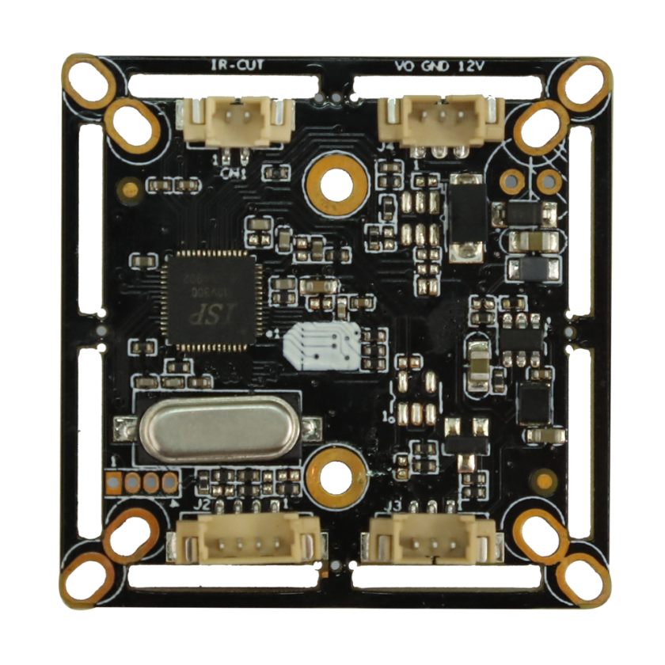

、

J2 1 2 3 4

J3 3 2 1

Detailed Definition：
Socket | Specific No. | Interface Description | Function
J2 | 1 | GND | Ground
J2 | 2 | +3.3V | 3.3V input
J2 | 3 | MODE_N/P | N/P System conversion
J2 | 4 | ADC2VIN | DC12V input
CN1 | 1 | DRIOUT1 | IRCUT
CN1 | 2 | DRIOUT2 | IRCUT
J3 | 1 | ADC1VIN | Red_CTRL
J3 | 2 | GND | Ground
J3 | 3 | NC | Undefined
J4 | 1 | CVBS | Video out
J4 | 2 | GND | Ground
J4 | 3 | +12V | 12V input

