AHG-CMOS0012-32X32-V1_01 Interface Description
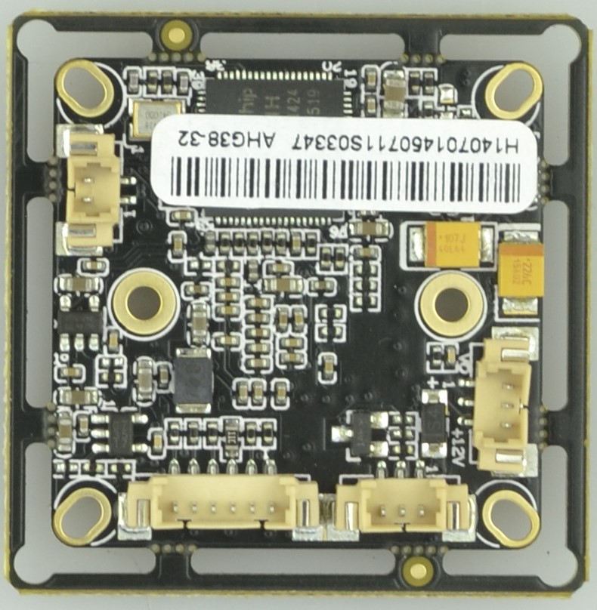
P3
1 2 3
P42 1
P2 3 2 1
P1 6 5 4 3 2 1

Detailed Definition
Label | Socket | Specific No. | Interface Description | Function
P1 | J1 | 1 | GND | Refer to the attachment
P1 | J1 | 2 | LEFT | Refer to the attachment
P1 | J1 | 3 | RIGHT | Refer to the attachment
P1 | J1 | 4 | SET | Refer to the attachment
P1 | J1 | 5 | UP | Refer to the attachment
P1 | J1 | 6 | DOWN | Refer to the attachment
P2 | CN4 | 1 | Infrared led Input | Signal Input
P2 | CN4 | 2 | GND | Ground
P2 | CN4 | 3 | NC | Undefined
P3 | CN2 | 1 | VIDEO | Video output
P3 | CN2 | 2 | GND | Ground
P3 | CN2 | 3 | +12V | 12V DC input
P4 | CN5 | 1 | ICR control signal | output
P4 | CN5 | 2 | ICR control signal | output

Attachment：P1(J1) function description:
remarks: functions can be supported only with the latest firmware(version 20140814& after that)
- With OSD key tail wire：
Label | Socket | Specific No. | Interface Description | Function
P1 | J1 | 1 | GND | Ground
P1 | J1 | 2 | LEFT | OSD Menu left key
P1 | J1 | 3 | RIGHT | OSD Menu right key
P1 | J1 | 4 | SET | OSD Menu OK key
P1 | J1 | 5 | UP | OSD Menu up key
P1 | J1 | 6 | DOWN | OSD Menu down key
Long-press shortcut：
- long press LEFT key：CVBS、AHD_L Switch（alternate）
- long press RIGHT key：AHD_M
- long press DOWN key：Switch NTSC、PAL
remarks：long press to switch, once switch successfully, please release the key(or restart after successful switch)
- With PAL short circuit tail wire(new)
- There is already a short circuit between Pins No. 1&3
- Short circuit between 1&3 only(default) AHD_M mode
c. Short circuit between 2 and 1&3,CVBS mode
d. Short circuit between 4 and 1&3，AHD_L mode
Label | Socket | Specific No. | Function
P1 | J1 | 1 | Ground
P1 | J1 | 2 | CVBS
P1 | J1 | 3 | Connected to No.1 pin（GND）
P1 | J1 | 4 | AHD_L
P1 | J1 | 5
P1 | J1 | 6
- With NTSC short circuit tail wire
- There is already a short circuit between Pins No. 1&2
- Short circuit between 1&2 only(default) AHD_M mode
- Short circuit between 5 and 1&2,CVBS mode
- Short circuit between 6 and 1&2，AHD_L mode
Label | Socket | Specific No. | Function
P1 | J1 | 1 | Ground
P1 | J1 | 2 | Connected to No.1 pin（GND）
P1 | J1 | 3
P1 | J1 | 4
P1 | J1 | 5 | CVBS
P1 | J1 | 6 | AHD_L

