BLK16E-0235-32X32-S-V1_01接口说明表-核心板接口详细定义
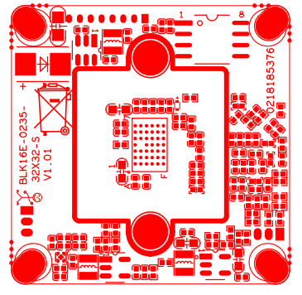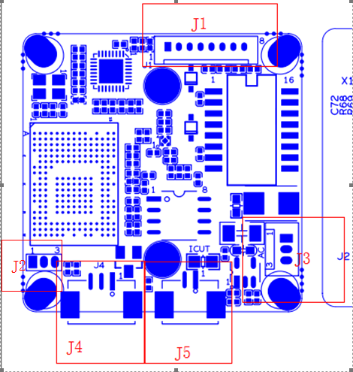
P3 电源网络接口
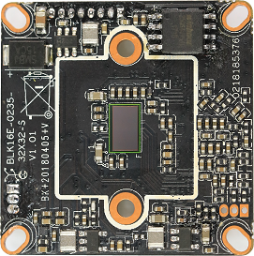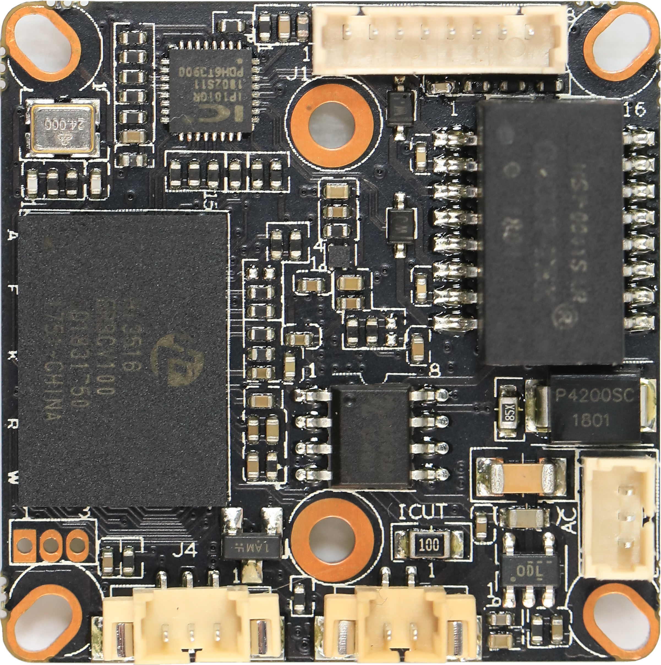
P5 红外接口
P4 IR-CUT接口
P2 音频1/1接口

标注 | 丝印编号 | 针脚编号 | 针脚定义 | 功能
P1 | J2 | 1 | UART0_RXD | 串口RX
 |  | 2 | UART0_TXD | 串口TX
 |  | 3 | GND | GND
P2 | J3 | 1 | AC_OUTL | 音频输出
 |  | 2 | AC_INL | 音频输入
 |  | 3 | GND | GND
P3 | J1 | 1 | LED/PHYAD0 | 指示灯
 |  | 2 | LED/PHYAD1 | 指示灯
 |  | 3 | ETHTX+ | 以太网信号
 |  | 4 | ETHTX- | 以太网信号
 |  | 5 | THTR+ | 以太网信号
 |  | 6 | THTR- | 以太网信号
 |  |  | GND | GND
 |  |  | +12V | +12V
P4 | J5 | 1 | BOUT | IRCUT驱动
 |  | 2 | AOUT | IRCUT驱动
P5 | J4 | 1 | 红外信号输入 | 红外信号输入
 |  | 2 | GND | GND
 |  | 3 | 3.3V | 3.3V

