KA18EV-S1-38X38-IM-WIFI-V2_01接口说明表
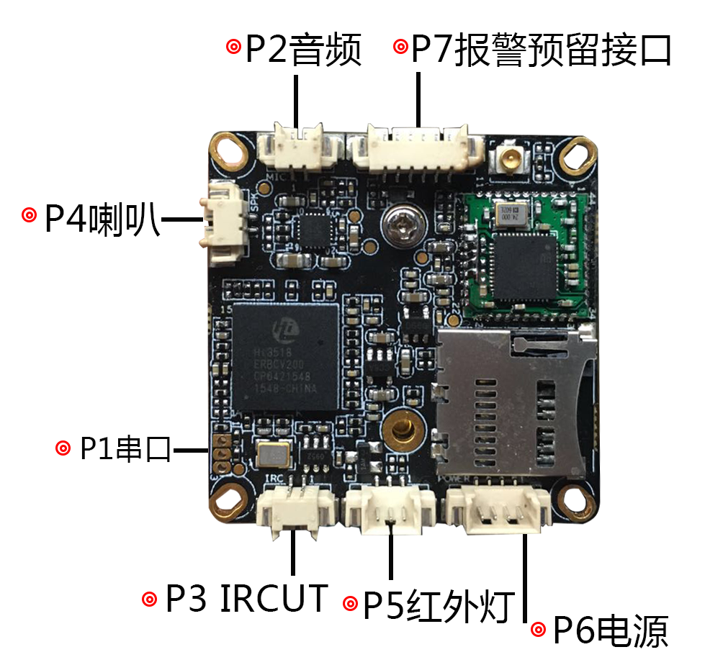

标注 | 丝印编号 | 针脚编号 | 针脚定义 | 功能
P1 | J3 | 1 | Uart_RXD | 串口接收
P1 | J3 | 2 | Uart_TXD | 串口发送
P1 | J3 | 3 | GND | GND
P2 | J9 | 1 | MIC_P | 音频输入
P2 | J9 | 2 | GND | 地
P3 | J1 | 1 | OUT1 | IRCUT驱动输出
P3 | J1 | 2 | OUT2 | IRCUT驱动输出
P4 | J8 | 1 | 喇叭 | 喇叭
P4 | J8 | 2 | 喇叭 | 喇叭
P5 | J4 | 1 | 红外输入 | 红外输入
P5 | J4 | 2 | GND | GND
P5 | J4 | 3 | NC | 悬空
P6 | J5 | 1 | NC | 悬空
P6 | J5 | 2 | NC | 悬空
P6 | J5 | 3 | GND | GND
P6 | J5 | 4 | +12V | 12V电源输入
P7 | J11 | 1 | 3.3V | 3.3V
P7 | J11 | 2 | GND | GND
P7 | J11 | 3 | ALARM_IN | 报警/复位
P7 | J11 | 4 | GPIO63
P7 | J11 | 5 | GPIO01
P7 | J11 | 6 | GPIO02
P8 | J7 | 1 | DATA0 | 数据口0
P8 | J7 | 2 | DATA1 | 数据口1
P8 | J7 | 3 | DATA2 | 数据口2
P8 | J7 | 4 | DATA3 | 数据口3
P8 | J7 | 5 | DATA4 | 数据口4
P8 | J7 | 6 | DATA5 | 数据口5
P8 | J7 | 7 | DATA6 | 数据口6
P8 | J7 | 8 | DATA7 | 数据口7
P8 | J7 | 9 | DATA8 | 数据口8
P8 | J7 | 10 | DATA9 | 数据口9
P8 | J7 | 11 | DATA10 | 数据口10
P8 | J7 | 12 | DATA11 | 数据口11
P8 | J7 | 13 | GND | GND
P8 | J7 | 14 | GND | GND
P8 | J7 | 15 | PCLK | 像素时钟
P8 | J7 | 16 | SENSOR_CLK | SENSOR主时钟
P8 | J7 | 17 | HS | 行同步
P8 | J7 | 18 | VS | 场同步
P8 | J7 | 19 | SCL | I2c时钟
P8 | J7 | 20 | SDA | I2c数据
P8 | J7 | 21 | DVDD | DVDD
P8 | J7 | 22 | GND | GND
P8 | J7 | 23 | DOVDD | DOVDD
P8 | J7 | 24 | AVDD | AVDD

