BLK19V101-38X38-B V1_01接口说明

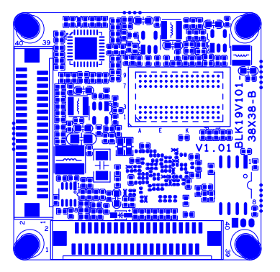
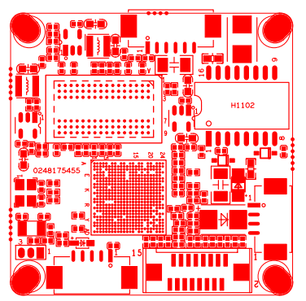
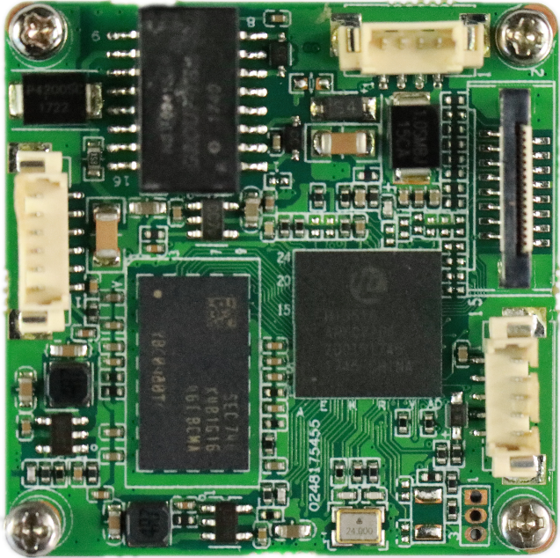

标注 | 丝印编号 | 针脚编号 | 针脚定义 | 功能
 | J3 | 1 | ETHRX- | 网口数据接收
 | J3 | 2 | ETHRX+ | 网口数据接收
 | J3 | 3 | LED/PHY_AD1 | 网络灯
 | J3 | 4 | ETHTX- | 网口数据发送
 | J3 | 5 | ETHTX+ | 网口数据发送
 | J3 | 6 | LED/PHY_AD0 | 网络灯
 | J1 | 1 | NC | 悬空
 | J1 | 2 | NC | 悬空
 | J1 | 3 | GND | GND
 | J1 | 4 | 12V | 12V输入
 | J14 | 1 | AC_OUT | 音频输出
 | J14 | 2 | MIC_P | 音频输入
 | J14 | 3 | GND | GND
 | J14 | 4 | ALMIN_GPIO144 | 报警输入
 | J14 | 5 | GND | GND
 | J19 | 1 | SD0_CCLK_OUT | SD时钟线
 | J19 | 2 | SD0_CCMD | SD控制线
 | J19 | 3 | SD0_CDATA0 | 数据位0
 | J19 | 4 | SD0_CDATA1 | 数据位1
 | J19 | 5 | SD0_CDATA2 | 数据位2
 | J19 | 6 | SD0_CDATA3 | 数据位3
 | J19 | 7 | LED_GPIO57 | 报警输入
 | J19 | 8 | GND | GND
 | J19 | 9 | SET_GPIO56 | 复位
 | J19 | 10 | BAT | 电池
 | J19 | 11 | GND | GND
 | J19 | 12 | ALMOUT_GPIO145 | 报警输出
 | J19 | 13 | USB_DM | USB数据口
 | J19 | 14 | USB_DP | USB数据口
 | J19 | 15 | +5V | 5V输入
 | J19 | 16 | USB_CONTROL | USB控制
 | J12 | 1 | +12V | +12V
 | J12 | 2 | +12V | +12V
 | J12 | 3 | GND | GND
 | J12 | 4 | GND | GND
 | J12 | 5 | +5V | +5V
 | J12 | 6 | GND | GND
 | J12 | 7 | MIPI0_CKP/VI0_DATA7 | 数据位7
 | J12 | 8 | MIPI0_D3P/VI0_DATA6 | 数据位6
 | J12 | 9 | MIPI0_D3M/VI0_DATA5 | 数据位5
 | J12 | 10 | MIPI1_CKM/VI0_DATA4 | 数据位4
 | J12 | 11 | MIPI1_CKP/VI0_DATA3 | 数据位3
 | J12 | 12 | MIPI0_D2P/VI0_DATA2 | 数据位2
 | J12 | 13 | MIPI0_D2M/VI0_DATA1 | 数据位1
 | J12 | 14 | MIPI0_D0P/VI0_DATA0 | 数据位0
 | J12 | 15 | MIPI0_D1M/VI0_HS | 行同步信号
 | J12 | 16 | MIPI0_D1P/VI0_CLK | 时钟
 | J12 | 17 | MIPI0_D0M/VI0_VS | 场同步信号
 | J12 | 18 | GND | GND
 | J12 | 19 | SENSOR0_CLK | Sensor时钟
 | J12 | 20 | SPI0_CLK/I2C0_SCL | I2C时钟
 | J12 | 21 | SPI0_CSN | SPI使能
 | J12 | 22 | SPI0_SDI | I2C数据
 | J12 | 23 | NC | NC
 | J12 | 24 | SAR_ADC_CH1/GPIO16_1 | 预留GPIO
 |  | 25 | GND | GND
 |  | 26 | GND | GND
 |  | 27 | GND | GND
 |  | 28 | +1.8V | +1.8V
 |  | 29 | SPI0_SDO/I2C0_SDA | I2C数据位
 |  | 30 | MIPI1_D0M/VI0_DATA15 | 数据位15
 |  | 31 | MIPI1_D1M/VI0_DATA14 | 数据位14
 |  | 32 | MIPI1_D1P/VI0_DATA13 | 数据位13
 |  | 33 | MIPI1_D2P/VI0_DATA12 | 数据位12
 |  | 34 | MIPI1_D2M/VI0_DATA11 | 数据位11
 |  | 35 | MIPI1_D3M/VI0_DATA10 | 数据位10
 |  | 36 | MIPI1_D3P/VI0_DATA9 | 数据位9
 |  | 37 | MIPI0_CKM/VI0_DATA8 | 数据位8
 |  | 38 | IRCA1_GPIO134 | IR控制
 |  | 39 | IRCB1_GPIO135 | IR控制
 |  | 40 | GND | GND
 | J13 | 1 | +12V | +12V
 | J13 | 2 | +12V | +12V
 | J13 | 3 | GND | GND
 | J13 | 4 | GND | GND
 | J13 | 5 | +5V | +5V
 | J13 | 6 | GND | GND
 | J13 | 7 | MIPI2_D2P/VI1_DATA7 | 数据位7
 | J13 | 8 | MIPI2_D2M/VI1_DATA6 | 数据位6
 | J13 | 9 | VI1_DATA5/GPIO2_7 | 数据位5
 | J13 | 10 | VI1_DATA4/GPIO2_6 | 数据位4
 | J13 | 11 | VI1_DATA3/GPIO2_5 | 数据位3
 | J13 | 12 | VI1_DATA2/GPIO2_4 | 数据位2
 | J13 | 13 | VI1_DATA1/GPIO2_3 | 数据位1
 | J13 | 14 | VI1_DATA0/GPIO2_2 | 数据位0
 | J13 | 15 | VI1_HS/GPIO3_0 | 行同步信号
 | J13 | 16 | VI1_CLK/GPIO2_1 | 时钟
 | J13 | 17 | VI1_VS/GPIO2_0 | 场同步信号
 | J13 | 18 | GND | GND
 | J13 | 19 | SENSOR1_CLK | SENSOR时钟
 | J13 | 20 | SPI1_CLK/I2C1_SCL | I2C时钟
 | J13 | 21 | SPI1_CSN | SPI使能
 | J13 | 22 | SPI1_SDI | I2C数据
 | J13 | 23 | NC | NC
 | J13 | 24 | SAR_ADC_CH2/GPIO16_2 | 预留GPIO
 | J13 | 25 | GND | GND
 | J13 | 26 | GND | GND
 | J13 | 27 | GND | GND
 | J13 | 28 | +1.8V | +1.8V
 | J13 | 29 | SPI1_SDO/I2C1_SDA | I2C时钟
 | J13 | 30 | MIPI2_CKM/VI1_DATA15 | 数据位15
 | J13 | 31 | MIPI2_CKP/VI1_DATA14 | 数据位14
 | J13 | 32 | MIPI2_D3M/VI1_DATA13 | 数据位13
 | J13 | 33 | MIPI2_D3P/VI1_DATA12 | 数据位12
 | J13 | 34 | MIPI2_D1M/VI1_DATA11 | 数据位11
 | J13 | 35 | MIPI2_D1P/VI1_DATA10 | 数据位10
 | J13 | 36 | MIPI2_D0P/VI1_DATA9 | 数据位9
 | J13 | 37 | MIPI2_D0M/VI1_DATA8 | 数据位8
 | J13 | 38 | IRCA2_GPIO136 | IR控制
 | J13 | 39 | IRCB2_GPIO137 | IR控制
 | J13 | 40 | GND | GND

