P1 IRCUT
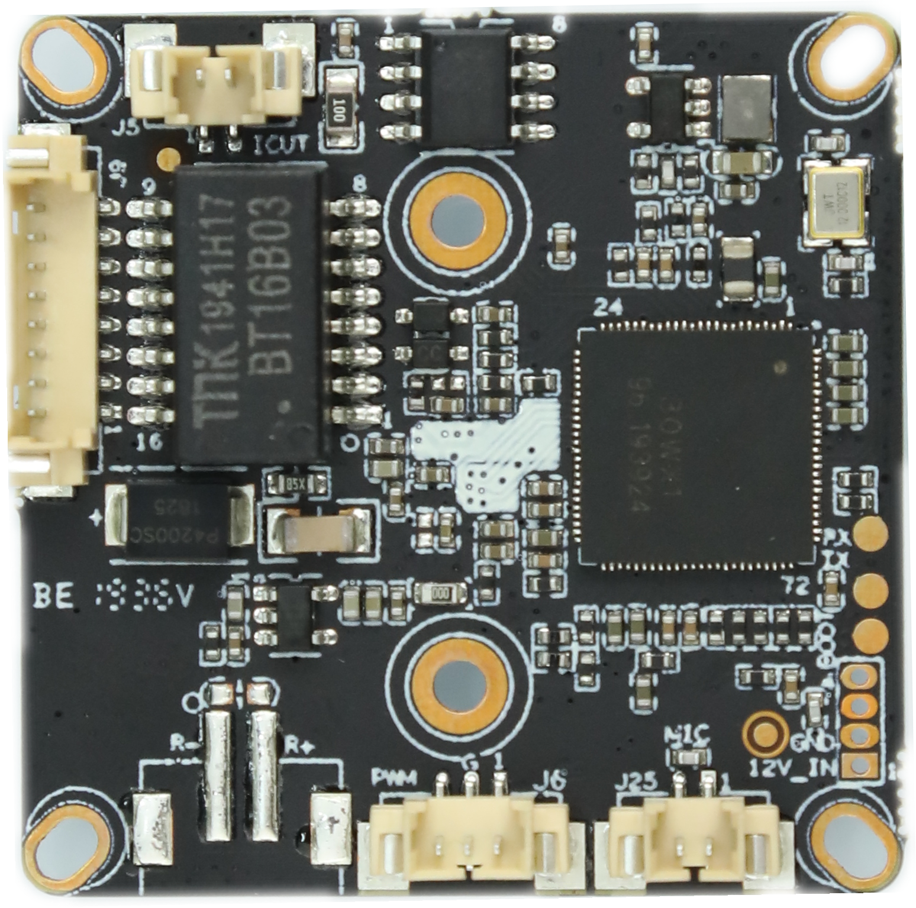
P3 Power&
Ethernet
P5 Infrared
P6 audio input

Socket | Specific No | Interface Description | Function | Socket
P1 | J5 | 1 | IR-CUT | IR-CUT Control line
P1 | J5 | 2 | IR-CUT | IR-CUT Control line
P7 |  | 1 | GND | GND
P7 |  | 2 | UATRO_TXD | UART0_TXD
P7 |  | 3 | UATRO_RXD | UART0_RXD
P5 | J6 | 1 | ADC1_IN | INFRARED LIGHT SIGNAL CONTROL
P5 | J6 | 2 | GND | GND
P5 | J6 | 3 | PWM | PWM OUTPUT
P3 | J9 | 1 | LED/PHY_AD0 | LED/PHY_AD0
P3 | J9 | 2 | LED/PHY_AD1 | LED/PHY_AD1
P3 | J9 | 3 | ETHTX+ | Ethernet signal+
P3 | J9 | 4 | ETHTX- | Ethernet signal-
P3 | J9 | 5 | ETHRX+ | Ethernet signal+
P3 | J9 | 6 | ETHRX- | Ethernet signal-
P3 | J9 | 7 | GND | GND
P3 | J9 | 8 | 12V input | 12V INPUT
P2 | J26 | 1 | 12V | 12V
P2 | J26 | 2 | GND | GND
P2 | J26 | 3 | AC_OUTL | AUDIO OUTPUT
P2 | J26 | 4 | AO_EN/YLED_GPIO093 | AO_EN/YLED_GPIO093
P6 | J24 | 1 | GND | GND
P6 | J24 | 2 | AC_INL/MICP | AUDIO INPUT
P4 | J27 | 1 | R- | R-
P4 | J27 | 2 | R+ | R+

