BLK3516A-53X53-AF-JF-V1_02接口说明接口说明表

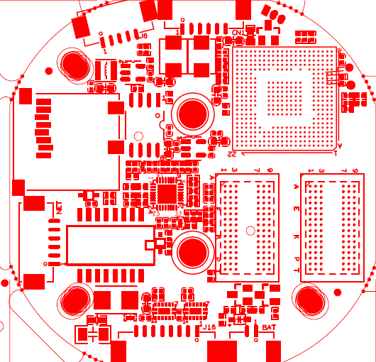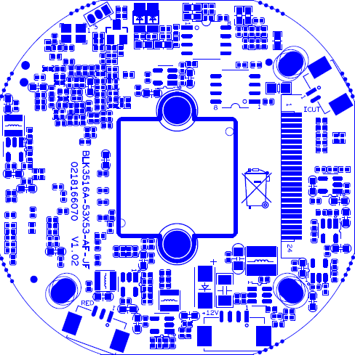

|  |  |  |  |  |
| --- | --- | --- | --- | --- |
| 标注 | 丝印编号 | 针脚编号 | 针脚定义 | 功能 |
| P1 | J8 | 1 | ETHRX- | 网口数据接收 |
| 2 | ETHRX+ | 网口数据接收 |
| 3 | LED/PHY_AD3 | 网络灯 |
| 4 | ETHTX- | 网口数据发送 |
| 5 | ETHTX+ | 网口数据发送 |
| 6 | LED/PHY_AD0 | 网络灯 |
| P2 | J3 | 1 | Uart_RXD | 串口接收 |
| 2 | Uart_TXD | 串口发送 |
| 3 | GND | GND |
| P3 | J7 | 1 | GND | GND |
| 2 | VBAT | 电池正极 |
| P4 | J4 | 1 | GND | GND |
| 2 | USB_DP | USB数据口 |
| 3 | USB_DM | USB数据口 |
| 4 | +5V | +5V电源 |
| P5 | J6 | 1 | GND | GND |
| 2 | VDAC_CVBS | CVBS视频输出 |
| 3 | AGN | 模拟地 |
| 4 | AC_OUT | 音频输出 |
| 5 | AC_LINE | 音频输入 |
| P6 | J2 | 1 | NC | 悬空 |
| 2 | NC | 悬空 |
| 3 | GND | GND |
| 4 | +12V | 12V电源输入 |
| P7 | CN1 | 1 | RS485B | 485接口 |
| 2 | RS485A | 485接口 |
| 3 | GND | GND |
| 4 | ALARM_IN2 | 报警输入 |
| 5 | GND | GND |
| 6 | ALARM_IN1 | 报警输入 |
| P8 | J13 | 1 | +5V | +5V |
| 2 | GND | GND |
| 3 | RED_C | 灯板输入信号 |
| P9 | J15 | 1 | Aout | IrcutA |
| 2 | Bout | IRCUTB |
| P10 | J16 | 1 | 1 | AF聚焦 |
| 2 | 2 | AF聚焦 |
| 3 | 3 | AF聚焦 |
| 4 | 4 | AF聚焦 |
| 5 | 5 | AF聚焦 |
| 6 | 6 | AF聚焦 |
| 7 | 7 | AF聚焦 |
| 8 | 8 | AF聚焦 |