**XMDZ-BLK18EV2-S1-IM-CZ-V1_02 接口说明**

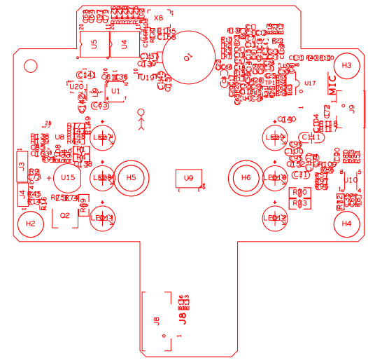

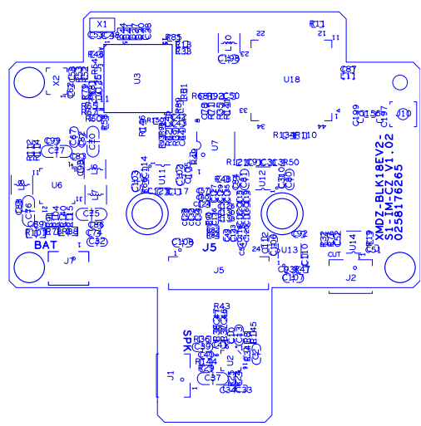

|  |  |  |  |  |
| --- | --- | --- | --- | --- |
| 标注 | 丝印编号 | 针脚编号 | 针脚定义 | 功能 |
| P1 | Q1 | 1 | +3.3V_PIR | +3.3V_PIR |
| 2 | PIR_OUT | PIR输出 |
| 3 | GND | GND |
| P2 | J2 | 1 | OUT1 | ICR输出端口1 |
| 2 | OUT2 | ICR输出端口2 |
| P3 | J8 | 1 | MCU_LED1 | 门铃指示灯 |
| 2 | MCU_LED2 | 门铃指示灯 |
| 3 | SET_GPIO03 | 按键信号 |
| 4 | GND | 地 |
| 5 | +3.3V_PIR | +3.3V PIR电源 |
| P4 | J4 | 1 | UART0_RXD | 串口接收信号 |
| 2 | UART0_TXD | 串口发射信号 |
| 3 | GND | 地 |
| P5 | J3 | 1 | +1.8V_STB | +1.8V |
| 2 | SWIM | 烧写引脚 |
| 3 | GND | 地 |
| 4 | NRST | 复位信号 |
| P6 | J9 | 1 | MIC_P | MIC 正 |
| 2 | GND | 地 |
| P7 | J7 | 1 | LI-BAT | 电池 |
| 2 | GND | 地 |
| P8 | J1 | 1 | VOP | 喇叭正 |
| 2 | VON | 喇叭负 |
| P9 | J5 | 1 | +5V | +5V |
| 2 | +5V | +5V |
| 3 | +5V | +5V |
| 4 | GND | 地 |
| 5 | GND | 地 |
| 6 | GND | 地 |
| 7 | USB_DM | USB负 |
| 8 | USB_DP | USB正 |
| 9 | GND | 地 |
| 10 | CARD_DETECT | 卡检测 |
| 11 | SD_EN | SD信号使能 |
| 12 | SDIO1_CDATA0 | SDIO数据 |
| 13 | SDIO1_CDATA1 | SDIO数据 |
| 14 | SDIO1_CDATA2 | SDIO数据 |
| 15 | SDIO1_CDATA3 | SDIO数据 |
| 16 | SDIO1_CCMD | 控制命令 |
| 17 | SDIO1_CCLK_OUT | SDIO时钟输出 |
| 18 | GND | 地 |
| 19 | 433_DATA | 433数据传输 |
| 20 | SW_ON/OFF | 开关开关信号 |
| 21 | GND | 地 |
| 22 | SDIO1_VOUT | SDIO1电压输出 |
|  |  | 23 | GND | 地 |
| 24 | +3.3V | +3.3V |

**BRD_XMDZ-CZ-LED_IF-V1_02 接口说明**

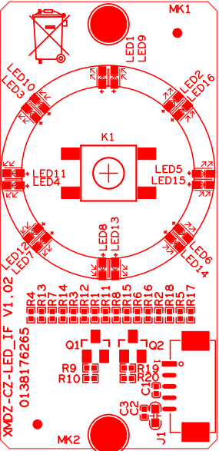

|  |  |  |  |  |
| --- | --- | --- | --- | --- |
| 标注 | 丝印编号 | 针脚编号 | 针脚定义 | 功能 |
| P1 | K1 | 1 | GND | 地 |
| 2 | GND | 地 |
| 3 | SET_GPIO03 | 按键信号 |
| 4 | SET_GPIO03 | 按键信号 |
| P2 | J1 | 1 | MCU_LED1 | 门铃指示灯 |
| 2 | MCU_LED2 | 门铃指示灯 |
| 3 | GND | 地 |
| 5 | +3.3V | +3.3V |

**BRD_XMDZ-CZ-POWER_IF-V1_02 接口说明**

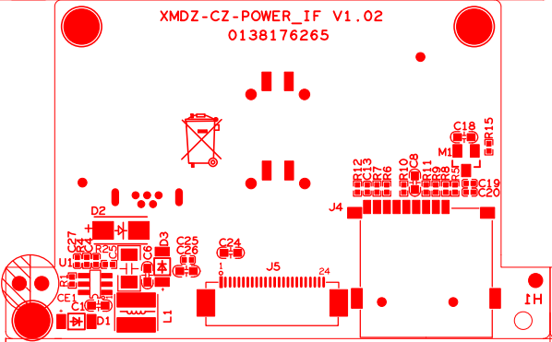

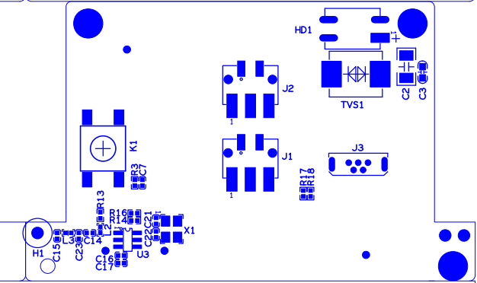

|  |  |  |  |  |  |
| --- | --- | --- | --- | --- | --- |
| 标注 | 丝印编号 | | 针脚编号 | 针脚定义 | 功能 |
| P1 | J1 | | 1 | AC24+ | 交流24V + |
| 2 | AC24+ | 交流24V + |
| 3 | AC24+ | 交流24V + |
| P2 | J2 | | 1 | AC24- | 交流24V - |
| 2 | AC24- | 交流24V - |
| 3 | AC24- | 交流24V - |
| P3 | J3 | | 1 | +5V | +5V |
| 2 | USB_DM | USB负 |
| 3 | USB_DP | USB正 |
| 5 | GND | 地 |
| P4 | J5 | | 1 | +3.3V | +3.3V |
| 2 | GND | 地 |
| 3 | SDIO1_VOUT | SDIO1电压输出 |
| 4 | GND | 地 |
| 5 | SW_ON/OFF | 开关开关信号 |
| 6 | 433_DATA | 433数据传输 |
| 7 | GND | 地 |
| 8 | SDIO1_CCLK_OUT | SDIO时钟输出 |
| 9 | SDIO1_CCMD | 控制命令 |
| 10 | SDIO1_CDATA3 | SDIO数据 |
| 11 | SDIO1_CDATA2 | SDIO数据 |
| 12 | SDIO1_CDATA1 | SDIO数据 |
| 13 | SDIO1_CDATA0 | SDIO数据 |
| 14 | SD_EN | SD信号使能 |
| 15 | CARD_DETECT | 卡检测 |
| 16 | GND | 地 |
| 17 | USB_DM | USB负 |
| 18 | USB_DP | USB正 |
| 19 | GND | 地 |
| 20 | GND | 地 |
| 21 | GND | 地 |
| 22 | +5V | +5V |
| 23 | +5V | +5V |
| 24 | +5V | +5V |
| P5 | J4 | | 1 | SDIO1_CDATA2 | SDIO数据 |
| 2 | SDIO1_CDATA3 | SDIO数据 |
| 3 | SDIO1_CCMD | 控制命令 |
| 4 | +3.3VSD | +3.3V SD卡电源 |
| 5 | SDIO1_CCLK_OUT | SDIO时钟输出 |
| 6 | GND | 地 |
| 7 | SDIO1_CDATA0 | SDIO数据 |
| 8 | SDIO1_CDATA1 | SDIO数据 |
| 9 | CARD_DETECT | 卡检测 |
| P6 | K1 | 1 | | GND | 地 |
| 2 | | GND | 地 |
| 3 | | +3.3V | +3.3V |
| 4 | | RESET | 复位信号 |