BLK19V101-38X38-B V1_01接口说明

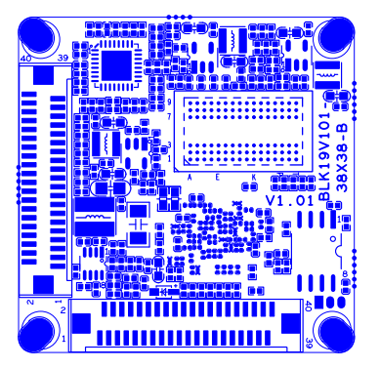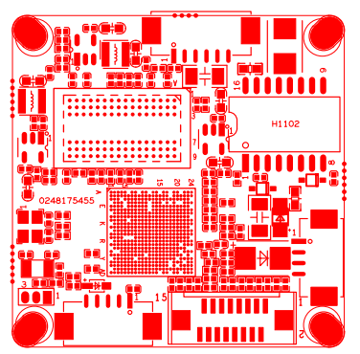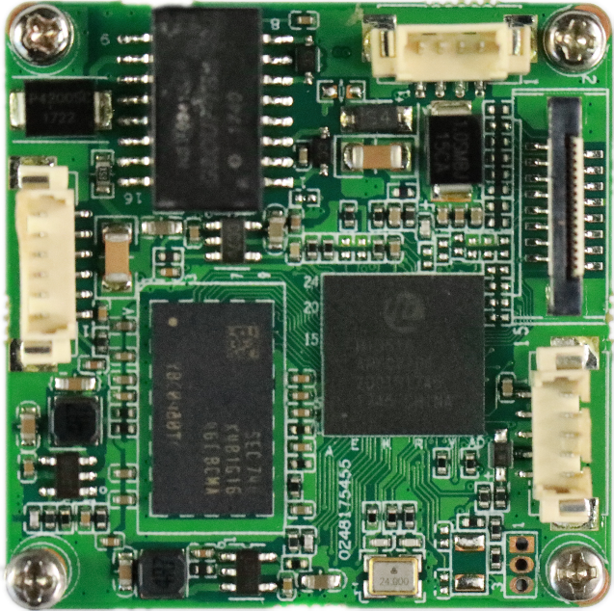

|  |  |  |  |  |
| --- | --- | --- | --- | --- |
| 标注 | 丝印编号 | 针脚编号 | 针脚定义 | 功能 |
|  | J3 | 1 | ETHRX- | 网口数据接收 |
|  | 2 | ETHRX+ | 网口数据接收 |
|  | 3 | LED/PHY_AD1 | 网络灯 |
|  | 4 | ETHTX- | 网口数据发送 |
|  | 5 | ETHTX+ | 网口数据发送 |
|  | 6 | LED/PHY_AD0 | 网络灯 |
|  | J1 | 1 | NC | 悬空 |
|  | 2 | NC | 悬空 |
|  | 3 | GND | GND |
|  | 4 | 12V | 12V输入 |
|  | J14 | 1 | AC_OUT | 音频输出 |
|  | 2 | MIC_P | 音频输入 |
|  | 3 | GND | GND |
|  | 4 | ALMIN_GPIO144 | 报警输入 |
|  | 5 | GND | GND |
|  | J19 | 1 | SD0_CCLK_OUT | SD时钟线 |
|  | 2 | SD0_CCMD | SD控制线 |
|  | 3 | SD0_CDATA0 | 数据位0 |
|  | 4 | SD0_CDATA1 | 数据位1 |
|  | 5 | SD0_CDATA2 | 数据位2 |
|  | 6 | SD0_CDATA3 | 数据位3 |
|  | 7 | LED_GPIO57 | 报警输入 |
|  | 8 | GND | GND |
|  | 9 | SET_GPIO56 | 复位 |
|  | 10 | BAT | 电池 |
|  | 11 | GND | GND |
|  | 12 | ALMOUT_GPIO145 | 报警输出 |
|  | 13 | USB_DM | USB数据口 |
|  | 14 | USB_DP | USB数据口 |
|  | 15 | +5V | 5V输入 |
|  | 16 | USB_CONTROL | USB控制 |
|  | J12 | 1 | +12V | +12V |
|  | 2 | +12V | +12V |
|  | 3 | GND | GND |
|  | 4 | GND | GND |
|  | 5 | +5V | +5V |
|  | 6 | GND | GND |
|  | 7 | MIPI0_CKP/VI0_DATA7 | 数据位7 |
|  | 8 | MIPI0_D3P/VI0_DATA6 | 数据位6 |
|  | 9 | MIPI0_D3M/VI0_DATA5 | 数据位5 |
|  | 10 | MIPI1_CKM/VI0_DATA4 | 数据位4 |
|  | 11 | MIPI1_CKP/VI0_DATA3 | 数据位3 |
|  | 12 | MIPI0_D2P/VI0_DATA2 | 数据位2 |
|  | 13 | MIPI0_D2M/VI0_DATA1 | 数据位1 |
|  | 14 | MIPI0_D0P/VI0_DATA0 | 数据位0 |
|  | 15 | MIPI0_D1M/VI0_HS | 行同步信号 |
|  | 16 | MIPI0_D1P/VI0_CLK | 时钟 |
|  | 17 | MIPI0_D0M/VI0_VS | 场同步信号 |
|  | 18 | GND | GND |
|  | 19 | SENSOR0_CLK | Sensor时钟 |
|  | 20 | SPI0_CLK/I2C0_SCL | I2C时钟 |
|  | 21 | SPI0_CSN | SPI使能 |
|  | 22 | SPI0_SDI | I2C数据 |
|  | 23 | NC | NC |
|  | 24 | SAR_ADC_CH1/GPIO16_1 | 预留GPIO |
|  |  | 25 | GND | GND |
|  | 26 | GND | GND |
|  | 27 | GND | GND |
|  | 28 | +1.8V | +1.8V |
|  | 29 | SPI0_SDO/I2C0_SDA | I2C数据位 |
|  | 30 | MIPI1_D0M/VI0_DATA15 | 数据位15 |
|  | 31 | MIPI1_D1M/VI0_DATA14 | 数据位14 |
|  | 32 | MIPI1_D1P/VI0_DATA13 | 数据位13 |
|  | 33 | MIPI1_D2P/VI0_DATA12 | 数据位12 |
|  | 34 | MIPI1_D2M/VI0_DATA11 | 数据位11 |
|  | 35 | MIPI1_D3M/VI0_DATA10 | 数据位10 |
|  | 36 | MIPI1_D3P/VI0_DATA9 | 数据位9 |
|  | 37 | MIPI0_CKM/VI0_DATA8 | 数据位8 |
|  | 38 | IRCA1_GPIO134 | IR控制 |
|  | 39 | IRCB1_GPIO135 | IR控制 |
|  | 40 | GND | GND |
|  | J13 | 1 | +12V | +12V |
|  | 2 | +12V | +12V |
|  | 3 | GND | GND |
|  | 4 | GND | GND |
|  | 5 | +5V | +5V |
|  | 6 | GND | GND |
|  | 7 | MIPI2_D2P/VI1_DATA7 | 数据位7 |
|  | 8 | MIPI2_D2M/VI1_DATA6 | 数据位6 |
|  | 9 | VI1_DATA5/GPIO2_7 | 数据位5 |
|  | 10 | VI1_DATA4/GPIO2_6 | 数据位4 |
|  | 11 | VI1_DATA3/GPIO2_5 | 数据位3 |
|  | 12 | VI1_DATA2/GPIO2_4 | 数据位2 |
|  | 13 | VI1_DATA1/GPIO2_3 | 数据位1 |
|  | 14 | VI1_DATA0/GPIO2_2 | 数据位0 |
|  | 15 | VI1_HS/GPIO3_0 | 行同步信号 |
|  | 16 | VI1_CLK/GPIO2_1 | 时钟 |
|  | 17 | VI1_VS/GPIO2_0 | 场同步信号 |
|  | 18 | GND | GND |
|  | 19 | SENSOR1_CLK | SENSOR时钟 |
|  | 20 | SPI1_CLK/I2C1_SCL | I2C时钟 |
|  | 21 | SPI1_CSN | SPI使能 |
|  | 22 | SPI1_SDI | I2C数据 |
|  | 23 | NC | NC |
|  | 24 | SAR_ADC_CH2/GPIO16_2 | 预留GPIO |
|  | 25 | GND | GND |
|  | 26 | GND | GND |
|  | 27 | GND | GND |
|  | 28 | +1.8V | +1.8V |
|  | 29 | SPI1_SDO/I2C1_SDA | I2C时钟 |
|  | 30 | MIPI2_CKM/VI1_DATA15 | 数据位15 |
|  | 31 | MIPI2_CKP/VI1_DATA14 | 数据位14 |
|  | 32 | MIPI2_D3M/VI1_DATA13 | 数据位13 |
|  | 33 | MIPI2_D3P/VI1_DATA12 | 数据位12 |
|  | 34 | MIPI2_D1M/VI1_DATA11 | 数据位11 |
|  | 35 | MIPI2_D1P/VI1_DATA10 | 数据位10 |
|  | 36 | MIPI2_D0P/VI1_DATA9 | 数据位9 |
|  | 37 | MIPI2_D0M/VI1_DATA8 | 数据位8 |
|  | 38 | IRCA2_GPIO136 | IR控制 |
|  | 39 | IRCB2_GPIO137 | IR控制 |
|  | 40 | GND | GND |