BRD_XMJP-RM-BLK18EV-0145-S-V1_01 Interface Description

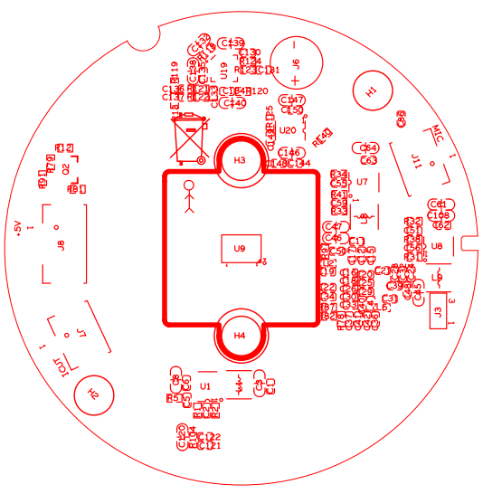 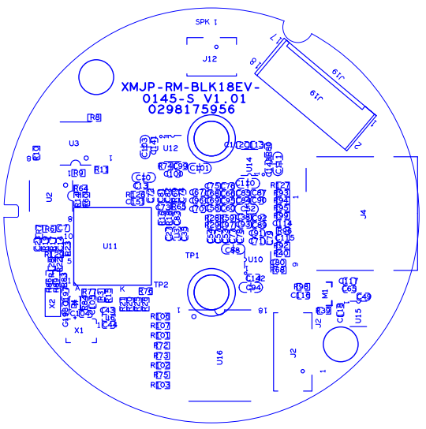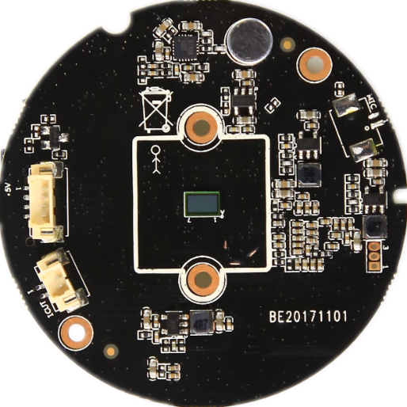 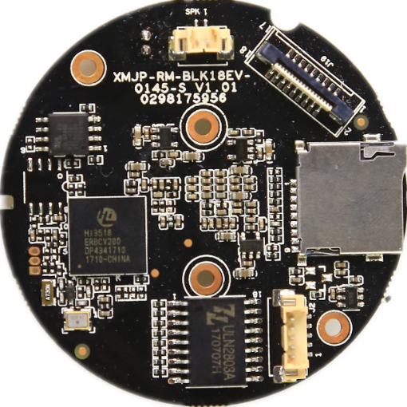

P1 Infrared

P8 motor

P8 SD

P7 Extension

P6 SPK

P5 IR CUT

P3 MIC

P2 MIC

|  |  |  |  |  |  |
| --- | --- | --- | --- | --- | --- |
| Label | | Socket | Specific No | Interface Description | Label |
| P1 | J8 | | 1 | +5V | +5V |
| 2 | GND | GND |
| 3 | IRC_GPIO30 | IRC_GPIO30 |
| 4 |  |  |
| P2 | | J11 | 1 | GND | GND |
| 2 | MIC_P | MIC_P |
| P3 | | J6 | 1 | MIC_P | MIC_P |
| 2 | GND | GND |
| P4 | | J3 | 1 | UART0_RXD | UART0_RXD |
| 2 | UART0_TXD | UART0_TXD |
| 3 | GND | GND |
| P5 | | J7 | 1 |  |  |
| 2 |  |  |
| P6 | | J12 | 1 | SPK+ | SPK+ |
| 2 | SPK- | SPK- |
| P7 | | J19 | 1 | OUT1 | OUT1 |
| 2 | OUT2 | OUT2 |
| 3 | OUT3 | OUT3 |
| 4 | OUT4 | OUT4 |
| 5 | GND | GND |
| 6 | PRESET_GPIO7_4 | PRESET_GPIO7_4 |
| 7 | RED_GPIO0_1 | RED_GPIO0_1 |
| 8 | GREEN_GPIO0_2 | GREEN_GPIO0_2 |
| 9 | GND | GND |
| 10 | USB_DP | USB_DP |
| 11 | USB_DM | USB_DM |
| 12 | GND | GND |
| 13 | USB_CTRL | USB_CTRL |
| 14 | GND | GND |
| 15 | GND | GND |
| 16 | +5V | +5V |
| 17 | +5V | +5V |
| 18 | +5V | +5V |
| P8 | | J4 | 1 | SD_ CDATA2 | SD_ CDATA2 |
| 2 | SD_ CDATA3 | SD_ CDATA3 |
| 3 | SD_ _CMD | SD_ _CMD |
| 4 | +3.3V_SD | +3.3V_SD |
| 5 | X_SD_CLK | X_SD_CLK |
| 6 | GND | GND |
| 7 | SD_ CDATA0 | SD_ CDATA0 |
| 8 | SD_ CDATA1 | SD_ CDATA1 |
| 9 | DETECT | DETECT |

|  |  |  |  |  |
| --- | --- | --- | --- | --- |
| Label | Socket | Specific No | Interface Description | Label |
| P9 | J2 | 1 | +5V_M1 | +5V_M1 |
| 2 | OUT 8 | motor OUT 8 |
| 3 | OUT 7 | motor OUT 7 |
| 4 | OUT 6 | motor OUT 6 |
| 5 | OUT 5 | motor OUT 5 |

BRD_XMJP-RM18EV-WIFI-USB-IF-S-V1_01 Interface Description

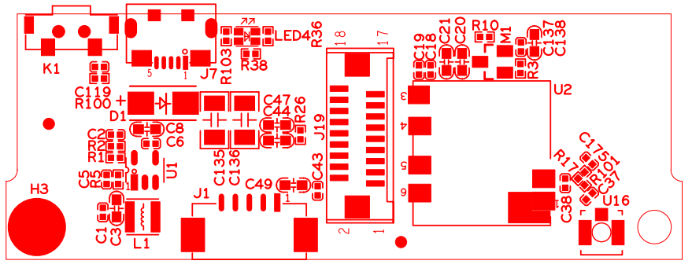

Extension

P3 RESET

P1 POWER

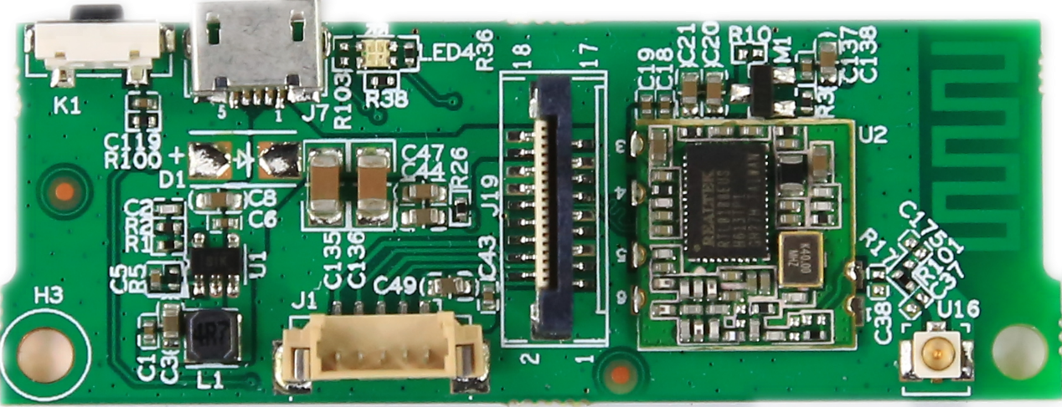

P2 motor

|  |  |  |  |  |  |
| --- | --- | --- | --- | --- | --- |
| Label | | Socket | Specific No | Interface Description | Label |
| P1 | J7 | | 1 | +5V | +5V |
| 5 | GND | GND |
|  |  |  |
|  | |  |  |  |  |
| P2 | | J1 | 1 | +5V_M2 | +5V_M2 |
| 2 | OUT1 | motor OUT1 |
| 3 | OUT2 | motor OUT2 |
| 4 | OUT3 | motor OUT3 |
| 5 | OUT4 | motor OUT4 |
| P3 | | K1 | 1 | GND | GND |
| 2 | PRESET_GPIO7_4 | PRESET_GPIO7_4 |
|  |  |  |
|  |  |  |