BLK510-0062-WIFI-SD-38X38-V1_01 Interface Description
J29
24-1（L→R）

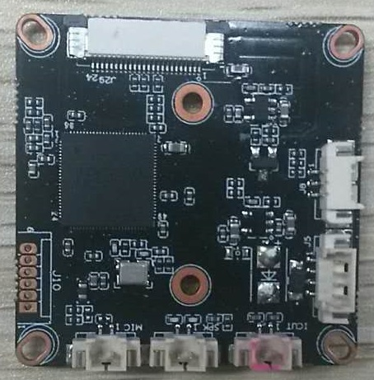
J8
1
2
3
J10
This interface is not welded

J5
1
2
3
4

3
J11 This interface is not welded

J12 This interface is not welded

J7
2 1

Detailed Definition
Label | Socket | Specific No | Interface Description
J5 | 1 | NC | Undefined
J5 | 2 | NC | Undefined
J5 | 3 | GND | GND
J5 | 4 | 5V | 5V DC input
J8 | 1 | LED_CTRL | Infrared input
J8 | 2 | GND | GND
J8 | 3 | PWR_VIN | DC input
J7 | 1 | IRCUT_A | IRCUT
J7 | 2 | IRCUT_B | IRCUT
J12 | 1 | SPKN | SPK
J12 | 2 | SPKP | SPK
J29 | 1 | 3V3 | 3.3V
J29 | 2 | 3V3 | 3.3V
J29 | 3 | GND | GND
J29 | 4 | VBAT
J29 | 5 | ALARM_IN | ALARM_IN
J29 | 6 | GPIO_07 | Key-set
J29 | 7 | GPIO46 | LED
J29 | 8 | ALARM_OUT | ALARM_OUT
J29 | 9 | GND | GND
J29 | 10 | WIFI_DATA0 | WIFI_DATA0
J29 | 11 | WIFI_PDN | WIFI_PDN
J29 | 12 | GND | GND
J29 | 13 | WIFI_CMD | WIFI_CMD
J29 | 14 | GND | GND
J29 | 15 | WIFI_CLK | WIFI_CLK
J29 | 16 | GND | GND
J29 | 17 | SD_DATA3 | SD_DATA3
J29 | 18 | SD_DATA2 | SD_DATA2
J29 | 19 | SD_DATA1 | SD_DATA1
J29 | 20 | SD_DATA0 | SD_DATA0
J29 | 21 | GND | GND
J29 | 22 | SD_CMD | SD_CMD
J29 | 23 | GND | GND
J29 | 24 | SD_CLK | SD_CLK
J11 | 1 | MIC1 | MIC
J11 | 2 | MIC2 | MIC
J10 | 1 | NC | Undefined
J10 | 2 | GND | GND
J10 | 3 | UART0_TXD | UART0_TXD
J10 | 4 | UART0_RXD | UART0_RXD
J10 | 5 | SWTICH_KEY | SWTICH_KEY
J10 | 6 | EXT_RSTN | EXT_RSTN

BLK510-38X38-PORT-WP-V1_01 Interface Description
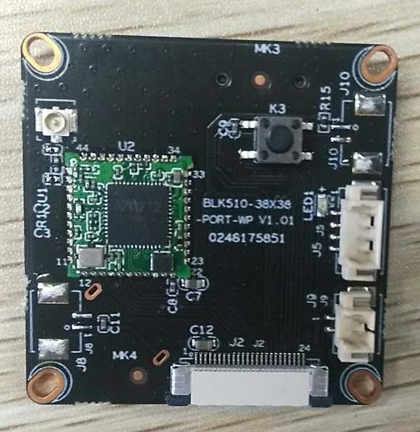
J10
This interface is not welded

J8
This interface is not welded

J9
This interface is not welded

J5
This interface is not welded

3
J2
1-24（L→R）

详细定义
sign | Socket | Specific No | Interface Description
J5 | 1 | GPIO46 | LED
J5 | 2 | GND | GND
J5 | 3 | GND | GND
J5 | 4 | ALARM_OUT1 | ALARM_OUT
J8（预留） | 1 | VBAT | VBAT
J8（预留） | 2 | GND | GND
J9 | 1 | ALARM_IN | ALARM_IN
J9 | 2 | GND | GND
J10（预留） | 1 | GPIO_07
J10（预留） | 2 | GND | GND
J2 | 1 | 3V3 | 3V3
J2 | 2 | 3V3 | 3V3
J2 | 3 | GND | GND
J2 | 4 | VBAT | VBAT
J2 | 5 | ALARM_IN | ALARM_IN
J2 | 6 | GPIO_07 | GPIO_07
J2 | 7 | GPIO46 | GPIO46
J2 | 8 | ALARM_OUT | ALARM_OUT
J2 | 9 | GND | GND
J2 | 10 | WIFI_DATA0 | WIFI_DATA0
J2 | 11 | WIFI_PDN | WIFI_PDN
J2 | 12 | GND | GND
J2 | 13 | WIFI_CMD | WIFI_CMD
J2 | 14 | GND | GND
J2 | 15 | WIFI_CLK | WIFI_CLK
J2 | 16 | GND | GND
J2 | 17 | SD_DATA3 | SD_DATA3
J2 | 18 | SD_DATA2 | SD_DATA2
J2 | 19 | SD_DATA1 | SD_DATA1
J2 | 20 | SD_DATA0 | SD_DATA0
J2 | 21 | GND | GND
J2 | 22 | SD_CMD | SD_CMD
J2 | 23 | GND | GND
J2 | 24 | SD_CLK | SD_CLK
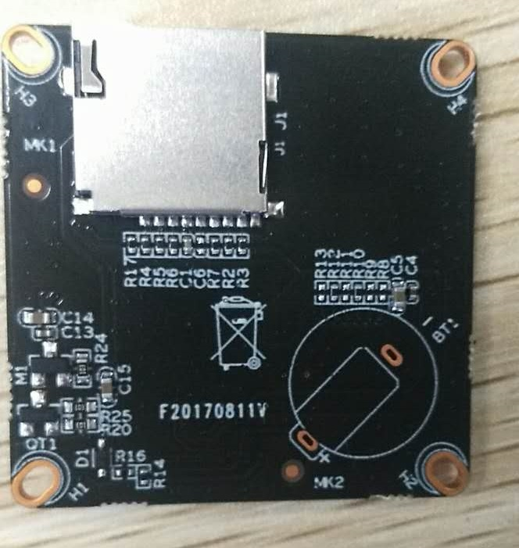
J1 This interface is not welded

sign | Socket | Specific No | Interface Description
J1 | / | SD Card | SD Card

