IPG-50X10PT-WRQ
IPC-RM-BLK510-0062-S-V1.01 Interface Description
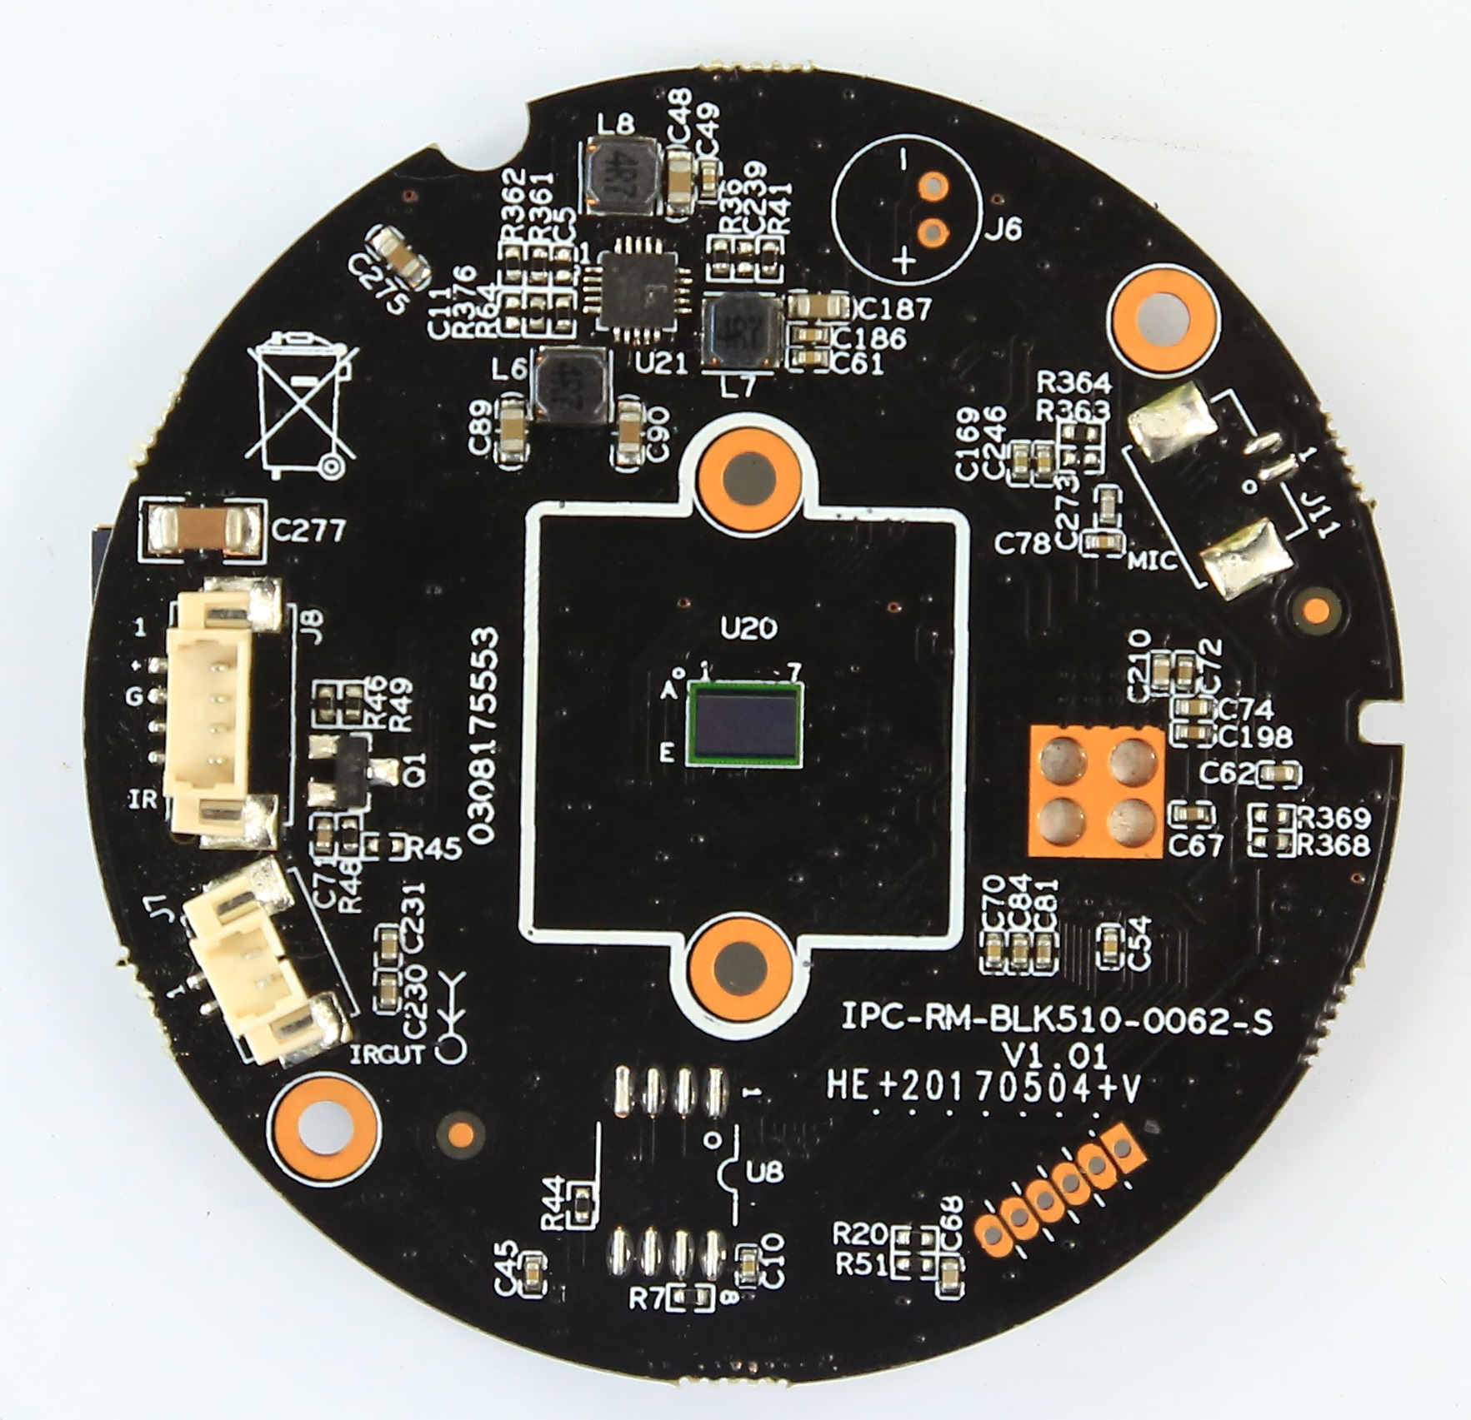
J11
2
1
J8
1
2
3
4
J7
1
2

Detailed Definition
Socket | Specific No | Interface Description | Function
J7 | 1 | IRCUT_A | IRCUT output A
J7 | 2 | IRCUT_B | IRCUT output B
J8 | 1 | +5V | +5V DC input
J8 | 2 | GND | GND
J8 | 3 | ADC_IN | ADC_IN
J8 | 4 | NC | NC
J11 | 1 | MIC_G | MIC INPUT
J11 | 2 | MIC_IN | MIC INPUT
J12
2 1
J19
18 17
16 15
14 13
12 11
10 9
8 7
6 5
4 3
2 1
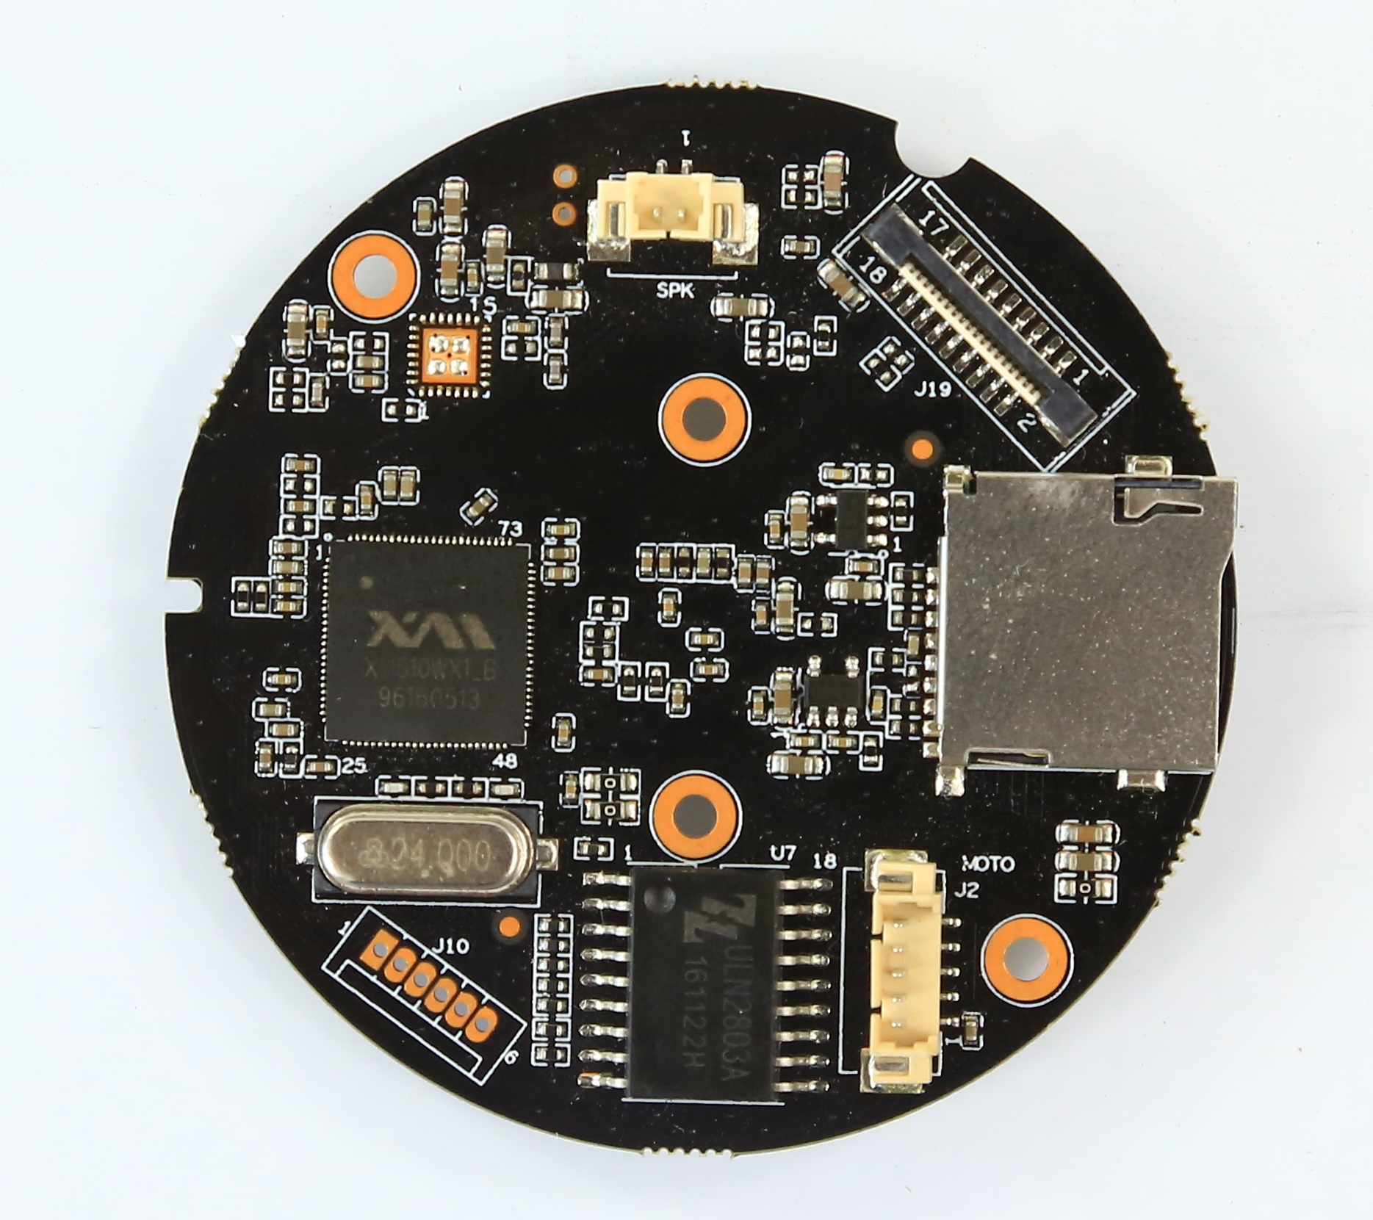
J4
J2
5
4
3
2
1
J10
1
2
3
4
5
6

Socket | Specific No | Interface Description | Function
J2 | 1 | +5V | +5V DC input
J2 | 2 | OUT8 | Vertical motor drive pin
J2 | 3 | OUT7 | Vertical motor drive pin
J2 | 4 | OUT6 | Vertical motor drive pin
J2 | 5 | OUT5 | Vertical motor drive pin
J12 | 1 | SPKN | MIC
J12 | 2 | SPKP | MIC
J4 | \ | SD Card | SD card
J19 | 1 | OUT1 | Horizontal motor drive pin
J19 | 2 | OUT2 | Horizontal motor drive pin
J19 | 3 | OUT3 | Horizontal motor drive pin
J19 | 4 | OUT4 | Horizontal motor drive pin
J19 | 5 | GPIO_07 | GPIO
J19 | 6 | GND | GND
J19 | 7 | GND | GND
J19 | 8 | WIFI_DATA3 | WIFI signal data transfer pin
J19 | 9 | WIFI_DATA2 | WIFI signal data transfer pin
J19 | 10 | WIFI_DATA1 | WIFI signal data transfer pin
J19 | 11 | WIFI_DATA0 | WIFI signal data transfer pin
J19 | 12 | WIFI_CMD | WIFI control pin
J19 | 13 | WIFI_CLK | WIFI clock signal
J19 | 14 | WIFI_PDN | WIFI power supply pin
J19 | 15 | GND | GND
J19 | 16 | GND | GND
J19 | 17 | +5V | +5V DC input
J19 | 18 | +5V | +5V DC input
J10 | 1 | NC | NC
J10 | 2 | GND | GND
J10 | 3 | TXD | Serial data transmit pin
J10 | 4 | RXD | Serial data receiving pin
J10 | 5 | SWITCH_KEY | SWITCH_KEY
J10 | 6 | RSTN | reset

IPC-RM510-WIFI-USB-IF-S-V2_01 Interface Description
J7
J19

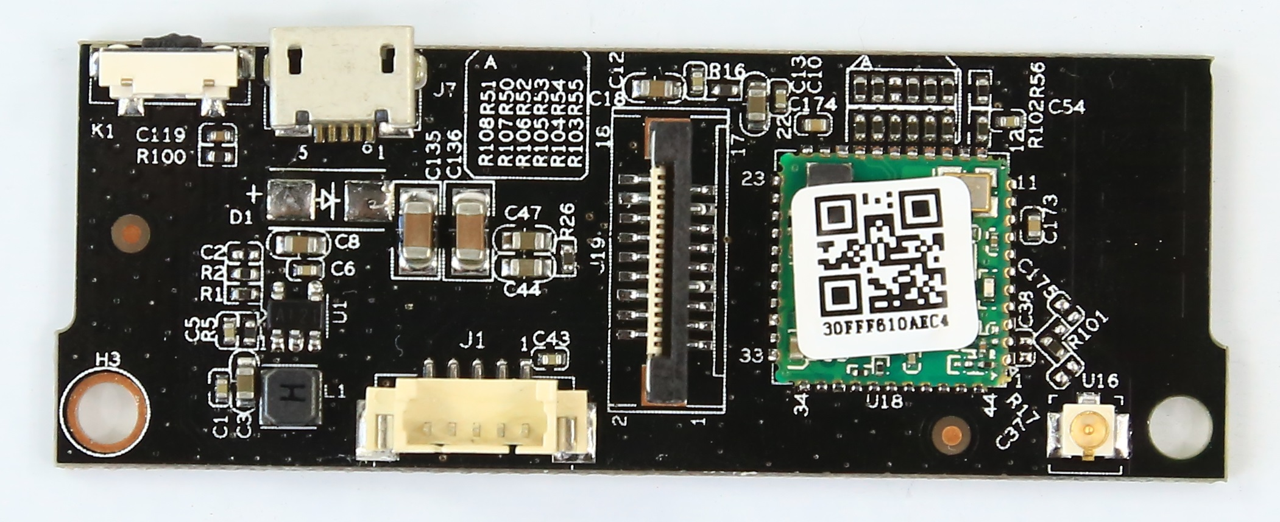
K1
J1
5 4 3 2 1
U16

Socket | Specific No | Interface Description | Function
K1 | \ | \ | Key
J1 | 1 | +5V | +5V DC input
J1 | 2 | OUT1 | Horizontal motor drive pin
J1 | 3 | OUT2 | Horizontal motor drive pin
J1 | 4 | OUT3 | Horizontal motor drive pin
J1 | 5 | OUT4 | Horizontal motor drive pin
U16 | \ | \
J19 | \ | \
J7 | \ | \

