BLK510-0130-0065-WIFI-F-V1_02 Interface Description
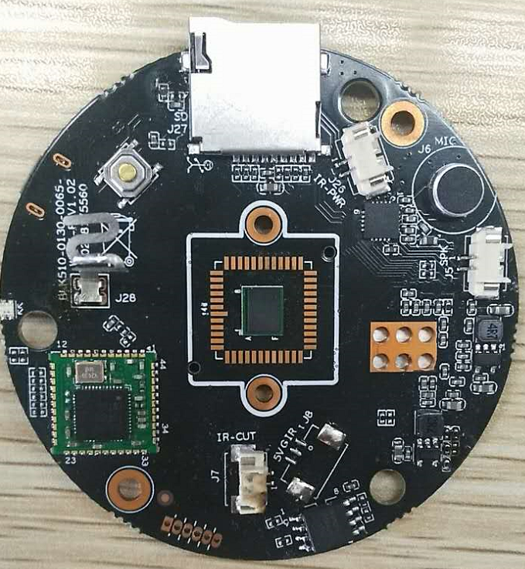
J26
1
2

3
J5
1
2
J7
2
1
J27
K1
J8
1
2
3

3

Detailed Definition
Socket | Specific No | Interface Description | Function
J26 | 1 | SEN+ | +Infrared lamp power supply drive
J26 | 2 | SEN- | -Infrared lamp power supply drive
J5 | 1 | SPKOUT+ | +Speaker output
J5 | 2 | SPKOUT- | -Speaker output
J27 | / | SD Card | SD
K1 | / | / | Key
J8() | 1 | RED_CTRL | RED_CTRL
J8() | 2 | GND | GND
J8() | 3 | 5V | 5V power input
J7 | 1 | IRC_B | IRCUT output signal B
J7 | 2 | IRC_A | IRCUT output signal A
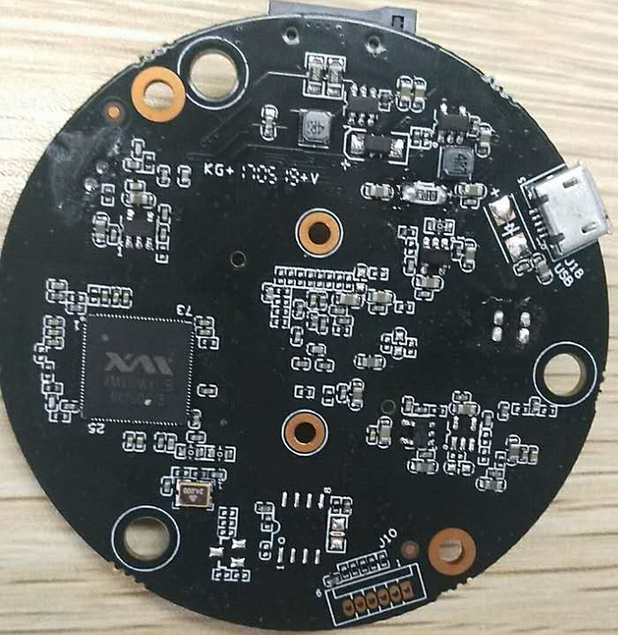
J10
6 5 4 3 2 1
J18

Socket | Specific No | Interface Description | Function
J10 | 1 | NC | NC
J10 | 2 | GND | GND
J10 | 3 | TXD | Serial data send pins
J10 | 4 | RXD | Serial data receive pins
J10 | 5 | SWITCH_KEY | open control program
J10 | 6 | RSTN | reset
J18 | / | USB | USB

