IPC-FD-510WX1-0065-P1-S-V1.02Interface Description
J34
1 2 3

J26
1 2

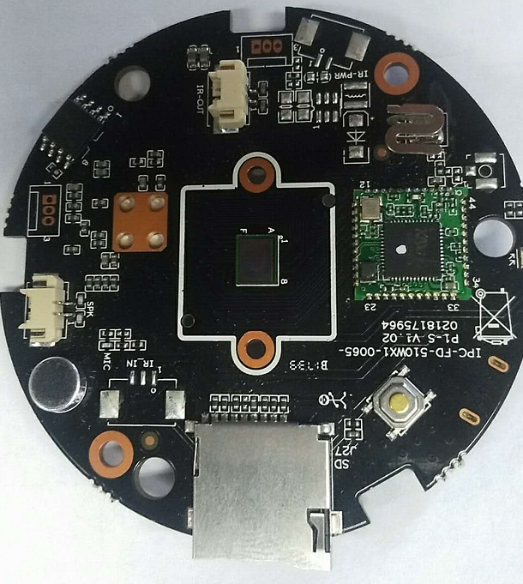
J28
J30
2
1
U23
J8
3 2 1
J7
2
1

J32
1
2
3
J29
K1
J27

Socket | Specific No | Interface Description | Function
K1 | / | KEY | K1
J7 | 1 | IRCUT1 | J7
J7 | 2 | IRCUT2 | J7
J27 | / | SD Card | SD Card
J29 | / | MIC | MIC
U23 | / | / | Antenna interface
J28 | / | / | WIFI antenna
J8 | 1 | LED_CTRL | Infrared control input
J8 | 2 | GND | GND
J8 | 3 | 5V | 5V DC input
J26 | 1 | SEN1 | IRPWR
J26 | 2 | SEN2 | IRPWR
J34 | 1 | GND | GND
J34 | 2 | ALARM_IN1 | ALARM_IN1
J34 | 3 | 5V | 12V DC input
J30 | 1 | SPKP | SPK
J30 | 2 | SPKN | SPK
J32 | 1 | GND | GND
J32 | 2 | UART0_TXD | UART0_TXD
J32 | 3 | UART0_RXD | UART0_RXD
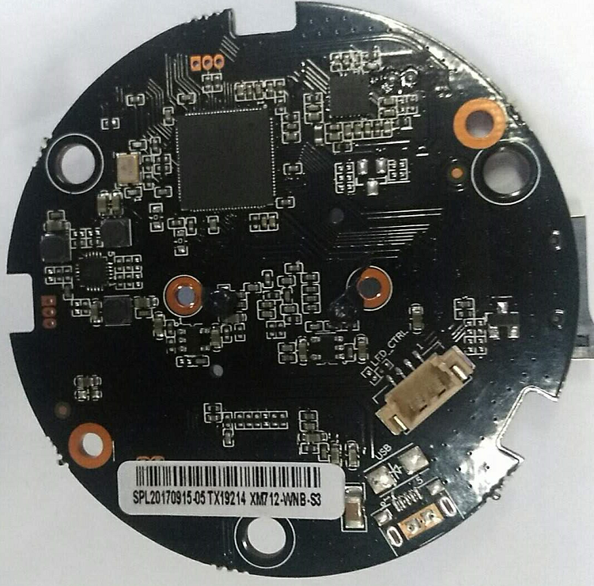
J18
J33
4 3 2 1

Socket | Specific No | Interface Description | Function
J33 | 1 | 5V | 5V DC input
J33 | 2 | GND | GND
J33 | 3 | LED_CTRL | LED_CTRL
J33 | 4 | RED_CTRL | RED_CTRL
J18 | / | / | USB Power supply interface

