BLK510FX1-0065- 38X38-WP-V1_01 Interface Description
J1
1 2 3 4 5 6

J7
1 2 3 4

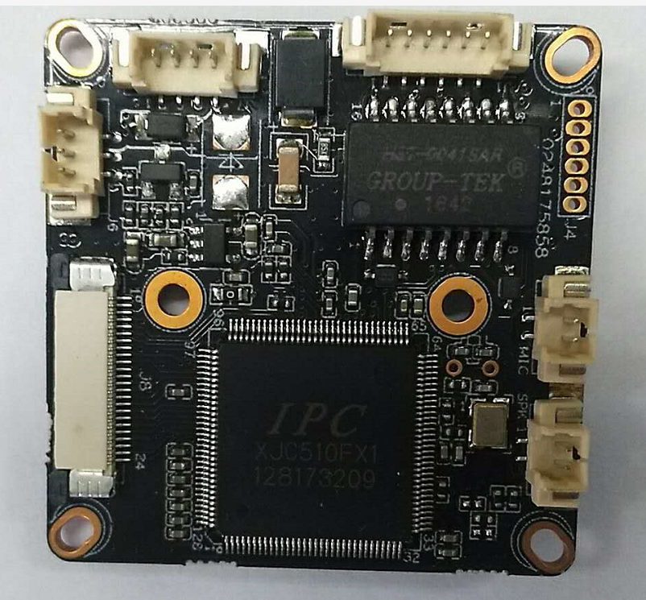
J4
1
2
3
4
5
6
J8
1-24
J3
This interface is not welded
J2
This interface is not welded
J6
3
2
1

Detailed Definition
Label | Socket | Specific No | Interface Description
J1 | 1 | ETHRX- | ETHRX-
J1 | 2 | ETHRX+ | ETHRX+
J1 | 3 | PHY_AD0 | PHY_AD0
J1 | 4 | ETHTX- | ETHTX-
J1 | 5 | ETHTX+ | ETHTX+
J1 | 6 | PHY_AD3 | PHY_AD3
J7 | 1 | NC | Undefined
J7 | 2 | NC | Undefined
J7 | 3 | GNG | GND
J7 | 4 | 12V | 12V DC input
J6 | 1 | LED_CTRL | Infrared input
J6 | 2 | GND | GND
J6 | 3 | NC | DC input
J4 | 1 | NC | NC
J4 | 2 | GND | GND
J4 | 3 | UART0_TXD | UART0_TXD
J4 | 4 | UART0_RXD | UART0_RXD
J4 | 5 | SWTICH_PROG | SWTICH_PROG
J4 | 6 | EXT_RXTN | EXT_RXTN
J3 | 1 | MICIN | MIC
J3 | 2 | MICIN | MIC
J2 | 1 | SPKP | SPK
J2 | 2 | SPKN | SPK
J3 | 1 | 3V3 | 3.3V
J3 | 2 | 3V3 | 3.3V
J3 | 3 | GND | GND
J3 | 4 | VBAT
J3 | 5 | ALARM_IN | ALARM_IN
J3 | 6 | GPIO_07 | Key-set
J3 | 7 | GPIO46 | LED
J3 | 8 | ALARM_OUT | ALARM_OUT
J3 | 9 | GND | GND
J3 | 10 | WIFI_DATA0 | WIFI_DATA0
J3 | 11 | WIFI_PDN | WIFI_PDN
J3 | 12 | GND | GND
J3 | 13 | WIFI_CMD | WIFI_CMD
J3 | 14 | GND | GND
J3 | 15 | WIFI_CLK | WIFI_CLK
J3 | 16 | GND | GND
J3 | 17 | SD_DATA3 | SD_DATA3
J3 | 18 | SD_DATA2 | SD_DATA2
J3 | 19 | SD_DATA1 | SD_DATA1
J3 | 20 | SD_DATA0 | SD_DATA0
J3 | 21 | GND | GND
J3 | 22 | SD_CMD | SD_CMD
J3 | 23 | GND | GND
J3 | 24 | SD_CLK | SD_CLK
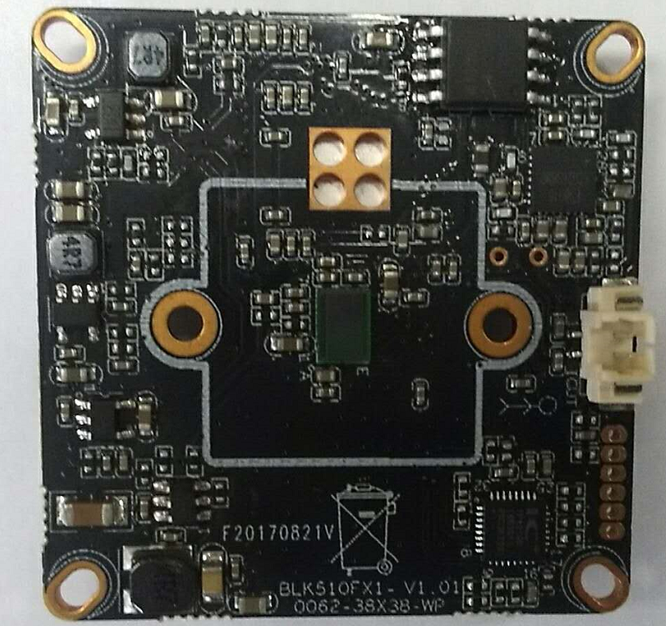
J5
1
2
J3 | 1 | IRCUT1 | IRCUT
J3 | 2 | IRCUT2 | IRCUT

BLK510-38X38-PORT-WP-V2_01

BLK510-38X19-PORT-WP-V2_01 Interface Description
J10
1 2

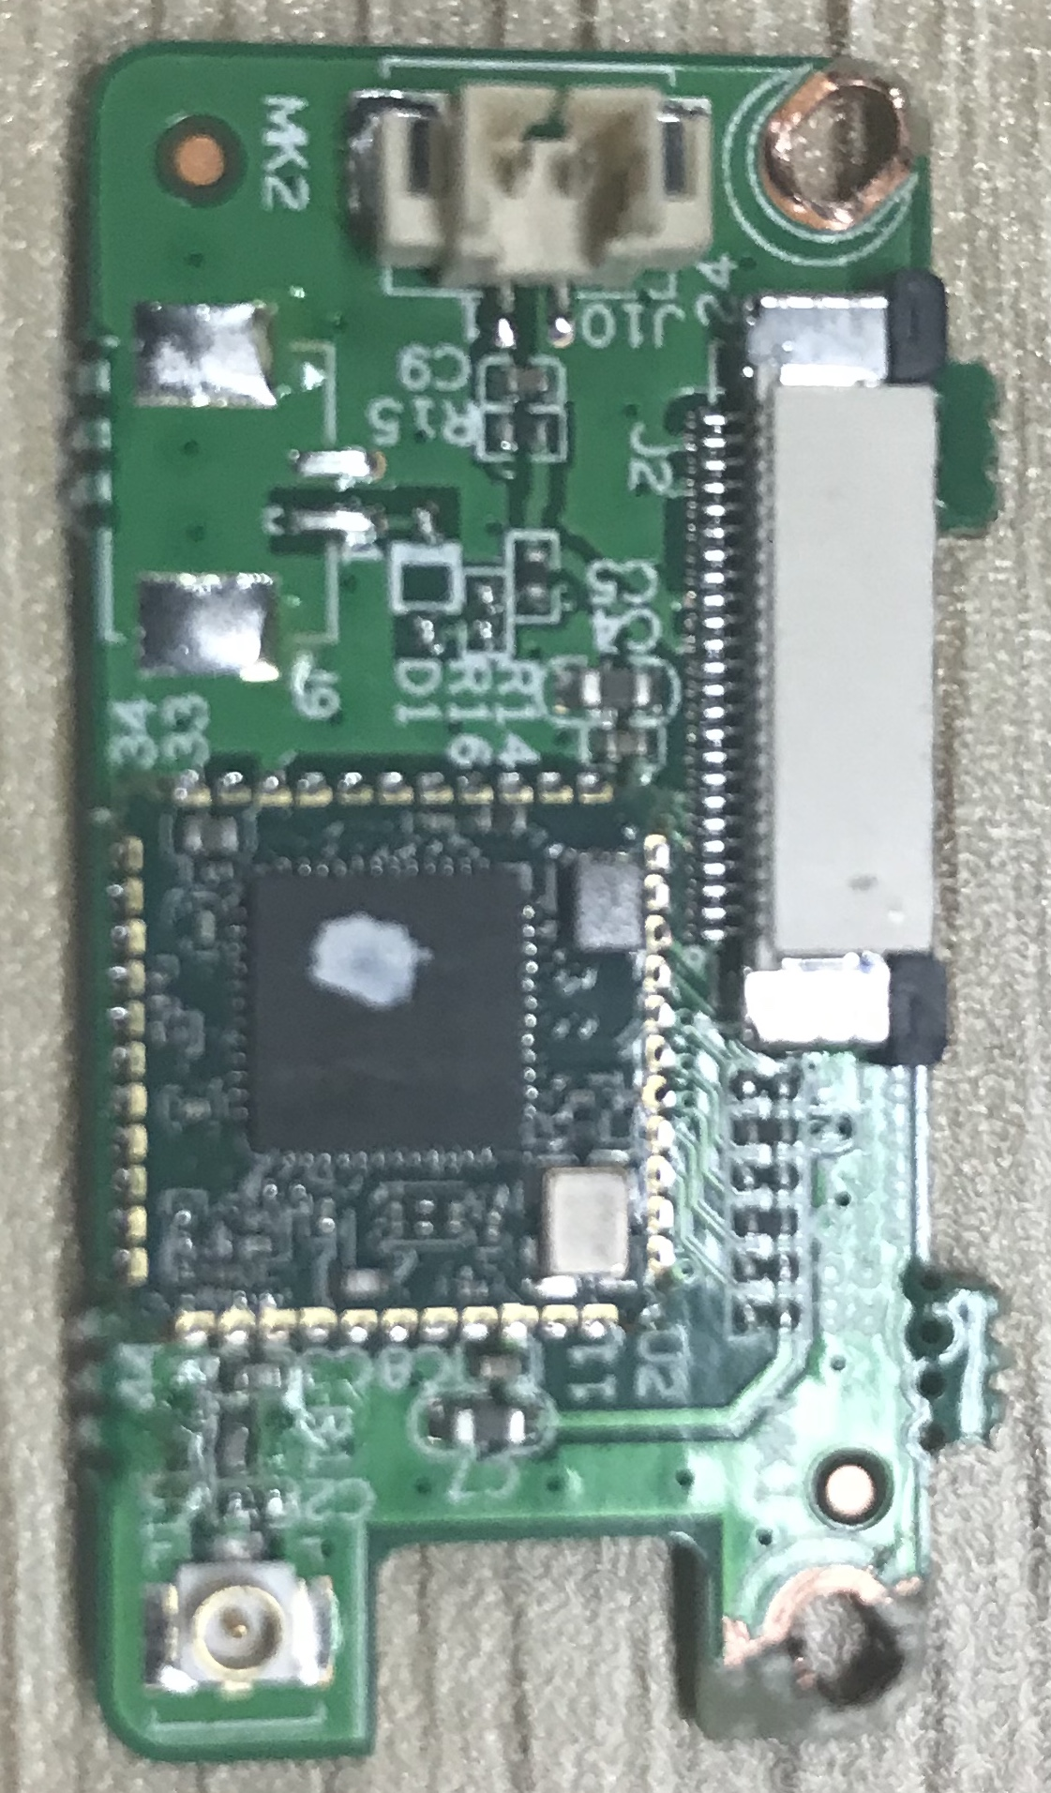
J2
24-1
U1
J9（预留）
2
1

J2 | 1 | 3V3 | 3.3V
J2 | 2 | 3V3 | 3.3V
J2 | 3 | GND | GND
J2 | 4 | VBAT | VBAT
J2 | 5 | ALARM_IN | ALARM_IN
J2 | 6 | GPIO_07 | GPIO_07
J2 | 7 | GPIO46 | GPIO46
J2 | 8 | ALARM_OUT | ALARM_OUT
J2 | 9 | GND | GND
J2 | 10 | WIFI_DATA0 | WIFI_DATA0
J2 | 11 | WIFI_PDN | WIFI_PDN
J2 | 12 | GND | GND
J2 | 13 | WIFI_CMD | WIFI_CMD
J2 | 14 | GND | GND
J2 | 15 | WIFI_CLK | WIFI_CLK
J2 | 16 | GND | GND
J2 | 17 | SD_DATA3 | SD_DATA3
J2 | 18 | SD_DATA2 | SD_DATA2
J2 | 19 | SD_DATA1 | SD_DATA1
J2 | 20 | SD_DATA0 | SD_DATA0
J2 | 21 | GND | GND
J2 | 22 | SD_CMD | SD_CMD
J2 | 23 | GND | GND
J2 | 24 | SD_CLK | SD_CLK
U1 | / | / | /
J9 | 1 | AL_IN1 | AL_IN1
J9 | 2 | GND | GND
J10 | 1 | GPIO_07 | GPIO_07
J10 | 2 | GND | GND

