J6
1 2 3
J9
1 2 3 4… 7 8

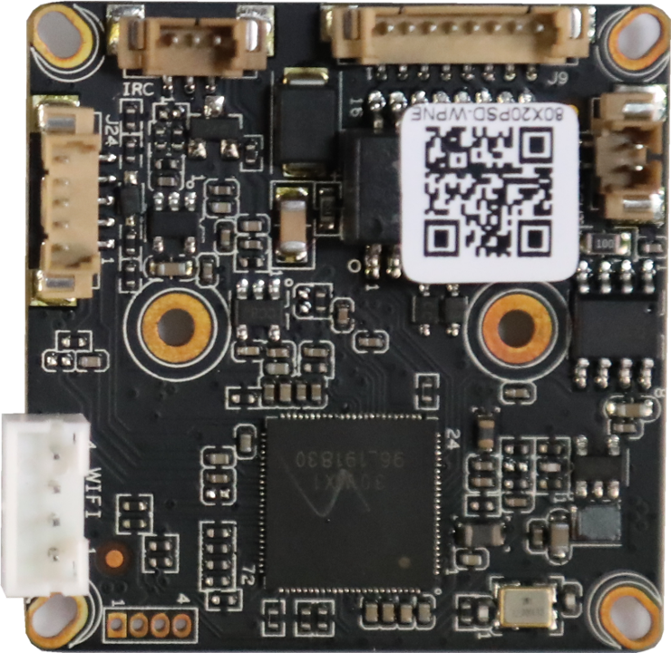
J1
4
3
2
1
J24
5
4
3
2
1
J5
1
2

Socket | Specific No | Interface Description | Function
J9 | 1 | LED0 | LED/PHY_AD0 | Connect the tail line of the camera module
J9 | 2 | LED1 | LED/PHY_AD1 | Connect the tail line of the camera module
J9 | 3 | ETHTX+ | Ethernet signal+ | Connect the tail line of the camera module
J9 | 4 | ETHTX- | Ethernet signal- | Connect the tail line of the camera module
J9 | 5 | ETHRX+ | Ethernet signal+ | Connect the tail line of the camera module
J9 | 6 | ETHRX- | Ethernet signal- | Connect the tail line of the camera module
J9 | 7 | GND | GND | Connect the tail line of the camera module
J9 | 8 | 12V | 12V DC input | Connect the tail line of the camera module
J24 | 1 | AC_OUTL | AC_OUT | Audio&Alarm
J24 | 2 | AC_INL/MICP | AC_IN | Audio&Alarm
J24 | 3 | GND | GND | Audio&Alarm
J24 | 4 | ALARM_IN1 | ALARM_GPIO | Audio&Alarm
J24 | 5 | ALARM_OUT | ALARM_GPIO（Reserve） | Audio&Alarm
J1 | 1 | +5V WIFI | +5Voutput | WIFI/4G module
J1 | 2 | USB_DN | USB data- | WIFI/4G module
J1 | 3 | USB_DP | USB data+ | WIFI/4G module
J1 | 4 | GND | GND | WIFI/4G module
J5 | 1 | IR_CUTA | IR-CUT A OUT | IR_CUT
J5 | 2 | IR_CUTB | IR-CUT B OUT | IR_CUT
J6 | 1 | IR | Infrared input | Connect the camera lamp board
J6 | 2 | GND | GND | Connect the camera lamp board
J6 | 3 | PWM | PWM-OUT | Connect the camera lamp board

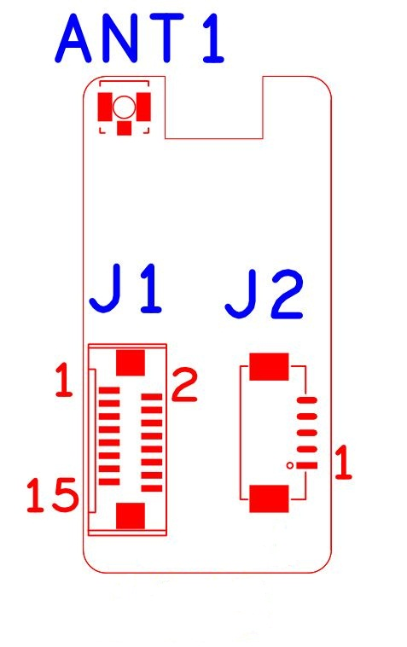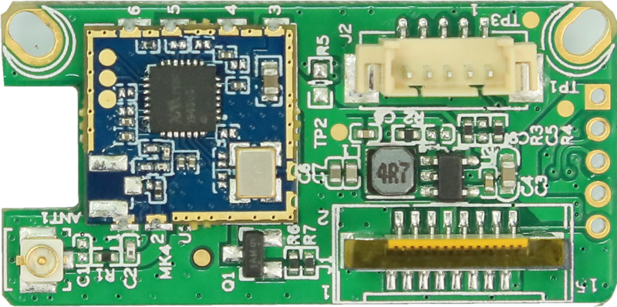

Socket | Specific No | Interface Description | Function
J2 | 1 | GND | 5P1.25mm WIFI Expansion seat
J2 | 2 | USB_DP | 5P1.25mm WIFI Expansion seat
J2 | 3 | USB_DM | 5P1.25mm WIFI Expansion seat
J2 | 4 | +5V | 5P1.25mm WIFI Expansion seat
J2 | 5 | USB_CTRL | 5P1.25mm WIFI Expansion seat
J1 | 1 | NC | 16P FPC WIFI Expansion seat
J1 | 2 | NC | 16P FPC WIFI Expansion seat
J1 | 3 | NC | 16P FPC WIFI Expansion seat
J1 | 4 | NC | 16P FPC WIFI Expansion seat
J1 | 5 | NC | 16P FPC WIFI Expansion seat
J1 | 6 | NC | 16P FPC WIFI Expansion seat
J1 | 7 | NC | 16P FPC WIFI Expansion seat
J1 | 8 | GND | 16P FPC WIFI Expansion seat
J1 | 9 | NC | 16P FPC WIFI Expansion seat
J1 | 10 | NC | 16P FPC WIFI Expansion seat
J1 | 11 | GND | 16P FPC WIFI Expansion seat
J1 | 12 | NC | 16P FPC WIFI Expansion seat
J1 | 13 | USB_DM | 16P FPC WIFI Expansion seat
J1 | 14 | USB_DP | 16P FPC WIFI Expansion seat
J1 | 15 | +5V | 16P FPC WIFI Expansion seat
J1 | 16 | USB_CTRL | 16P FPC WIFI Expansion seat
ANT1 | 1 |  | IPEXAntenna interface
PS: USB_CTRL is the power supply control pin of the WIFI module. Low level enables power supply.

