J4（Not welded）
1 2 3 4
J8
23 21 ...5 3 1
24 22 ...6 4 2
J30（Not welded）
2
1

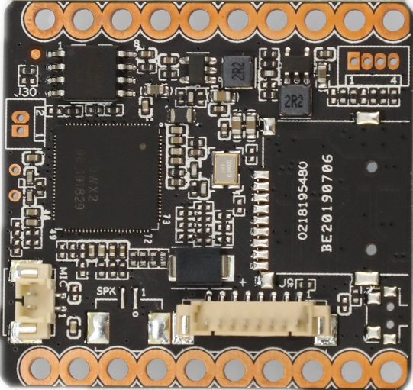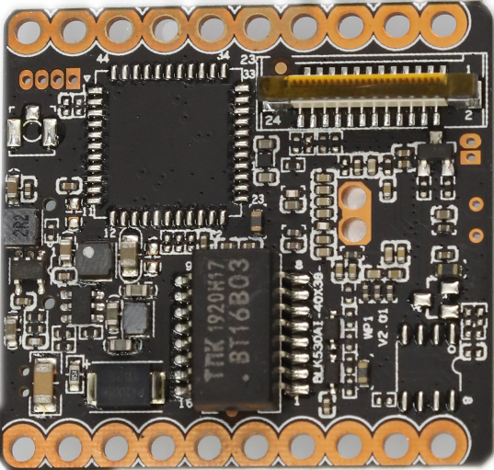
J25（Not welded）
2 1
J26
2
1
J9
8 7 6...3 2 1

Socket | Specific No | Interface Description | Function
J9 | 1 | KEY_SET | KEY_SET | Connect the tail line of the camera module
J9 | 2 | LED1 | LED/PHY_AD1 | Connect the tail line of the camera module
J9 | 3 | ETHTX+ | Ethernet signal+ | Connect the tail line of the camera module
J9 | 4 | ETHTX- | Ethernet signal- | Connect the tail line of the camera module
J9 | 5 | ETHRX+ | Ethernet signal+ | Connect the tail line of the camera module
J9 | 6 | ETHRX- | Ethernet signal- | Connect the tail line of the camera module
J9 | 7 | GND | GND | Connect the tail line of the camera module
J9 | 8 | 12V | 12V DC input | Connect the tail line of the camera module
J26 | 1 | MICIN | MIC IN- | Connect the pickup
J26 | 2 | MICIP | MIC IP+ | Connect the pickup
J25 | 1 | SPKN | SPKN- | Connect the speakers
J25 | 21 | SPKP | SPKP+ | Connect the speakers
J30 | 1 | RTC_BAT | RTC_BAT | Connect the RTC Battery
J30 | 2 | GND | GND | Connect the RTC Battery
J4 | 1 | GND | GND | Serial port debugging seat
J4 | 2 | UART0_TXD | UART0_TXD | Serial port debugging seat
J4 | 3 | UART0_RXD | UART0_RXD | Serial port debugging seat
J4 | 4 | BOOTSEL_0 | BOOTSEL_0 | Serial port debugging seat
J8 | 1 | I_MIPI_DATA1N | I_MIPI_DATA1N | Connect the sensor module
J8 | 2 | I_MIPI_DATA1P | I_MIPI_DATA1P | Connect the sensor module
J8 | 3 | I_MIPI_DATA2N | I_MIPI_DATA2N | Connect the sensor module
J8 | 4 | I_MIPI_DATA2P | I_MIPI_DATA2P | Connect the sensor module
J8 | 5 | I_MIPI_DATA3N | I_MIPI_DATA3N | Connect the sensor module
J8 | 6 | I_MIPI_DATA3P | I_MIPI_DATA3P | Connect the sensor module
J8 | 7 | I_MIPI_CLKP | I_MIPI_CLKP | Connect the sensor module
J8 | 8 | I_MIPI_CLKN | I_MIPI_CLKN | Connect the sensor module
J8 | 9 | I_MIPI_DATA0P | I_MIPI_DATA0P | Connect the sensor module
J8 | 10 | I_MIPI_DATA0N | I_MIPI_DATA0N | Connect the sensor module
J8 | 11 | GND | GND | Connect the sensor module
J8 | 12 | ADC1_IN | ADC1_IN | Connect the sensor module
J8 | 13 | SEN0_MCLK | SEN0_MCLK | Connect the sensor module
J8 | 14 | GND | GND | Connect the sensor module
J8 | 15 | SDA | SDA | Connect the sensor module
J8 | 16 | SCL | SCL | Connect the sensor module
J8 | 17 | IRCUT_A | IRCUT_A | Connect the sensor module
J8 | 18 | IRCUT_B | IRCUT_B | Connect the sensor module
J8 | 19 | IR_CTRL/ALARM_IN | IR_CTRL/ALARM_IN | Connect the sensor module
J8 | 20 | GND | GND | Connect the sensor module
J8 | 21 | LED_CTRL/ALARM_OUT | LED_CTRL/ALARM_OUT | Connect the sensor module
J8 | 22 | PWM | PWM | Connect the sensor module
J8 | 23 | GND | GND | Connect the sensor module
J8 | 24 | +5V | +5V | Connect the sensor module
J1
1 2

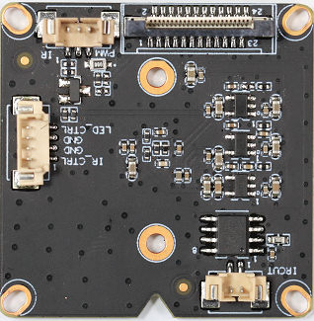
J7
1
2
3
4

J8
23 21 ...5 3 1
24 22 ...6 4 2
J4
3 2 1

Socket | Specific No | Interface Description | Function
J1 | 1 | IR_CUTA | IR-CUT Control line A | Connect IR-CUT
J1 | 2 | IR_CUTB | IR-CUT Control line B | Connect IR-CUT
J4 | 1 | IR | IR | Infrared signal input
J4 | 2 | GND | GND | Infrared signal input
J4 | 3 | PWM | PWM | Infrared signal input
J7 | 1 | IR_CTRL/ALARM_IN | IR_CTRL/ALARM_IN | GPIO
J7 | 2 | GND | GND | GPIO
J7 | 3 | GND | GND | GPIO
J7 | 4 | LED_CTRL/ALARM_OUT | LED_CTRL/ALARM_OUT | GPIO
J8 | 24 | I_MIPI_DATA1N | I_MIPI_DATA1N | Connect the main module
J8 | 23 | I_MIPI_DATA1P | I_MIPI_DATA1P | Connect the main module
J8 | 22 | I_MIPI_DATA2N | I_MIPI_DATA2N | Connect the main module
J8 | 21 | I_MIPI_DATA2P | I_MIPI_DATA2P | Connect the main module
J8 | 20 | I_MIPI_DATA3N | I_MIPI_DATA3N | Connect the main module
J8 | 19 | I_MIPI_DATA3P | I_MIPI_DATA3P | Connect the main module
J8 | 18 | I_MIPI_CLKP | I_MIPI_CLKP | Connect the main module
J8 | 17 | I_MIPI_CLKN | I_MIPI_CLKN | Connect the main module
J8 | 16 | I_MIPI_DATA0P | I_MIPI_DATA0P | Connect the main module
J8 | 15 | I_MIPI_DATA0N | I_MIPI_DATA0N | Connect the main module
J8 | 14 | GND | GND | Connect the main module
J8 | 13 | ADC1_IN | ADC1_IN | Connect the main module
J8 | 12 | SEN0_MCLK | SEN0_MCLK | Connect the main module
J8 | 11 | GND | GND | Connect the main module
J8 | 10 | SDA | SDA | Connect the main module
J8 | 9 | SCL | SCL | Connect the main module
J8 | 8 | IRCUT_A | IRCUT_A | Connect the main module
J8 | 7 | IRCUT_B | IRCUT_B | Connect the main module
J8 | 6 | IR_CTRL/ALARM_IN | IR_CTRL/ALARM_IN | Connect the main module
J8 | 5 | GND | GND | Connect the main module
J8 | 4 | LED_CTRL/ALARM_OUT | LED_CTRL/ALARM_OUT | Connect the main module
J8 | 3 | PWM | PWM | Connect the main module
J8 | 2 | GND | GND | Connect the main module
J8 | 1 | +5V | +5V | Connect the main module

