J5
1 2

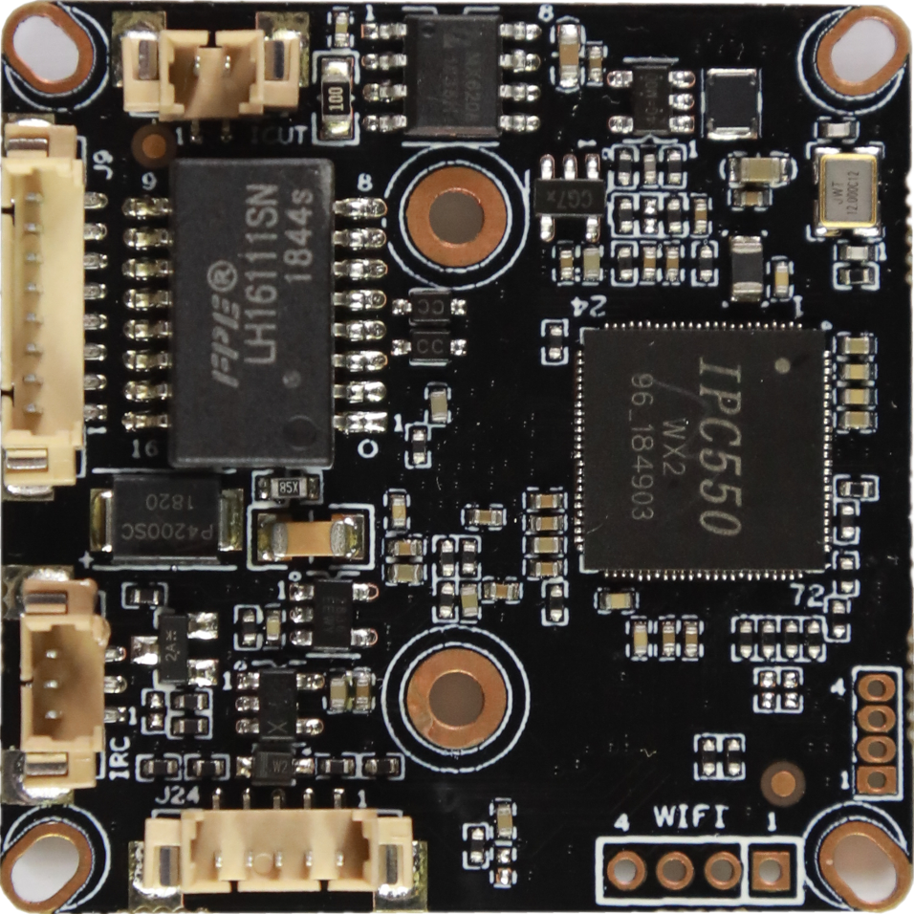
J6
3
2
1
J9

8
7
...
2
1
5 4 3 2 1
J24
4 3 2 1
J1

Socket | Specific No | Interface Description | Function
J9 | 1 | LED0 | LED/PHY_AD0 | Connect the tail line of the camera module
J9 | 2 | LED1 | LED/PHY_AD1 | Connect the tail line of the camera module
J9 | 3 | ETHTX+ | Ethernet signal+ | Connect the tail line of the camera module
J9 | 4 | ETHTX- | Ethernet signal- | Connect the tail line of the camera module
J9 | 5 | ETHRX+ | Ethernet signal+ | Connect the tail line of the camera module
J9 | 6 | ETHRX- | Ethernet signal- | Connect the tail line of the camera module
J9 | 7 | GND | GND | Connect the tail line of the camera module
J9 | 8 | 12V | 12V DC input | Connect the tail line of the camera module
J5 | 1 | IR-CUTA | BOUT | IR_CUT
J5 | 2 | IR-CUTA | AOUT | IR_CUT
J6 | 1 | IR-IN | Infrared input | Connect the camera lamp board
J6 | 2 | GND | GND | Connect the camera lamp board
J6 | 3 | PWM-OUT | +3.3V | Connect the camera lamp board
J24 | 1 | AC_OUT | AC_OUT | audio
J24 | 2 | AC_IN | AC_IN | audio
J24 | 3 | GND | GND | audio
J24 | 4 | ALARM-IN | ALARM_GPIO | audio
J24 | 5 | ALARM-OUT | ALARM_GPIO（Reserve） | audio
J1 | 1 | 3.3V | WIFI Module power supply | Connect the USB WIFI Module
J1 | 2 | USB_DN | USB | Connect the USB WIFI Module
J1 | 3 | USB_DP | USB | Connect the USB WIFI Module
J1 | 4 | GND | GND | Connect the USB WIFI Module

