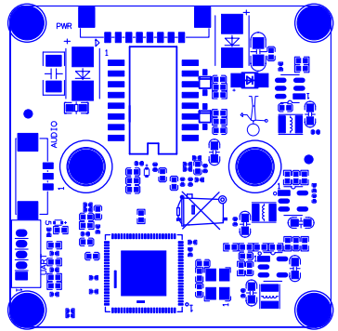
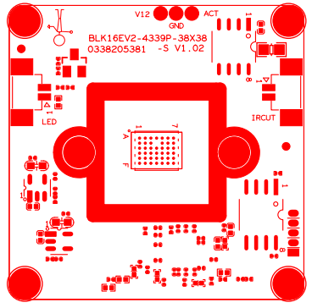
P4
5
4
3
2
1
P2 1 2 3 ……..8

P5
3
2
1
P1
1
2
P3
2
1
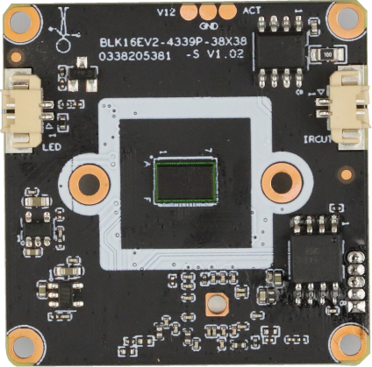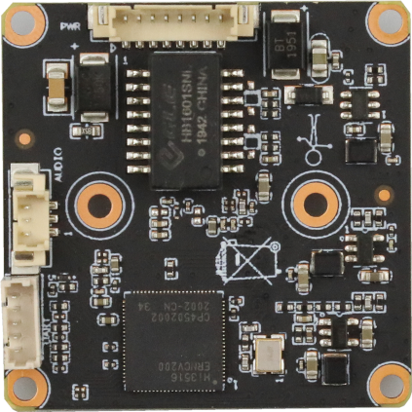
P3 Infrared
P5 Audio

P2 power&NET

P4 Extension

P1 IRCUT
sign | Socket | Specific No | Interface Description | Function
P1 | J4 | 1 | IRCUT-CONTROL2 | Ic-cut drive
P1 | J4 | 2 | IRCUT-CONTROL1 | Ic-cut drive
P4 | J1 | 1 | UATRO_RXD | UATRO_RXD
P4 | J1 | 2 | UATRO_TXD | UATRO_TXD
P4 | J1 | 3 | UATR1_RXD | UATR1_RXD
P4 | J1 | 4 | UATR1_TXD | IO port audio power amplifier control
P4 | J1 | 5 | ALARM | White light output
P3 | J2 | 1 | GPIO | Infrared signal control
P3 | J2 | 2 | IRIN_GPIO1_7 | Infrared signal input
P5 | J8 | 1 | GND | GND
P5 | J8 | 2 | AC_INL | Audio input
P5 | J8 | 3 | AC_OUTL | Audio output
P2 | J3 | 1 | ETH_LINK_STA_LED | LED
P2 | J3 | 2 | ETH_LINK_ACT_LED | LED
P2 | J3 | 3 | ETHTX+ | ETHTX+
P2 | J3 | 4 | ETHTX- | ETHTX-
P2 | J3 | 5 | ETHRX+ | ETHRX+
P2 | J3 | 6 | ETHRX- | ETHRX-
P2 | J3 | 7 | GND | GND
P2 | J3 | 8 | VCC | 12V input

