AHD-XM330A1-0235-38X38 –S V1.1 Interface Description
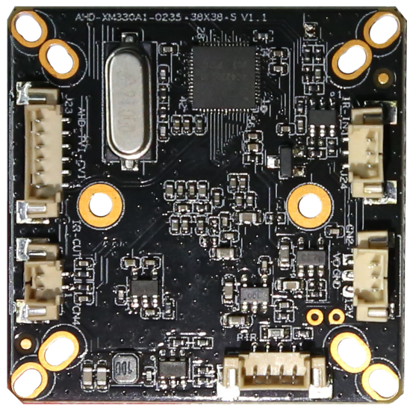
J23 6
5
4
3
2
1
PIR 4 3 2 1
J24 1
2 3
CN4
2
1
CN2 1
2 3

详细定义
Label | Socket | Specific No | Interface Description
J24 | 1 | IRC | Infrared input
J24 | 2 | GND | GND
J24 | 3 | NC | /
J23 | 1 | GND | GND
J23 | 2 | NC | /
J23 | 3 | PAL/NTSC | PAL/NTSC
J23 | 4 | NC | /
J23 | 5 | CVI | CVI
J23 | 6 | TVI | TVI
CN2 | 1 | VIDEO | VIDEO OUTPUT
CN2 | 2 | GND | GND
CN2 | 3 | 12V | 12V INPUT
CN4 | 1 | ICR | OUTPUT
CN4 | 2 | ICR | OUTPUT
PIR | 1 | ALARM_IN1 | PIR INPUT
PIR | 2 | GND | GND
PIR | 3 | 3.5V | 3.5V
PIR | 4 | GND | GND

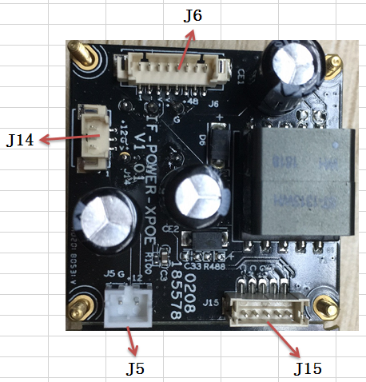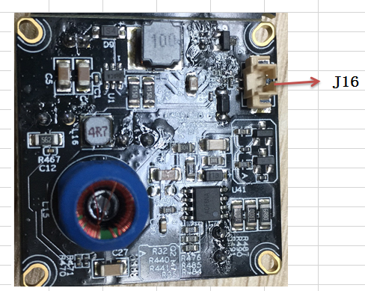
Label | Socket | Specific No | Interface Description | Connect to
J14 | 1 | CVBS | CVBS | CN2
J14 | 2 | GND | GND | CN2
J14 | 3 | 12V | 12V OUTPUT | CN2
J6 | 1 | NC | / | tail line
J6 | 2 | 3.3V | tail line LED | tail line
J6 | 3 | AGND | AGND | tail line
J6 | 4 | CVBS | CVBS | tail line
J6 | 5 | GND | 48V GND | tail line
J6 | 6 | 48V | 48V INPUT | tail line
J16 | 1 | IR | IR-CUT Switching control | J24
J16 | 2 | GND | GND | J24
J5 | 1 | 12V | 12V OUTPUT | Camera lamp board
J5 | 2 | GND | GND | Camera lamp board
J15 | 1 | LED+ | LED+ | Camera lamp board
J15 | 2 | LED- | LED- | Camera lamp board
J15 | 3 | GND | GND | Camera lamp board
J15 | 4 | CDS+ | CDS+ | Camera lamp board
J15 | 5 | CDS- | CDS- | Camera lamp board

