XMDZ-BLK18EV2-S1-IM-CZ-V1_02
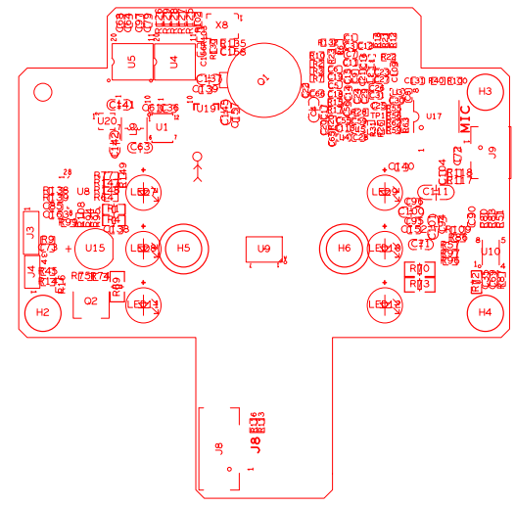
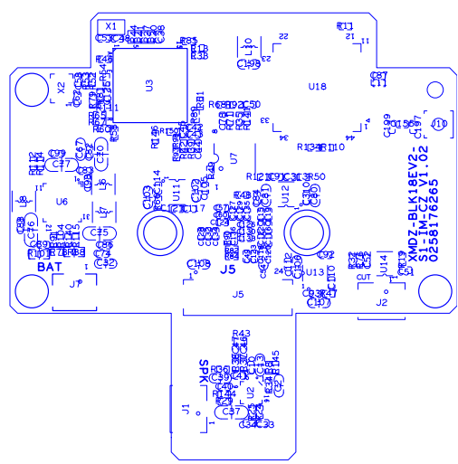

sign | Socket | Specific No | Interface Description | Function
P1 | Q1 | 1 | +3.3V_PIR | +3.3V_PIR
P1 | Q1 | 2 | PIR_OUT | PIR output
P1 | Q1 | 3 | GND | GND
P2 | J2 | 1 | OUT1 | ICR out1
P2 | J2 | 2 | OUT2 | ICR out 2
P3 | J8 | 1 | MCU_LED1 | Doorbell indicator
P3 | J8 | 2 | MCU_LED2 | Doorbell indicator
P3 | J8 | 3 | SET_GPIO03 | signal
P3 | J8 | 4 | GND | GND
P3 | J8 | 5 | +3.3V_PIR | +3.3V PIR power
P4 | J4 | 1 | UART0_RXD | UART0_RXD
P4 | J4 | 2 | UART0_TXD | UART0_TXD
P4 | J4 | 3 | GND | GND
P5 | J3 | 1 | +1.8V_STB | +1.8V
P5 | J3 | 2 | SWIM | SWIM
P5 | J3 | 3 | GND | GND
P5 | J3 | 4 | NRST | NRST
P6 | J9 | 1 | MIC_P | MIC_P
P6 | J9 | 2 | GND | GND
P7 | J7 | 1 | LI-BAT | LI-BAT
P7 | J7 | 2 | GND | GND
P8 | J1 | 1 | VOP | VOP
P1 | Q1 | 2 | VON | VON
P9 | J5 | 1 | +5V | +5V
P9 | J5 | 2 | +5V | +5V
P9 | J5 | 3 | +5V | +5V
P9 | J5 | 4 | GND | GND
P9 | J5 | 5 | GND | GND
P9 | J5 | 6 | GND | GND
P9 | J5 | 7 | USB_DM | USB_DM
P9 | J5 | 8 | USB_DP | USB_DP
P9 | J5 | 9 | GND | GND
P7 | J7 | 10 | CARD_DETECT | CARD_DETECT
P7 | J7 | 11 | SD_EN | SD_EN
P6 | J5 | 12 | SDIO1_CDATA0 | SDIO1_CDATA0
P6 | J5 | 13 | SDIO1_CDATA1 | SDIO1_CDATA1
P6 | J5 | 14 | SDIO1_CDATA2 | SDIO1_CDATA2
P6 | J5 | 15 | SDIO1_CDATA3 | SDIO1_CDATA3
P6 | J5 | 16 | SDIO1_CCMD | SDIO1_CCMD
P6 | J5 | 17 | SDIO1_CCLK_OUT | SDIO1_CCLK_OUT
P6 | J5 | 18 | GND | GND
P6 | J5 | 19 | 433_DATA | 433_DATA
P6 | J5 | 20 | SW_ON/OFF | SW_ON/OFF
P7 | J7 | 21 | GND | GND
P7 | J7 | 22 | SDIO1_VOUT | SDIO1_VOUT
 |  | 23 | GND | GND
 |  | 24 | +3.3V | +3.3V

BRD_XMDZ-CZ-LED_IF-V1_02

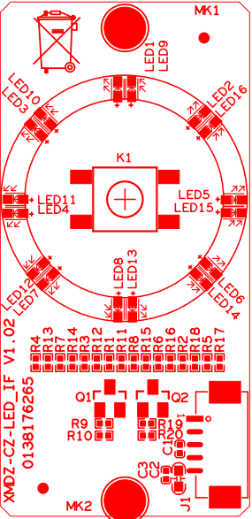

sign | Socket | Specific No | Interface Description | Function
P1 | K1 | 1 | GND | GND
P1 | K1 | 2 | GND | GND
P1 | K1 | 3 | SET_GPIO03 | SET_GPIO03
P1 | K1 | 4 | SET_GPIO03 | SET_GPIO03
P2 | J1 | 1 | MCU_LED1 | MCU_LED1
P2 | J1 | 2 | MCU_LED2 | MCU_LED2
P2 | J1 | 3 | GND | GND
P2 | J1 | 5 | +3.3V | +3.3V

BRD_XMDZ-CZ-POWER_IF-V1_02

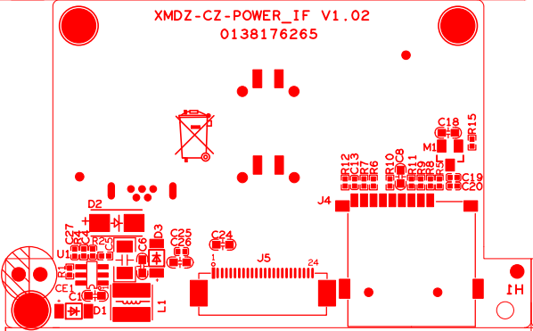

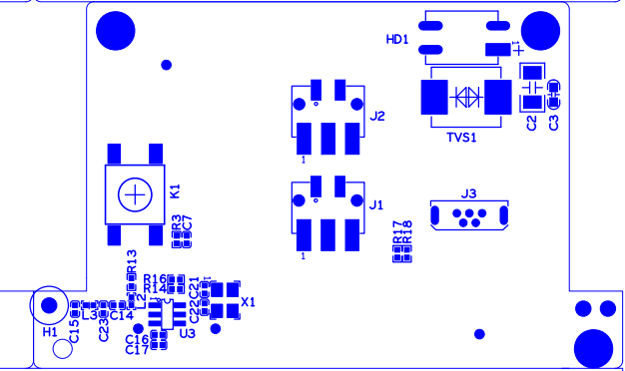

sign | Socket | Specific No | Interface Description | Function
P1 | J1 | 1 | AC24+ | AC24+
P1 | J1 | 2 | AC24+ | AC24+
P1 | J1 | 3 | AC24+ | AC24+
P2 | J2 | 1 | AC24- | AC24-
P2 | J2 | 2 | AC24- | AC24-
P2 | J2 | 3 | AC24- | AC24-
P3 | J3 | 1 | +5V | +5V
P3 | J3 | 2 | USB_DM | USB_DM
P3 | J3 | 3 | USB_DP | USB_DP
P3 | J3 | 5 | GND | GND
P4 | J5 | 1 | +3.3V | +3.3V
P4 | J5 | 2 | GND | GND
P4 | J5 | 3 | SDIO1_VOUT | SDIO1_VOUT
P4 | J5 | 4 | GND | GND
P4 | J5 | 5 | SW_ON/OFF | SW_ON/OFF
P4 | J5 | 6 | 433_DATA | 433_DATA
P4 | J5 | 7 | GND | GND
P4 | J5 | 8 | SDIO1_CCLK_OUT | SDIO1_CCLK_OUT
P4 | J5 | 9 | SDIO1_CCMD | SDIO1_CCMD
P4 | J5 | 10 | SDIO1_CDATA3 | SDIO1_CDATA3
P4 | J5 | 11 | SDIO1_CDATA2 | SDIO1_CDATA2
P4 | J5 | 12 | SDIO1_CDATA1 | SDIO1_CDATA1
P4 | J5 | 13 | SDIO1_CDATA0 | SDIO1_CDATA0
P4 | J5 | 14 | SD_EN | SD_EN
P4 | J5 | 15 | CARD_DETECT | CARD_DETECT
P4 | J5 | 16 | GND | GND
P4 | J5 | 17 | USB_DM | USB_DM
P4 | J5 | 18 | USB_DP | USB_DP
P4 | J5 | 19 | GND | GND
P4 | J5 | 20 | GND | GND
P4 | J5 | 21 | GND | GND
P4 | J5 | 22 | +5V | +5V
P4 | J5 | 23 | +5V | +5V
P4 | J5 | 24 | +5V | +5V
P5 | J4 | 1 | SDIO1_CDATA2 | SDIO1_CDATA2
P5 | J4 | 2 | SDIO1_CDATA3 | SDIO1_CDATA3
P5 | J4 | 3 | SDIO1_CCMD | SDIO1_CCMD
P5 | J4 | 4 | +3.3VSD | +3.3VSD
P5 | J4 | 5 | SDIO1_CCLK_OUT | SDIO1_CCLK_OUT
P5 | J4 | 6 | GND | GND
P5 | J4 | 7 | SDIO1_CDATA0 | SDIO1_CDATA0
P5 | J4 | 8 | SDIO1_CDATA1 | SDIO1_CDATA1
P5 | J4 | 9 | CARD_DETECT | CARD_DETECT
P6 | K1 | 1 | GND | GND
P6 | K1 | 2 | GND | GND
P6 | K1 | 3 | +3.3V | +3.3V
P6 | K1 | 4 | RESET | RESET

