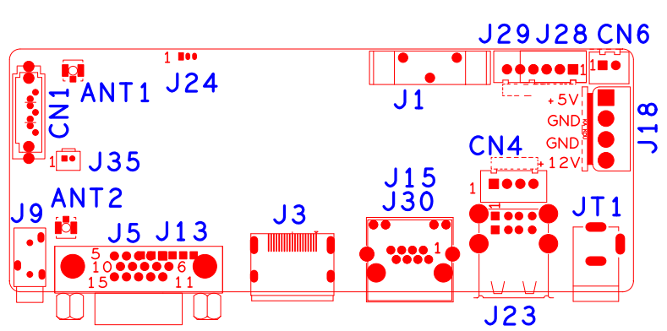

sign | Function | Interface Description
CN1 | SATA
J24 | Debug UART | 1:RXD | 2:TXD | 3:GND
J1 | Battery holder
J28 | 4Pin front panel interface | 1:+3.3 | 2:GND | 3:LINK_LED | 4: REC_LED
J18 | Hard disk power socket | 1:+5 | 2:GND | 3:GND | 4:+12
JT1 | 12V input
J23 | 2*USB
CN4 | USB Extension interface
J15&J30 | RJ45
J3 | HDMI
J5 | VGA
J9 | 3.5mm Audio output interface
ANT2 | Antenna

