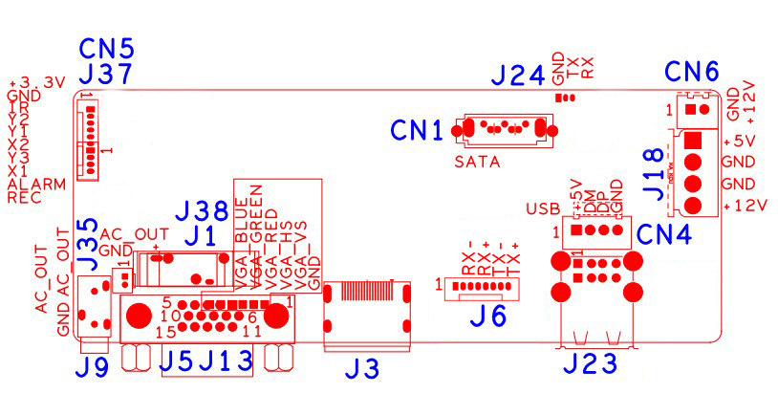

sign | Function | Interface Description
CN5 | 10pin without MCU front panel expansion socket(1.25*10) | 1:+3.3 | 2:GND | 3:IR | 4:COL2
CN5 | 10pin without MCU front panel expansion socket(1.25*10) | 5:COL1 | 6:ROW2 | 7:COL3 | 8:ROW1
CN5 | 10pin without MCU front panel expansion socket(1.25*10) | 9:ALARM | 10:REC
CN1 | SATA
J9 | 3.5mm Audio output interface
J1 | Battery holder
J5 | VGA
J3 | HDMI
J6 | POE network extension socket
CN4 | USB Extension interface
J23 | 2*USB
J18 | Hard disk power socket | 1:+5 | 2:GND | 3:GND | 4:+12
CN6 | FAN | 1:+12 | 2:GND

