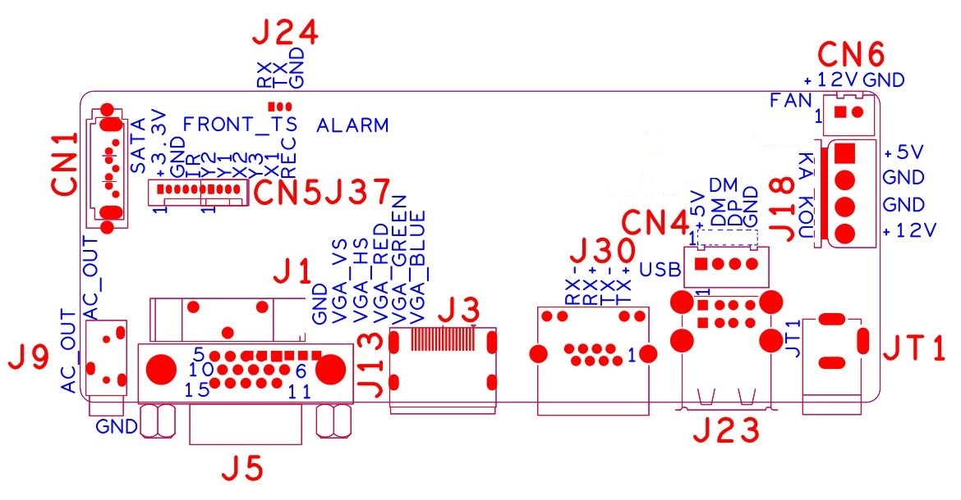

sign | Function | Interface Description
CN1 | SATA
J24 | Debug UART | 1:RXD | 2:TXD | 3:GND
J1 | Battery holder
CN5 | 10PIN front panel interface 10PIN front panel interface | 1:+3.3 | 2:GND | 3:IR | 4:COL2
CN5 | 10PIN front panel interface 10PIN front panel interface | 5:COL1 | 6:ROW2 | 7:COL3 | 8:ROW1
CN5 | 10PIN front panel interface 10PIN front panel interface | 9:ALARM | 10:REC
J18 | Hard disk power socket | 1:+5 | 2:GND | 3:GND | 4:+12
JT1 | 12V input
J23 | 2*USB
CN4 | USB Extension interface
J15&J30 | RJ45
J3 | HDMI
J5 | VGA
J9 | 3.5mm Audio output interface

