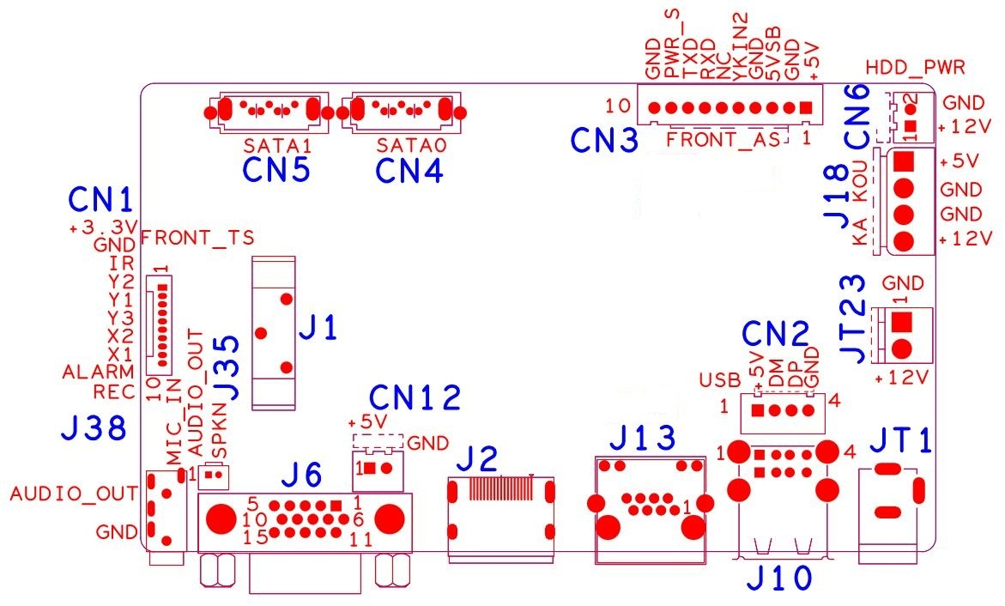

Sign | Function | Interface Description
CN1 | Expansion socket without MCU front panel（1.25*10P） | 1:+3.3 | 2:GND | 3:IR | 4:COL2
CN1 | Expansion socket without MCU front panel（1.25*10P） | 5:COL1 | 6:ROW2 | 7:COL3 | 8:ROW1
CN1 | Expansion socket without MCU front panel（1.25*10P） | 9:ALARM | 10:REC
CN5 | SATA
CN4 | SATA
CN3 | Expansion base with MCU front panel | 1:+5 | 2:GND | 3:+5_STB | 4:GND
CN3 | Expansion base with MCU front panel | 5:NC | 6:NC | 7:RXD_FRONT | 8:TX_FRONT
CN3 | Expansion base with MCU front panel | 9:PWR_S | 10:GND
CN6 | Fan power holder | 1:+12 | 2:GND
J18 | Hard disk power socket | 1:+5 | 2:GND | 3:GND | 4:+12
JT23 | 12V input (reserved for POE expansion)
JT1 | 12V input
J10 | 2*USB
CN2 | USB Extension interface(Scalable 3G WIFI)
J13 | RJ45
J2 | HDMI
J6 | VGA
CN12 | 5V output 2PIN extension (reserved)
J35 | Speaker extension (reserved, can be connected to speakers)
J9 | Audio 3.5mm input and output interface
J1 | CR2032 Battery holder

