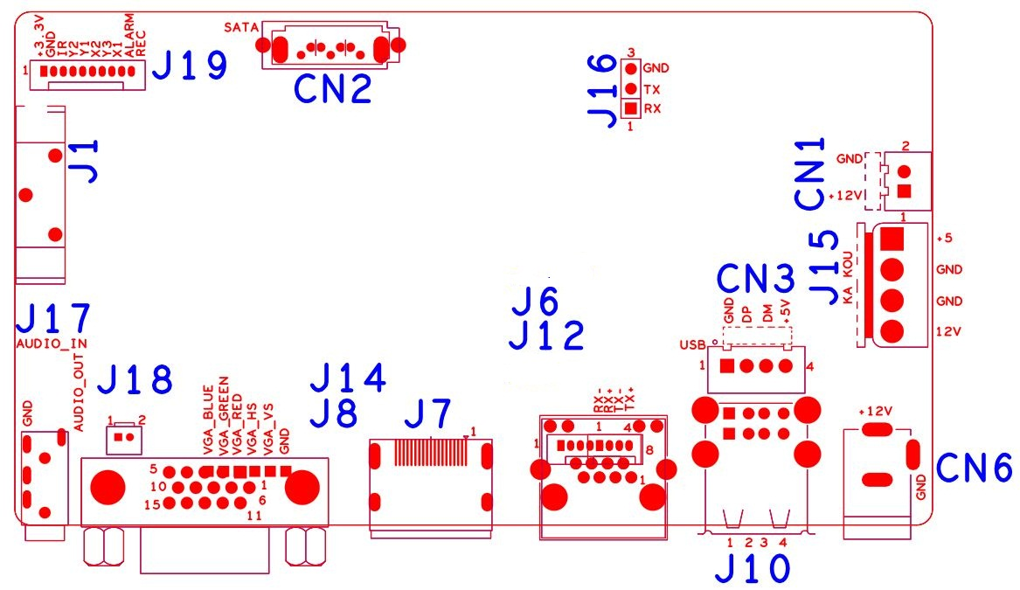

sign | Function | Interface Description
J1 | Battery holder
CN2 | SATA
J19 | 10Pin front panel interface(1.25*10P) | 1:+3.3 | 2:GND | 3:IR | 4:COL2
J19 | 10Pin front panel interface(1.25*10P) | 5:COL1 | 6:ROW2 | 7:COL3 | 8:ROW1
J19 | 10Pin front panel interface(1.25*10P) | 9:ALARM | 10:REC
J16 | RS232
J15 | SATA power extension socket | 1:+5 | 2:GND | 3:GND | 4:+12
CN1 | Fan seat | 1:+12 | 2:GND
CN6 | 12V input
J10 | 2*USB
CN3 | USB Extension interface | 1:+5 | 2:USB_DM | 3:USB_DP | 4:GND
J6 | RJ45
J12 | POE switch expansion interface (compatible) | 1:NC | 2:NC | 3:NC | 4:NC
J12 | POE switch expansion interface (compatible) | 5:ETHRX- | 6:ETHRX+ | 7:ETHTX- | 8:ETHTX+
J7 | HDMI
J8 | VGA
J14 | VGA expansion interface (compatible)
J18 | Audio extension socket (compatible)
J17 | 3.5mm Audio In/Output interface

