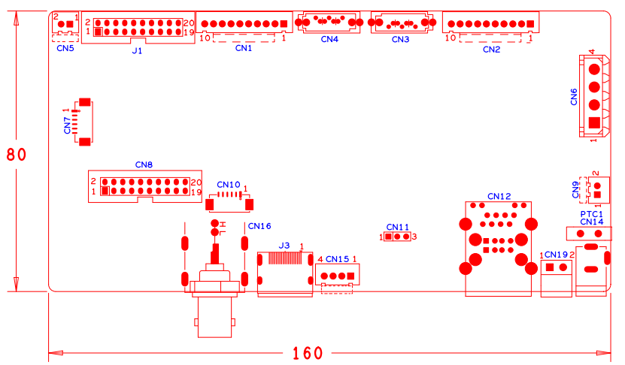

|  |  |  |  |  |  |
| --- | --- | --- | --- | --- | --- |
| 位号 | 功能描述 | 接口定义 | | | |
| CN5 | 风扇电源座子 | 1:+12 | 2:GND |  |  |
| J1 | 20PIN前面板座子 | 1:GND | 2:ROW0 | 3:ROW1 | 4:ROW2 |
|  |  | 5:ROW3 | 6:COL0 | 7:COL1 | 8:COL2 |
|  |  | 9:COL3 | 10:ALARM | 11:REC | 12:IR |
|  |  | 13:LINK | 14:+3.3 | 15:ROW4 | 16:COL4 |
|  |  | 17:NC | 18:GND | 19:NC | 20:NC |
| CN1 | 10PIN不带单片机前面板座子 | 1:+3.3 | 2:GND | 3:IR | 4:COL1 |
|  |  | 5:COL3 | 6:COL4 | 7:ROW4 | 8:COL2 |
|  |  | 9:ALARM | 10:REC |  |  |
| CN4 | SATA接口座子 |  |  |  |  |
| CN3 | SATA接口座子 |  |  |  |  |
| CN2 | 带单片机前面板扩展接口 | 1:+5V | 2:GND | 3:+5_STB | 4:GND |
|  |  | 5:NC | 6:NC | 7:UART_RXD | 8:UART_TX |
|  |  | 9:PWR_S | 10:GND |  |  |
| CN7 | 视频扩展接口 | 1:VIDEO5 | 2:VIDEO6 | 3:VIDEO7 | 4:VIDEO8 |
|  |  | 5:GND | 6:GND |  |  |
| CN6 | 硬盘电源座子 | 1:+12 | 2:GND | 3:GND | 4:+5 |
| CN8 | 音视频报警扩展座子 | 1:GND | 2:+5 | 3:VIDEO8 | 4:VIDEO7 |
|  |  | 5:VIDEO6 | 6:VIDEO5 | 7:AUDIO6 | 8:AUDIO7 |
|  |  | 9:GND | 10:GND | 11:AUDIO2 | 12:AUDIO5 |
|  |  | 13:AUDIO4 | 14:AUDIO3 | 15:AUDIO8 | 16:ALIN1 |
|  |  | 17:ALIN4 | 18:ALIN2 | 19:ALOUT1 | 20:ALIN3 |
| CN10 | VGA扩展座子 | 1:GND | 2:VGA_RED | 3:VGA_GREEN | 4:VGA_BLUE |
|  |  | 5:VGA_HSO | 6:VGA_VSO |  |  |
| CN9 | 风扇电源座子 | 1:+12 | 2:GND |  |  |
| CN16 | 音视频输出端子 | 1:AUDIO_OUT_MAIN | 2:VIDEO_OUT_MAIN |  |  |
| J3 | HDMI接口 |  |  |  |  |
| CN15 | USB扩展接口 | 1:+5 | 2:USB2DM | 3:USB2DP | 4:GND |
| CN11 | 串口座子 | 1:UART0_RXD | 2:UART0_TXD | 3:GND |  |
| CN12 | 2USB+网口组合座子 |  |  |  |  |
| CN19 | RS485接口 | 1:RS485_A | 2:RS485_B |  |  |
| PTC1 | PTC器件 |  |  |  |  |
| CN14 | 12V电源输入接口 |  |  |  |  |
|  |  |  |  |  |  |