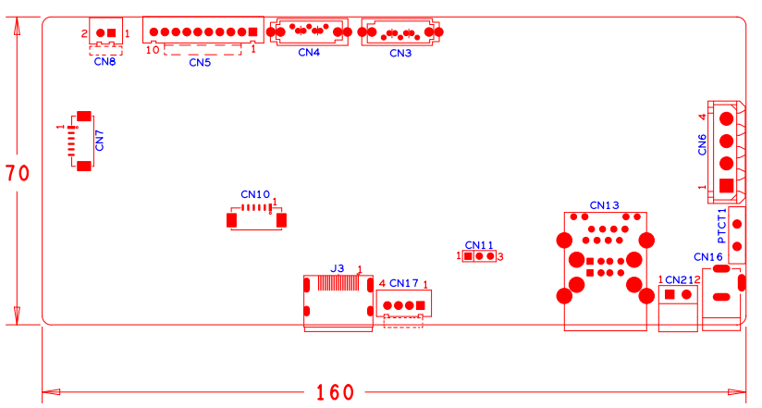

|  |  |  |  |  |  |
| --- | --- | --- | --- | --- | --- |
| 位号 | 功能描述 | 接口定义 | | | |
| CN8 | 风扇电源座子接口 | 1:+12 | 2:GND |  |  |
| CN5 | 10PIN不带单片机前面板接口 | 1:+3.3 | 2:GND | 3:IR | 4:COL1 |
|  |  | 5:COL3 | 6:COL4 | 7:ROW4 | 8:COL2 |
|  |  | 9:ALARM | 10:REC |  |  |
| CN4 | SATA接口 |  |  |  |  |
| CN3 | SATA接口 |  |  |  |  |
| CN7 | 视频扩展接口 | 1:VIDEO5 | 2:VIDEO6 | 3:VIDEO7 | 4:VIDEO8 |
|  |  | 5:GND | 6:GND |  |  |
| CN6 | 硬盘电源座子 | 1:+12 | 2:GND | 3:GND | 4:+5 |
| CN10 | VGA扩展接口 | 1:GND | 2: VGA_RED | 3: VGA_GREEN | 4: VGA_BLUE |
|  |  | 5: VGA_HSO | 6: VGA_VSO |  |  |
| J3 | HDMI接口 |  |  |  |  |
| CN17 | USB扩展接口 | 1:+5 | 2:USB2DM | 3:USB2DP | 4:GND |
| CN11 | 串口座子 | 1:UART0_RXD | 2:UART0_TXD | 3:GND |  |
| CN13 | 2USB+网口组合座子 |  |  |  |  |
| CN21 | RS485接口 | 1:RS485_A | 2:RS485_B |  |  |
| PTC1 | PTC器件 |  |  |  |  |
| CN16 | 12V电源输入接口 |  |  |  |  |
|  |  |  |  |  |  |