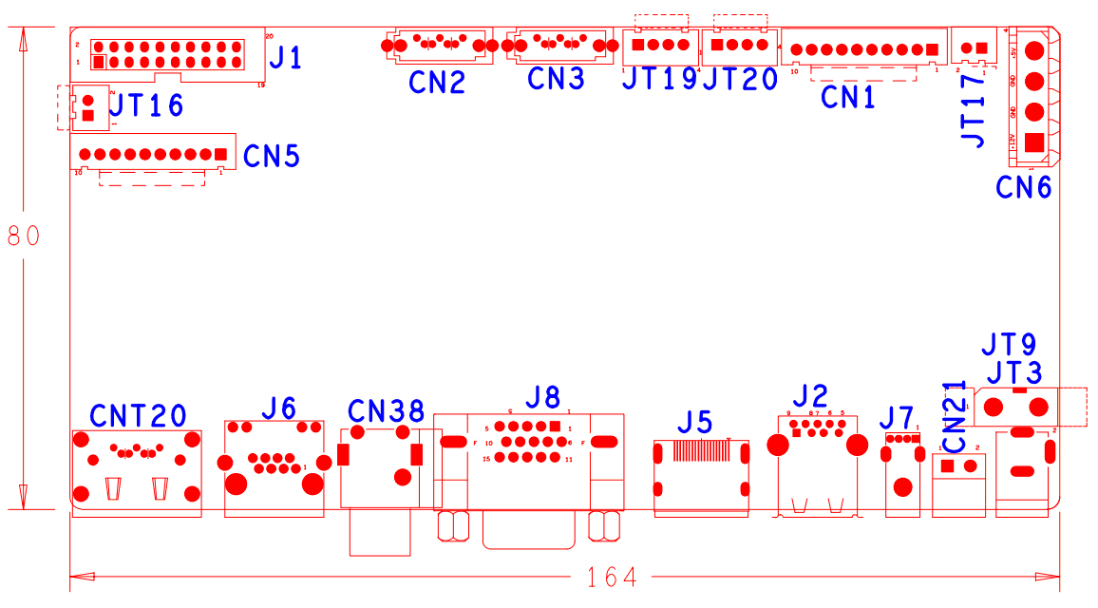

|  |  |  |  |  |  |
| --- | --- | --- | --- | --- | --- |
| 代号 | 功能描述 | 接口定义 | | | |
| J1 | 18PIN按键板接口 | 1：GND | 2: ROW0 | 3: ROW4 | 4: COL4 |
|  |  | 5: ROW3 | 6: COL0 | 7: COL2 | 8: ROW1 |
|  |  | 9: COL1 | 10: ALARM | 11: REC | 12: IR |
|  |  | 13: LINK | 14: +3.3 | 15: COL3 | 16: ROW2 |
|  |  | 17:NC | 18:GND | 19:NC | 20:NC |
| CN2 | SATA接口 |  |  |  |  |
| CN3 | SATA接口 |  |  |  |  |
| JT19 | USB扩展接口 | 1：+5V | 2：USB1_DM | 3:USB1_DP | 4:GND |
| JT20 | USB扩展接口 | 1：+5V | 2：USB2_DM | 3:USB2_DP | 4:GND |
| CN1 | 带单片机前面板扩展接口 | 1：+5V | 2：GND | 3：+5_STB | 4:GND |
|  |  | 5:NC | 6:NC | 7:UART_RXD | 8:UART_TX |
|  |  | 9:PWR_S | 10:GND |  |  |
| JT17 | 风扇电源接口 | 1：+12 | 2：GND |  |  |
| CN6 | 硬盘电源接口 | 1：+12 | 2：GND | 3：GND | 4：+5V |
| JT16 | 风扇电源接口 | 1：+12 | 2：GND |  |  |
| CN5 | 不带单片机前面板扩展接口(10P) | 1:+3.3 | 2：GND | 3：IR | 4：COL1 |
|  |  | 5：COL3 | 6：COL4 | 7：ROW4 | 8：COL2 |
|  |  | 9：ALARM | 10：REC |  |  |
| CNT20 | ESATA座子 |  |  |  |  |
| J6 | 网络接口 |  |  |  |  |
| CN38 | 音频输入输出座子 | 1T(靠近板子)：AUDIO_OUT_MAIN | 2T(远离板子)：AUDIO_LINE_IN |  |  |
| J8 | VGA接口 |  |  |  |  |
| J5 | HDMI接口 |  |  |  |  |
| J2 | USB3.0 |  |  |  |  |
| J7 | USB2.0 |  |  |  |  |
| CN21 | RS485接口 | 1：RS485_A | 2：RS485_B |  |  |
| JT9 | 开关座子 |  |  |  |  |
| JT3 | +12V电源输入座子 |  |  |  |  |
|  |  |  |  |  |  |