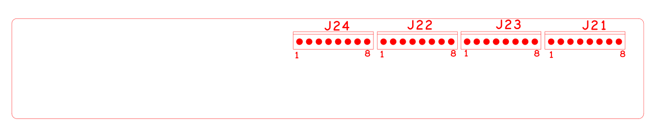

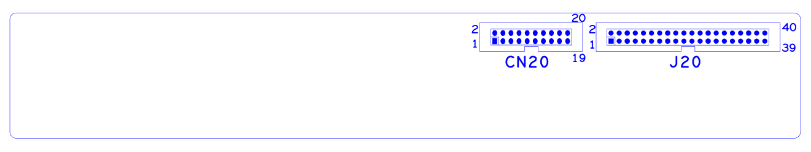

代号 | 功能描述 | 接口定义
J24 | 报警接口 | 1:ALARM_IN16 | 2:GND | 3:ALARMOUT3_C | 4:ALARMOUT3_NO
 |  | 5:ALARMOUT4_C | 6:ALARMOUT4_NO | 7:RS485_A | 8:RS485_B
J22 | 报警接口 | 1:ALARM_IN9 | 2:ALARM_IN10 | 3:ALARM_IN11 | 4:ALARM_IN12
 |  | 5:GND | 6:ALARM_IN13 | 7:ALARM_IN14 | 8:ALARM_IN15
J23 | 报警接口 | 1:ALARM_IN8 | 2:GND | 3:ALARMOUT1_C | 4:ALARMOUT1_NO
 |  | 5:ALARMOUT2_C | 6:ALARMOUT2_NO | 7:RS232_R | 8:RS232_T
J21 | 报警接口 | 1:ALARM_IN1 | 2:ALARM_IN2 | 3:ALARM_IN3 | 4:ALARM_IN4
 |  | 5:GND | 6:ALARM_IN5 | 7:ALARM_IN6 | 8:ALARM_IN7
J20 | 报警输入输出、RS232、RS485扩展座子 | 1:NC | 2:NC | 3:NC | 4:GND
 |  | 5:NC | 6:NC | 7:GND | 8:NC
 |  | 9:NC | 10:GND | 11:NC | 12:NC
 |  | 13:GND | 14:ALOUT4 | 15:ALOUT2 | 16:GND
 |  | 17:ALOUT3 | 18:ALARMIN_16 | 19:GND | 20:RS232_R
 |  | 21:RS232_T | 22:GND | 23:RS485_B | 24:RS485_A
 |  | 25:GND | 26:ALARM_IN10 | 27:ALARM_IN9 | 28:ALARM_IN11
 |  | 29:ALARM_IN8 | 30:ALARM_IN12 | 31:GND | 32:GND
 |  | 33:ALARM_IN5 | 34:ALARM_IN13 | 35:ALARM_IN6 | 36:ALARM_IN14
 |  | 37:ALARM_IN7 | 38:ALARM_IN15 | 39:GND | 40:GND
CN20 | 报警输入输出扩展座子 | 1:NC | 2:5V | 3:GND | 4:5V
 |  | 5:NC | 6:5V | 7:NC | 8:NC
 |  | 9:GND | 10:GND | 11:NC | 12:NC
 |  | 13:NC | 14:NC | 15:NC | 16:ALARM_IN1
 |  | 17:ALARM_IN4 | 18:ALARM_IN2 | 19:ALOUT1 | 20:ALARM_IN3

本接口说明对应产品型号:F系列16路报警接口板-NVR专用

