NBD8128HG-F

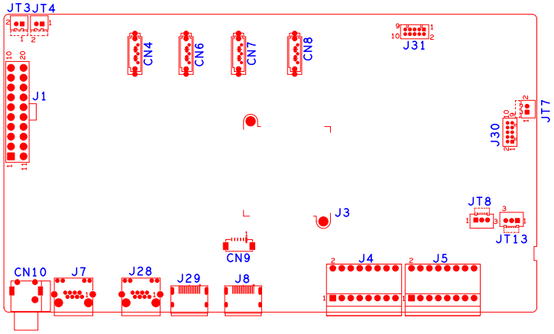

|  |  |  |  |  |  |
| --- | --- | --- | --- | --- | --- |
| 位号 | 功能描述 | 接口定义 | | | |
| JT3 | 风扇电源座子 | 1:+12 | 2:GND |  |  |
| JT4 | 风扇电源座子 | 1:+12 | 2:GND |  |  |
| JT7 | 风扇电源座子 | 1:+12 | 2:GND |  |  |
| JT8 | RS232接口 | 1:RXD | 2:TXD | 3:GND |  |
| JT13 | RS232接口 | 1:RXD | 2:TXD | 3:GND |  |
| J31 | 3U机箱USB扩展板接口 |  |  |  |  |
| J7 | 网口座子 |  |  |  |  |
| J28 | 网口座子 |  |  |  |  |
| CN9 | VGA扩展座子 | 1:GND | 2: VGA_RED | 3: VGA_GREEN | 4: VGA_BLUE |
|  |  | 5: VGA_HSO | 6: VGA_VSO |  |  |
| J30 | 3U机箱按键板扩展接口 |  |  |  |  |
| J4 | 报警输入输出座子 | 1:ALARM_IN8 | 2:ALARM_IN16 | 3:GND | 4:GND |
|  |  | 5: ALARMOUT1_C | 6: ALARMOUT3_C | 7: ALARMOUT1_NO | 8:ALARMOUT3_NO |
|  |  | 9: ALARMOUT2_C | 10: ALARMOUT4_C | 11:ALARMOUT2_NO | 12:ALARMOUT4_NO |
|  |  | 13:RS232_R | 14:RS485_A | 15:RS232_T | 16:RS485_B |
| J5 | 报警输入输出座子 | 1:ALARM_IN1 | 2:ALARM_IN9 | 3:ALARM_IN2 | 4:ALARM_IN10 |
|  |  | 5:ALARM_IN3 | 6:ALARM_IN11 | 7:ALARM_IN4 | 8:ALARM_IN12 |
|  |  | 9: GND | 10:GND | 11:ALARM_IN5 | 12:ALARM_IN13 |
|  |  | 13:ALARM_IN6 | 14:ALARM_IN14 | 15:ALARM_IN7 | 16:ALARM_IN15 |
| CN10 | 音频输入输出座子 | 1T:AUDIO_OUT_MAIN | 2T:AUDIO_LINE_IN |  |  |
| CN4 | SATA接口 |  |  |  |  |
| CN6 | SATA接口 |  |  |  |  |
| CN7 | SATA接口 |  |  |  |  |
| CN8 | SATA接口 |  |  |  |  |
| J8 | HDMI接口 |  |  |  |  |
| J29 | HDMI接口 |  |  |  |  |
| J1 | ATX电源座子 | 1：+3.3 | 2：+3.3 | 3：GND. | 4：+5 |
|  |  | 5：GND | 6:+5 | 7:GND | 8:NC |
|  |  | 9:+5_STB | 10:+12 | 11:+3.3 | 12:NC |
|  |  | 13:GND | 14:PWR_S | 15:GND | 16:GND |
|  |  | 17:GND | 18:NC | 19:+5 | 20：+5 |