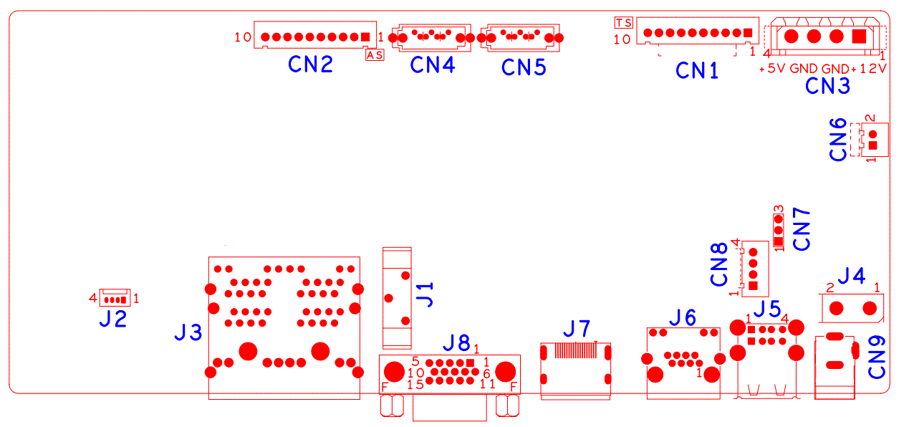

|  |  |  |  |  |  |
| --- | --- | --- | --- | --- | --- |
| 代号 | 功能描述 | 接口定义 | | | |
| CN2 | 带单片机前面板扩展座子 | 1:+5 | 2:GND | 3:+5_STB | 4:GND |
|  |  | 5:NC | 6:NC | 7:RXD_FRONT | 8:TXD_FRONT |
|  |  | 9:PWR_S | 10:GND |  |  |
| CN4 | SATA接口 |  |  |  |  |
| CN5 | SATA接口 |  |  |  |  |
| CN1 | 10Pin不带单片机前面板扩展座子 | 1:+3.3 | 2:GND | 3:IR | 4:COL1 |
|  |  | 5:COL3 | 6:COL4 | 7:ROW4 | 8:COL2 |
|  |  | 9:ALARM | 10:REC |  |  |
| CN3 | 硬盘电源座子 | 1:+12 | 2:GND | 3:GND | 4:+5 |
| CN6 | 风扇电源座子 | 1：+12 | 2：GND |  |  |
| J4 | 48V电源开关 |  |  |  |  |
| CN9 | 48V电源输入接口 |  |  |  |  |
| J5 | 2USB组合座子 |  |  |  |  |
| CN7 | RS232 |  |  |  |  |
| CN8 | 前面板USB扩展座子 | 1:+5 | 2:USB2DM | 3:USB2DP | 4:GND |
| J6 | RJ45网口 |  |  |  |  |
| J7 | HDMI接口 |  |  |  |  |
| J8 | VGA接口 |  |  |  |  |
| J1 | 电池座子 |  |  |  |  |
| J3 | 4路XPOE功能组合网口 |  |  |  |  |
| J2 | 单片机烧写扩展座子 |  |  |  |  |