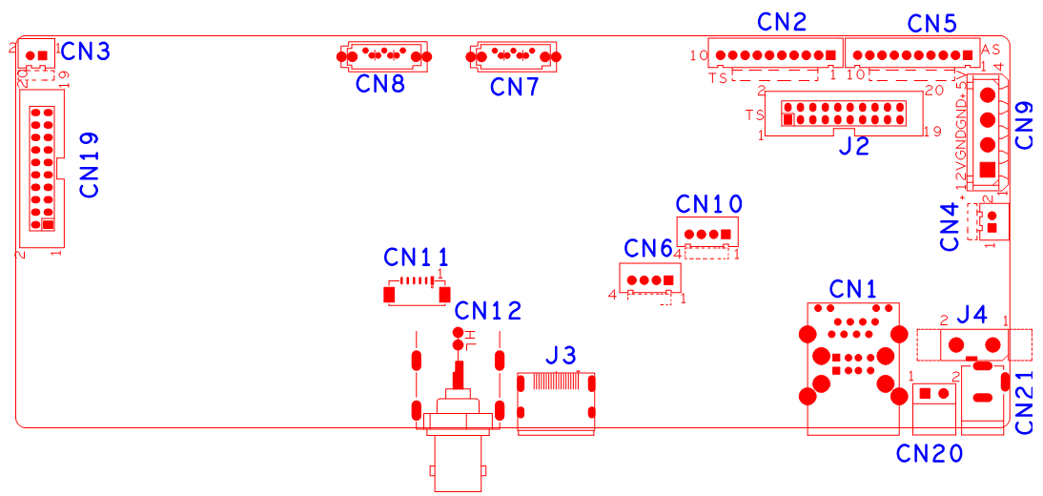

|  |  |  |  |  |  |
| --- | --- | --- | --- | --- | --- |
| 位号 | 功能描述 | 接口定义 | | | |
| CN19 | 报警输入输出扩展座子 | 1:GND | 2:+5V | 3:NC | 4:NC |
|  |  | 5:NC | 6:NC | 7:NC | 8:NC |
|  |  | 9:GND | 10:GND | 11:NC | 12:NC |
|  |  | 13:NC | 14:NC | 15:NC | 16:ALIN1 |
|  |  | 17:ALIN4 | 18:ALIN2 | 19:ALOUT1 | 20:ALIN3 |
| CN3 | 风扇电源座子 | 1:+12 | 2:GND |  |  |
| CN8 | SATA接口 |  |  |  |  |
| CN7 | SATA接口 |  |  |  |  |
| CN2 | 10PIN前面板座子 | 1:+3.3V | 2:GND | 3:IR | 4:COL1 |
|  |  | 5:COL3 | 6:COL4 | 7: ROW4 | 8:COL2 |
|  |  | 9:ALARM | 10:REC |  |  |
| CN5 | 10PIN带单片机前面板座子 | 1:+5V | 2:GND | 3:+5_STB | 4:GND |
|  |  | 5:NC | 6:NC | 7:RXD_FRONT | 8:TXD_FRONT |
|  |  | 9: PWR_S | 10:GND |  |  |
| CN9 | 硬盘电源座子 |  |  |  |  |
| CN4 | 风扇电源座子 | 1:+12 | 2:GND |  |  |
| J2 | 20PIN前面板座子 | 1:GND | 2:ROW0 | 3:ROW1 | 4:ROW2 |
|  |  | 5:ROW3 | 6:COL0 | 7:COL1 | 8:COL2 |
|  |  | 9:COL3 | 10:ALARM | 11:REC | 12:IR |
|  |  | 13:LINK | 14:+3.3V | 15:ROW4 | 16:COL4 |
| J4 | 12V电源开关 |  |  |  |  |
| CN21 | 12V电源输入接口 |  |  |  |  |
| CN20 | RS485接口 |  |  |  |  |
| CN1 | 2USB+网口组合座子 |  |  |  |  |
| CN10 | RS232接口 | 1:UART0_RXD | 2:UART0_TXD | 3:GND | 4:+5V |
| CN6 | USB扩展接口 | 1:+5V | 2:USB2DM | 3:USB2DP | 4:GND |
| J3 | HDMI接口 |  |  |  |  |
| CN11 | VGA扩展座子 |  |  |  |  |
| CN12 | 音频输出端子 | 1:AUDIO_OUT_MAIN |  |  |  |